PRESS RELEASE
26th April 2023
QUANTRON expands the Clean Transportation Alliance partner network with three international technology companies for decentralised hydrogen solutions in Europe
- As part of Q-Days 2023, QUANTRON announced three new partnerships for the Clean Transportation Alliance – the companies initiative to build an ecosystem supporting the unique holistic solution Quantron-as-a-Servivce (QaaS)
- The new partner companies Green Hydrogen Technology (GHT) UNIWASTEC and Plagazi focus on the production of green hydrogen from waste materials such as municipal and industrial waste, sewage sludge, plastic and non-recyclable materials
- These new collaborations facilitate the construction of hydrogen infrastructures within the framework of regional industrial projects where local H2 production takes place thereby reducing the costs associated with transporting the hydrogen
As part of Q-Days 2023, Quantron AG, a clean-tech company and specialist in sustainable passenger and freight transport, has announced further strategic partnerships for expanding the Clean Transportation Alliance. The new partners Green Hydrogen Technology (GHT), UNIWASTEC and Plagazi are also clean-tech enterprises specialising in waste-to-hydrogen technology that produce green hydrogen from a wide range of waste materials. The clean energy source will be used to decarbonise the transport and logistics sector for Quantron-as-a-Service (QaaS) customers throughout Europe.
Sustainable circular economy
All three new partners produce green hydrogen from various waste materials such as municipal and industrial waste (UNIWASTEC), sewage sludge and plastic waste (GHT) as well as non-recyclable materials (Plagazi). Clean and renewable energy is obtained from substances that are otherwise of no use and have a negative impact on the environment. This innovative waste-to-hydrogen circular economy corresponds to QUANTRON's corporate philosophy of conserving natural resources through the use of sustainable technologies.
At the same time, decentralised hydrogen production is not dependent on a complex distribution infrastructure. The production facilities are suitable, among other things, for use in on-site hydrogen production at industrial applications, waste disposal companies and energy suppliers. These businesses are usually located in logistically advantageous locations for the transport sector so that the obstacles and costs usually associated with storing and transporting the fuel can be avoided as far as possible. In the ideal case, the Hydrogen is consumed directly at the production site and –amongst other applications- directly filled into the tanks of QUANTRON trucks.
The new partners of the Clean Transportation Alliance
UNIWASTEC produces green electricity through thermolytic conversion of municipal and industrial waste. This energy is fed into a patented process that uses sea or waste water to produce highly purified, climate-neutral hydrogen. The technology does not require precious drinking water and requires significantly less energy than conventional electrolysis processes.
Urs Pelizzoni, CEO of UNIWASTEC, explains: “The future of transport is carbon neutral and includes new, smarter energy sources. The cooperation between QUANTRON, a world-class mobility provider and its innovative QaaS transport model, and UNIWASTEC, a global provider of climate-neutral hydrogen that offers market-leading waste-to-energy solutions based on outstanding patented technologies, facilitates a unique strategic collaboration. We are very pleased to engage in this partnership. Together with QUANTRON, we are now able to offer customers the entire end-to-end solution while simultaneously realising our shared vision of a carbon-neutral green future.”
Green Hydrogen Technology (GHT) has developed an innovative process for generating green hydrogen without using fossil fuels. The production plant can be adapted to accommodate the available resources and produces H2 through a three-stage process using sewage sludge, plastic and wood waste as raw materials.

“Energy transition is a team sport. We are delighted to have QUANTRON, a great partner for the decarbonisation of the transport sector, at our side,” says Robert Nave, CEO of GHT. "Our technology allows cost-effective production of green hydrogen - and with such production capacities which means many QaaS trucks can be powered with it in the future. At the same time, GHT production facilities can be supplied with these trucks in a climate-neutral manner. This is how we envision the circular economy.”
Plagazi has a patented Swedish technology that converts non-recyclable waste such as auto-shredder-residue, contaminated plastics, wind turbine blades, industrial waste, hazardous waste or difficult biomass into green hydrogen via plasma gasification at a highly competitive production cost.
Establishing a strategic cooperation agreement with a leading and forward-thinking mobility developer such as QUANTRON creates a exceedingly interesting and promising outlook on the future of sustainable, zero-emission road transport in Europe as well and its synergy with waste-to-hydrogen as a hydrogen-supplying technology.”, says Torsten Granberg, CEO of Plagazi. “We believe that our technology caters excellently to the location flexible requirements of sustainable mobility, and it is exciting to see that QUANTRON shares that sentiment. We very much look forward to working with them.”
Michael Perschke, CEO of Quantron AG, says: “For the decarbonisation of the transport sector, the fuel cell drive is the decisive technology in heavy-duty transport for long distances. However, a filling station network must also be in place to ensure a reliable supply of hydrogen. With GHT, UNIWASTEC and Plagazi, we have found three partners who will support us in establishing a decentralised infrastructure for green hydrogen for our sustainable mobility concepts in Europe."

Images (click on image preview to download):
 | Urs Pelizzoni, CEO UNIWASTEC
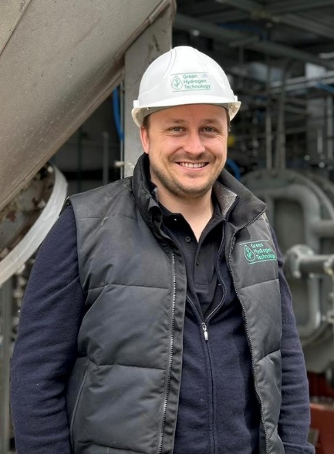 | Robert Nave, CEO Green Hydrogen Technology
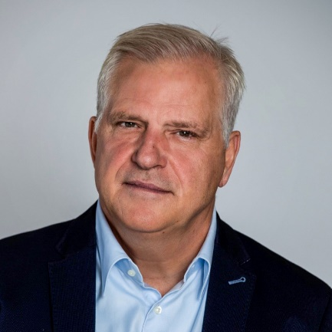 | Torsten Granberg, CEO Plagazi
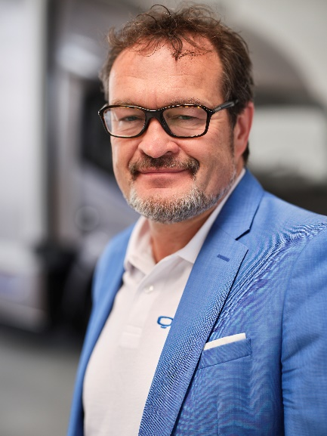 | Michael Perschke, CEO Quantron AG

The original photos are available in both low and high resolutions here: Quantron AG press releases (https://www.quantron.net/q-news/pr-berichte/)
About Quantron AG
Quantron AG is a platform provider and specialist in sustainable mobility for people and goods; in particular ,for trucks, buses and vans with all-electric drive trains and H₂fuel cell technology. As a high-tech spin-off of the renowned Haller KG, the Augsburg/Bavaria-based company combines more than 140 years of commercial vehicle experience with the very latest e-mobility know-how, and positions itself globally as a partner to existing OEMs.
With the Quantron-as-a-Service Ecosystem (QaaS), QUANTRON offers an overall concept that includes all facets of the mobility value-added chain: QUANTRON INSIDE includes a wide range of new vehicles as well as conversions for existing and used vehicles from diesel to battery and hydrogen-electric drives with the highly innovative QUANTRON INSIDE technology. With a Europe-wide network of 700 service partners,QUANTRON CUSTOMER SOLUTIONS guarantees digital and physical after-sales solutions along with a range of services for maintenance, repairs and spare parts, telematics and in-cloud solutions for remote diagnosis and fleet management. Customers receive individual advice on, among other things, tailored charging and tank solutions, rental, financing and leasing offers. Training courses and workshops are also offered in the QUANTRON Academy. In future, QUANTRON ENERGY & POWER STATIONS will realise the production of green hydrogen and electricity as a platform. To this end, Quantron AG has teamed up with a number of strong global partners. At the same time, this Clean Transportation Alliance is also an important building block for supplying vehicles with the required green charging and H2 tank infrastructure.
QUANTRON stands for the core values RELIABLE, ENERGETIC, BRAVE . The team of experts at the innovation driver for e-mobility is making a significant contribution to sustainable, environmentally friendly passenger and freight transport.
Visit Quantron AG on our social media channels onLinkedIn and YouTube. More informationen available at www.quantron.net

About UNIWASTEC
UNIWASTEC AG is based in Rotkreuz, Switzerland. The waste-to-energy specialist converts a wide range of waste into raw materials and green energies using the most innovative and efficient technologies available. UNIWASTEC offers solutions for the production of highly purified green hydrogen, green electricity, synthetic catalytic fuel or synthetic natural gas.

About Green Hydrogen Technology GmbH
The Green Hydrogen Technology GmbH, headquartered in Augsburg, is a young enterprise that has developed a technology to produce green hydrogen from sewage sludge and non-recyclable plastic and wood waste. Potential users of this technology are industrial companies, energy suppliers and the municipal economy which can use the process to produce green hydrogen locally on an industrial scale. With 4,500 tonnes per year, the production capacity of GHT installations far exceeds the amounts produced by conventional electrolysis plants. The patented GHT technology also solves a major disposal problem: landfilling of sewage sludge will only be possible from 2029 onwards if the phosphorus content is recovered beforehand. The requirement can be met using GHT technology as it can efficiently separate the phosphorus contained in the sludge. The company is currently testing the technology using an H₂ pilot plant on an industrial scale.
More information: www.green-ht.eu

About Plagazi AB (publ)
Plagazi AB is a Swedish clean-tech company which is revolutionizing the production of green hydrogen. Plagazi helps society close the circular loop by transforming waste into green hydrogen through plasma gasification, contributing to resolve the significant global issue of non-recyclable waste, renewable energy sources and carbon emissions. With multiple active projects across Europe, the company aims to become the answer to the continent’s mission to reach its climate goals.
More Information: www.Plagazi.com

Contact persons:
Jörg Zwilling, Director Global Communication & Business Development, j.zwilling@quantron.net
Stephanie Miller, Marketing & Communications Quantron AG, press@quantron.net

