PRESS RELEASE May 3rd, 2023
Quantron US unveils its Range Class Leading Hydrogen Powered Class 8 truck and connects customers to market leading hydrogen fueling network by FirstElement Fuel at the ACT Expo show in California
- QUANTRON is showcasing its new range class leading hydrogen fuel-cell electric (FCEV) semitruck prototype, designed for heavy-duty, long haul applications
- Quantron US and FirstElement Fuel announced a commitment to provide fleet operators access to hydrogen refueling network – as a market leader with already 40 H2 fueling stations
- The arrangement builds on Quantron-as-a-Service – a 360-degree turnkey service that gives fleet owners access to everything required to transition to hydrogen

Quantron US, a subsidiary of the German specialist for sustainable passenger and freight transport Quantron AG, and FirstElement Fuel announced that QUANTRON will be one of the first to take advantage of FirstElement’s market leading network of hydrogen stations designed for hydrogen fuel-cell electric trucks.
QUANTRON and FirstElement Fuel executives announced their commitment at the Advanced Clean Transportation Expo in Anaheim, California. QUANTRON is showcasing a complete two-step solution for operators to easily transition to carbon-free hydrogen fleets at the show, including showcasing its new hydrogen fuel-cell electric (FCEV) semi-truck. With its 80kg of hydrogen on board, it is demonstrating best-in-class tank capacity. When complete, QUANTRON expects its trucks to offer a range of about 750 – 850 miles on a 100 kg tank system which will set a new benchmark. It is expected to only require 10 –15 minutes for refueling to 100% capacity, which is comparable to current diesel trucks on the road today and significantly quicker than electric vehicles.
The commitment between the two companies assures that QUANTRON customers have access to hydrogen refueling through the FirstElement station network. The announcement expands Quantron-as-a-Service, a 360-degree per-mile service that gives fleet owners access to everything required to transition to hydrogen.
“QUANTRON is about making it easy for fleets to transition to carbon-free mobility,” said Rick Haas, Quantron US president and CEO. “By working with FirstElement, we are able to overcome the modern infrastructure challenge that limits the potential of other alternative energy sources – access to a reliable refueling network. FirstElement’s hydrogen network will allow drivers to seamlessly refuel and get back on the road, just like they would with diesel today, only now they’ll go further with zero-emission fuel.”
"We’re very grateful to the QUANTRON team for being the first to step up with a commitment – this will help us build out our truck station network more quickly,” said Joel Ewanick, CEO of FirstElement Fuel. “Hydrogen fueling needs to be reliable and uncomplicated, and our network will provide that convenience for QUANTRON’s customers so that they can offer this experience to many more operators. Fuel cells will play a huge role in the Zero Emission Truck future, and we are excited to be working with QUANTRON as the first of what we hope are many who will help us get our network of stations built across North America.”
The commitment between QUANTRON and FirstElement Fuel is structured to ensure reliable access to hydrogen fuel at distribution stations across its network in California. FirstElement Fuel operates the largest network of hydrogen refueling stations in the world, which during March 2023 performed over 60,000 fills and over sold over 162,000 kilograms of hydrogen. The company is now developing a network of "high flow” hydrogen stations capable of filling heavy duty, medium duty, and light duty class vehicles, with twelve stations across California as phase 1 of its development plan. The first of FirstElement Fuel’s “high flow” stations is set to open later this year near the Port of Oakland.
Quantron US is focusing on building its Class 8 hydrogen fuel-cell trucks
“After we found some early success in Europe, we started considering the vast potential for hydrogen fuel solutions in North America,” said Michael Perschke, Quantron AG CEO. “North American-based businesses depend on heavy cargo loads over long routes. As we are already the technical leader in Europe with our benchmark range of 700 KM in Europe, we transferred this DNA into the USA and we were looking for a partner with a proven track record – with undisputed market leadership of nearly 40 stations only in California. We did not want to build our plans on the basis of plans of start-ups, but wanted to build our H2 fueling capacity with the market and technical leader and thereby First Element was the natural choice.”
QUANTRON’s work with FirstElement Fuel helps advance development of the U.S. version of Quantron-as-a-Service. The service is an integrated solution for fleet owners to transition to zero- emissions. It provides everything required to make carbon-free hydrogen fleets no more costly than today’s diesel fleets: FCEV trucks, hydrogen fuel, designated fueling stations, maintenance and repairs, and insurance. By pairing best-in-class systems in the vehicle with its 360-degree service, QUANTRON makes it simple for fleets to begin the transition to carbon-free mobility.

Images (Please click on the image preview to download):
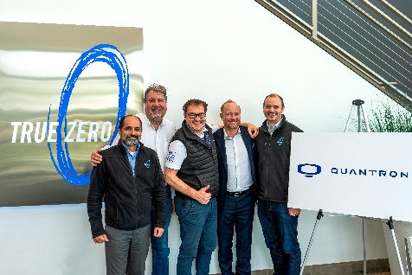 | QUANTRON and First Element Fuel are providing hydrogen powered heavy-duty trucks and the hydrogen refilling network to US fleet operators  From left: Ghassan Sleiman (CTO First Element Fuel), Richard Haas (President & CEO Quantron US), Michael Perschke (CEO Quantron AG), Andreas Haller (Executive Chairman & Founder Quantron AG), John McFarland (COO First Element Fuel)
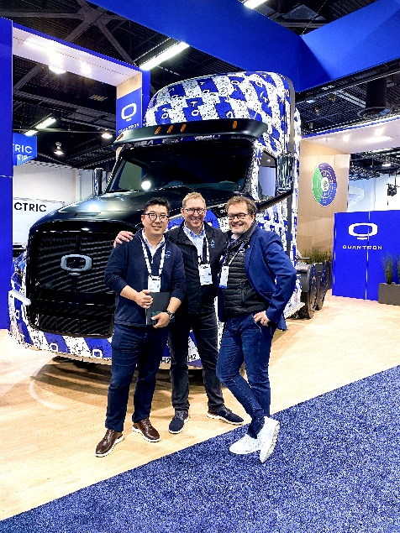 | From left: Isaac Kim (CFO FirstElement Fuel), Joel Ewanick (Chairman and CEO FirstElement Fuel), Michael Perschke (CEO Quantron AG)
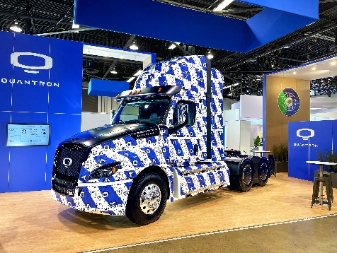 | Hydrogen-electric QUANTRON Class 8 US Truck at ACT Expo in Anaheim, California

You can find the original images in high and low resolution here: Press releases from Quantron AG (https://www.quantron.net/en/q-news/press-releases/)
About Quantron AG
Quantron AG is a platform provider and specialist for sustainable mobility for people and goods; in particular for trucks, buses and vans with fully electric powertrains and H₂ fuel cell technology. As a high-tech spinoff of the renowned Haller KG, the German company from Augsburg in Bavaria combines over 140 years of commercial vehicle experience with state-of-the-art e-mobility know-how and positions itself globally as a partner to existing OEMs.
With the Quantron-as-a-Service Ecosystem (QaaS), QUANTRON offers an overall concept that covers all facets of the mobility value chain: QUANTRON INSIDE includes a wide range of both new vehicles and conversions for existing and used vehicles from diesel to battery and hydrogen electric powertrains using the highly innovative QUANTRON INSIDE technology. QUANTRON CUSTOMER SOLUTIONS ensures digital and physical aftersales solutions with a Europe-wide network of 700 service partners, as well as a service offering for maintenance, repair and spare parts, telematics and in-cloud solutions for remote diagnostics and fleet management. Customers receive individual solutions: rental, financing and leasing offers such as training courses and workshops at the QUANTRON Academy. In the future, QUANTRON ENERGY & POWER STATION will realize the production of green hydrogen and electricity as a platform. To this end, Quantron AG has joined forces with strong global partners. This Clean Transportation Alliance also forms an important building block for the supply of vehicles with the necessary green charging and H₂ refueling infrastructure.
QUANTRON stands for the core values Reliable, Energetic, Brave. The team of experts at the innovation driver for e-mobility is making a significant contribution to sustainable, environmentally friendly passenger and freight transport. You can find more information at www.quantron.net
Visit the Quantron AG on its social media channels on LinkedIn and YouTube.
About FirstElement Fuel Inc.
FirstElement Fuel Inc. is a California-based company established in 2013 to provide safe, reliable, retail hydrogen to customers of fuel cell electric vehicles. The company is the developer, owner and operator of the True Zero brand of retail hydrogen stations, which currently represents the largest retail hydrogen station network in the world.

Your contact Quantron AG:
Jörg Zwilling, Director Global Communications & Business Development, j.zwilling@quantron.net
Stephanie Miller, Marketing & Communications, press@quantron.net

