PRESS RELEASE May 25th 2023
QUANTRON Supervisory Board confirms QUANTRON's successful road to success and internationalisation strategy
- The QUANTRON executive board confirms sales guidance of EUR 45-60 million to the supervisory board - also based on more than 70 million positive funding decisions from QUANTRON's customers with strong traction for the fuel cell products
- QUANTRON can use its position as "consolidator" in the conversion business and win additional orders
- Stifel as lead financial advisor supports the next round of capital increases for equity & debt raise
- Successful launch of the US truck at the ACT Expo in Anaheim, California with significant customer demand
In the meeting on May 24th 2023, the supervisory board of Quantron AG confirmed the current course of business activity and the internationalisation strategy of the clean tech company and noted the positive development with satisfaction.
Since the beginning of 2023, the specialist for sustainable passenger and goods transport has already exceeded the bid volume of the whole of last year and recorded over 70 in concrete orders with a total value of 26.8 million Euro. The demand for innovative and technologically advanced zero-emission solutions for the transport of goods and people is increasing significantly. QUANTRON can meet this demand with the widest range of climate-neutral vehicles on the market from 3.5t through to 44t.
Start of the next round of capital increases: collaboration with Stifel
QUANTRON was able to gain the support of Stifel for the current financing round, with a focus on attracting institutional investors from the USA. The aim of the financing round is to raise additional capital – both in the form of equity and debt. Stifel's financial experts will support QUANTRON in raising additional capital in its role as exclusive financial advisor and make its entire platform available to attract both European and US investors.
Focus on internationalisation
At the beginning of May, QUANTRON presented its concept for the US market for the first time at the largest trade fair for climate-friendly commercial vehicles in the USA - the Advanced Clean Transportation (ACT) trade fair in Anaheim, California. Centre of attention was the first prototype of QUANTRON's hydrogen-electric Class 8 truck. At the start of production, QUANTRON anticipates a range of around 750 to 850 miles for the heavy Class 8 truck with a tank capacity of 100 kg of hydrogen. As a result, QUANTRON can offer a real alternative to diesel-powered heavy-duty trucks in the USA. The truck will be developed and manufactured at QUANTRON's US facility near Detroit in Michigan. A team of specialists is already working there under the leadership of Rick Haas – an ex-Tesla manager. The truck was built in record time and, with its 100 kg capacity, is already the "Range Champion" of all Fuel Cell Class 8 trucks currently available in the USA.
Investment
The supervisory board has taken a very positive note of the current product development and status. The focus in the coming years will be on the development and market launch of the 3-4 fuel cell core products - with the target markets being Europe, USA and the Middle East. Furthermore, the development of the H2 ecosystem, Quantron-as-a-Service (QaaS), is now being accelerated in close partnership with currently more than ten network partners. A key investor will be announced within the next days.
After the successful launch of the US truck in California, QUANTRON continues to work on its internationalisation strategy and plans to be actively present in at least 15 countries by the end of 2023.
Klaus Schmitt, Quantron AG Supervisory Board Chairman: “The successful launch of the US truck at the ACT Expo trade show in California is an important milestone for the internationalisation of QUANTRON. With the support of Stifel, we are confident that QUANTRON will achieve its growth targets for this year and continue to expand its position as a leading provider of zero-emission mobility.”
Andreas Haller, founder and Executive Chairman of Quantron AG: “2023 has started really dynamically, three key events within four weeks in Augsburg, California and Munich have given us an offer volume in the triple-digit million euro range. The team has done a great job and the dynamic product experience has given our customers confidence in our technology leadership.”
Images (click on image preview to download):
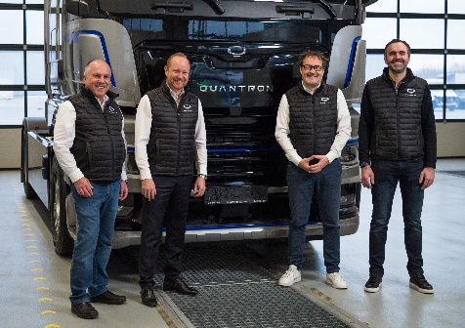 | QUANTRON Executive Board;  from left: Herbert Robel (CHRO), Andreas Haller (Founder and Executive Chairman), Michael Perschke (CEO) and René Wollmann (CTO)
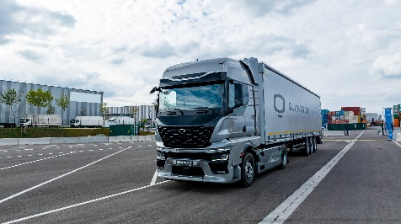 | The hydrogen-electric QUANTRON QHM FCEV AERO
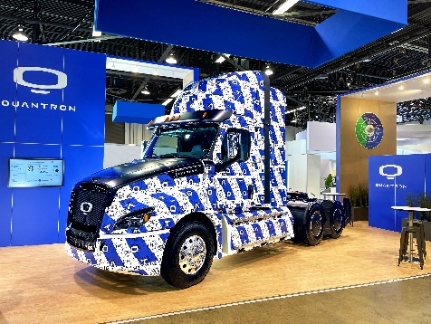 | The hydrogen-electric QUANTRON Class 8 truck at the ACT Expo in Anaheim, California

The original photos are available in both low and high resolutions here: Quantron AG press releases (https://www.quantron.net/en/q-news/press-releases/)
About Quantron AG
Quantron AG is a platform provider and specialist in sustainable mobility for people and goods; in particular, for trucks, buses and vans with all-electric drive trains and H₂fuel cell technology. As a high-tech spin-off of the renowned Haller KG, the Augsburg/Bavaria-based company combines more than 140 years of commercial vehicle experience with the very latest e-mobility know-how, and positions itself globally as a partner to existing OEMs.
With the Quantron-as-a-Service Ecosystem (QaaS), QUANTRON offers an overall concept that includes all facets of the mobility value-added chain: QUANTRON INSIDE includes a wide range of new vehicles as well as conversions for existing and used vehicles from diesel to battery and hydrogen-electric drives with the highly innovative QUANTRON INSIDE technology. With a Europe-wide network of 700 service partners,QUANTRON CUSTOMER SOLUTIONS guarantees digital and physical after-sales solutions along with a range of services for maintenance, repairs and spare parts, telematics and in-cloud solutions for remote diagnosis and fleet management. Customers receive individual advice on, among other things, tailored charging and tank solutions, rental, financing and leasing offers. Training courses and workshops are also offered in the QUANTRON Academy. In future, QUANTRON ENERGY & POWER STATIONS will realise the production of green hydrogen and electricity as a platform. To this end, Quantron AG has teamed up with a number of strong global partners. At the same time, this Clean Transportation Alliance is also an important building block for supplying vehicles with the required green charging and H2 tank infrastructure.
QUANTRON stands for the core values RELIABLE, ENERGETIC, BRAVE . The team of experts at the innovation driver for e-mobility is making a significant contribution to sustainable, environmentally friendly passenger and freight transport.
Visit Quantron AG on our social media channels onLinkedIn and YouTube. More informationen available at www.quantron.net

Contact persons:
Jörg Zwilling, Director Global Communication & Business Development, j.zwilling@quantron.net
Stephanie Miller, Marketing & Communications Quantron AG, press@quantron.net

