PRESS RELEASE May 31th, 2023
QUANTRON expands its international business with the establishment of Quantron Italy s.r.l.
- QUANTRON acquires the subsidiary EYES Group s.r.l. from the Italian FRIEM S.p.A. and establishes Quantron Italy s.r.l.
- With the new facility in Italy, QUANTRON aims to further establish itself on the European market
- The partnership between QUANTRON and FRIEM starts a large and organized project with a strong focus on energy transition
German Quantron AG, clean tech company and specialist in sustainable transportation solutions for people and goods, acquires EYES Group s.r.l from FRIEM S.p.A., top global player in the production of high-power converters with a leading positioning in the green hydrogen supply chain, and establishes Quantron Italy S.r.l.
FRIEM is transferring 100% of its subsidiary EYES Group s.r.l. to Quantron AG. The company, which specializes in the electrification of vehicles, will henceforth operate under the name Quantron Italy s.r.l. With the Italian subsidiary, QUANTRON follows its strategic internationalization plan and addresses the growing demand for zero-emission vehicles in Italy. Quantron Italy will entertain a facility in Milan where it will assemble emission free last mile vehicles in a first step.
This transaction is the first milestone of a strategic partnership between QUANTRON and FRIEM to develop further cooperations in the future. FRIEM is enhancing its investments in the electric mobility market with a technology leader in the field of transportation, committed to the energy transition, including green hydrogen applications.
Michael Perschke, CEO of Quantron AG, explains: "With the new location in Italy we want to strengthen our presence in Southern Europe and expand our zero-emission footprint in a fast-growing market. EYES has existing infrastructure as well as extensive expertise and knowledge of the local market, this is a perfect basis to grow successfully in the Italian market."
“We are very glad to support QUANTRON with its further development with the resources and skills of our team.”, affirms Lorenzo Carnelli, CEO of FRIEM. “This joint operation is consistent with our industrial plan and confirms FRIEM’s support and commitment to the energy transition.”
The new management team of Quantron Italy s.r.l.
Fabrizio Simoni, former CEO of EYES Group s.r.l., becomes Managing Director of Quantron Italy s.r.l. He has over 20 years of international experience in the automotive industry both in large companies and start-ups. His core competencies are in developing new structures and business models and managing complex tasks in a cross-functional and multicultural environment. Prior to EYES, he held leading positions at Qooder SA, Abarth & C and Fiat Chrysler Automobiles.
Fabrizio Simoni: “Quantron Italy’s mission is to establish QUANTRON as a key player for zero-emission mobility also in Italy, introducing our innovative products and advanced technology in one of the most relevant automotive market in Europe. Together with EYES Group, QUANTRON has already very successfully converted vehicles into fully electric minibuses and put them on Italian roads for our customer Ente Parco Arcipelago Toscano dell'Isola d'Elba. We look forward to further joint collaboration to decarbonize Southern European road transport.”
Massimiliano Bruno becomes Head of Sales for Quantron Italy s.r.l. He has over 20 years of experience as a senior manager in the commercial sector, including leadership roles in the development and management of commercial networks and in the management of global key accounts at Xerox. As a co-founder of innovative start-ups in the field of e-mobility, he has entrepreneurial experience in energy efficiency technology. Since 2016, he has focused on business development, strategic alliances and network development in the e-mobility market.
Images (Please click on the image preview to download):
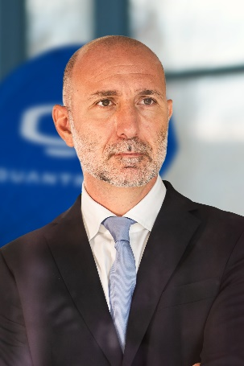 | Fabrizio Simoni, Managing Director Quantron Italy s.r.l.
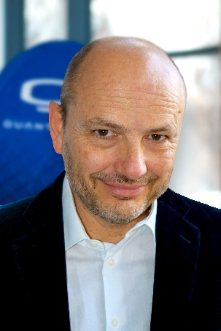 | Massimiliano Bruno, Head of Sales Quantron Italy s.r.l.
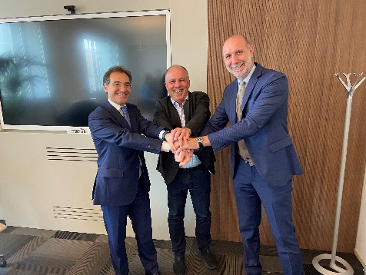 | From left: Lorenzo Carnelli, CEO FRIEM, Herbert Robel (CHRO & Co-Founder Quantron AG) and Fabrizio Simoni (Managing Director Quantron Italy s.r.l.)
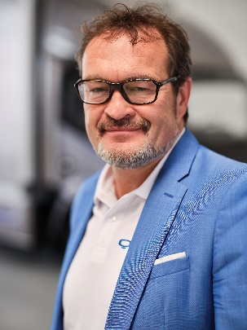 | Michael Perschke, CEO Quantron AG
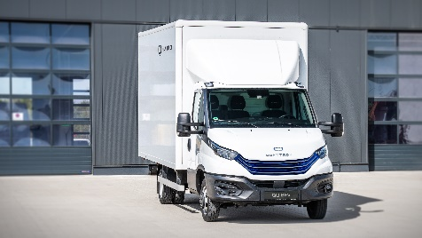 | The battery-electric QUANTRON Q-Light BEV

You can find the original images in low and high resolution here: Press releases from Quantron AG (https://www.quantron.net/en/q-news/press-releases/)
About Quantron AG
Quantron AG is a platform provider and specialist for sustainable mobility for people and goods; in particular for trucks, buses and vans with fully electric powertrains and H₂ fuel cell technology. As a high-tech spinoff of the renowned Haller KG, the German company from Augsburg in Bavaria combines over 140 years of commercial vehicle experience with state-of-the-art e-mobility know-how and positions itself globally as a partner to existing OEMs.
With the Quantron-as-a-Service Ecosystem (QaaS), QUANTRON offers an overall concept that covers all facets of the mobility value chain: QUANTRON INSIDE includes a wide range of both new vehicles and conversions for existing and used vehicles from diesel to battery and hydrogen electric powertrains using the highly innovative QUANTRON INSIDE technology. QUANTRON CUSTOMER SOLUTIONS ensures digital and physical aftersales solutions with a Europe-wide network of 700 service partners, as well as a service offering for maintenance, repair and spare parts, telematics and in-cloud solutions for remote diagnostics and fleet management. Customers receive individual solutions: rental, financing and leasing offers such as training courses and workshops at the QUANTRON Academy. In the future, QUANTRON ENERGY & POWER STATION will realize the production of green hydrogen and electricity as a platform. To this end, Quantron AG has joined forces with strong global partners. This Clean Transportation Alliance also forms an important building block for the supply of vehicles with the necessary green charging and H₂ refueling infrastructure.
QUANTRON stands for the core values Reliable, Energetic, Brave. The team of experts at the innovation driver for e-mobility is making a significant contribution to sustainable, environmentally friendly passenger and freight transport. You can find more information at www.quantron.net
Visit the Quantron AG on its social media channels on LinkedIn and YouTube.

ABOUT FRIEM S.p.A.
FRIEM is an Italian technology manufacturer founded in 1950, which specialises in the design and production of electrical converters for special applications. As one of the top global players in the high-power rectifier industry, FRIEM has reached a turnover of approximately 35 million euros (out of which over 90% of the amount stems from abroad), 1.5 GW of production capacity, while employing over 100 people worldwide. FRIEM, being a European leader in the green hydrogen production using electrolysis for large power plants, supports the energy transition by assuming a central position in the value chain. The group consists of the parent company FRIEM S.p.A., with its headquarters in Segrate (Milan); two subsidiaries based in the United States FRIEM America Ltd, FRIEM LATAM Eireli in Brazil; a commercial office in Indonesia; and DynAmp, an American producer of high-DC current measurement systems. The Italian TCE Consultore, it provides power electronics consultancy. In April 2022, Fondo Italiano d’Investimento has entered FRIEM’s capital through FITEC, with a minority share to accelerates growth and investments.
More information at www.friem.com
Contacts press office FRIEM; marketing@friem.com

Your contact:
Jörg Zwilling, Director Global Communication & Business Development, j.zwilling@quantron.net
Stephanie Miller, Marketing & Communications Quantron AG, press@quantron.net
Cristina Di Biase, Corporate Marketing & Communications Coordinator FRIEM, cristina.dibiase@friem.com
Press Office FRIEM, marketing@friem.com

