PRESS RELEASE May 9th 2023
QUANTRON places itself centre-stage with the largest portfolio of climate-friendly vehicles and presents the digital platform for Quantron-as-a-Service for the first time at the Transport Logistic trade fair in Munich
- Most extensive product portfolio on the market for zero-emission vehicles: At the Transport Logistic trade fair in Munich, QUANTRON is presenting the QUANTRON QARGO 4 EV and the QUANTRON QHM-BEV 28-350 truck for swap body use
- QUANTRON is also demonstrating the digital platform for the first time which allows the creation of the unique 360 degree Quantron-as-a-Service (QaaS) package

The clean tech company and specialist for sustainable passenger and goods transport, Quantron AG, will be presenting at this year's Transport Logistic in Munich from 9th to 12th May with the most comprehensive product portfolio of zero-emission vehicles available on the market. In addition, QUANTRON is showcasing the initial expansion stage of its digital platform for the first time which has allowed the realisation of the innovative Quantron-as-a-Service (QaaS) package. Apart from the emission-free vehicles and integrated technology (QUANTRON INSIDE), the 360-degree service also includes digital and physical solutions such as insurance, fleet management, after-sales and roadside assistance (QUANTRON CUSTOMER SOLUTIONS) as well as the corresponding energy infrastructure (QUANTRON ENERGY & POWER STATIONS).
Vehicle presentation at the exhibition stand – QUANTRON QARGO 4 EV and QUANTRON QHM-BEV 28-350
With its product portfolio of BEV and FCEV vehicles ranging from 3.5 to 44 tonnes, QUANTRON has the most comprehensive range of emission-free vehicles on the market. Visitors to Transport Logistic can inspect two of them – from the light and heavy segments – at first hand directly on the QUANTRON stand (Hall A6, Stand 103/204).
As a battery-electric truck in the class up to 4.2t, the QUANTRON QARGO 4 EV is designed for last mile deliveries with emission-free and quiet operability. This makes it the ideal vehicle for evening and night time delivery as well as urban zero-emission zones. It can be flexibly adapted to suit individual requirements through the use of various bodies und configurations. The QUANTRON QARGO 4 EV was selected by a customer in the Kingdom of Saudi Arabia to be the first electric truck to facilitate clean transport on the country´s roads.
The heavy-duty model, QUANTRON QHM-BEV 28-350 is a 6x2 truck for swap body use. It has a battery with 350kWh, which allows a range of 250 km and can be fast charged with up to 350kW (CCS standard). The vehicle features two different loading heights for the swap bodies for maximum versatility. For the most flexible customer operations, the truck is also equipped with a low coupling for trailer operation. The heavy 6x2 truck has a sleeper cabin and is thus suitable for long-distance transport.
Creating a digital platform for Quantron-as-a-Service
For the first time at the Transport Logistic, QUANTRON is presenting the digital platform for its QaaS and will be demonstrating the user interface that every QaaS customer can use.
Together with the IT service company, Goldstone Technologies Limited (GTL), QUANTRON has developed the innovative technology that has facilitated the realisation of the digital platform for QUANTRON's 360° ecosystem, Quantron-as-a-Service (QaaS). For this, a contract was concluded regarding the establishment of a joint venture with branches in Augsburg and Hyderabad/India. The manufacturer-independent platform is intended to support various digital services of QaaS, including transactions such as vehicle deployment, route planning, charging or refuelling, billing with gas stations and energy consumption. Customers can also use the user front end in order to measure the performance of the zero-emission vehicle such as hydrogen consumption, kilometres driven or CO₂ savings. In a first step this platform will serve Quantron AG and ETO Motors vehicles – in a next step starting in Q4/2023 it will be offered as an open market solution and will be OEM agnostic.
Andreas Haller, founder and CEO of Quantron AG, will be taking part in a panel discussion during Transport Logistic on 10th May on the subject of "Decarbonisation in long-distance road transport: hydrogen truck as saviour?”. He explains: “We must act now in order to secure a future worth living. Innovative technologies such as hydrogen as a fuel for zero-emission vehicles play an important role here. At QUANTRON, we are committed to making such sustainable alternatives more accessible to customers with our unique Quantron-as-a-Service package."
Images (click on image preview to download):
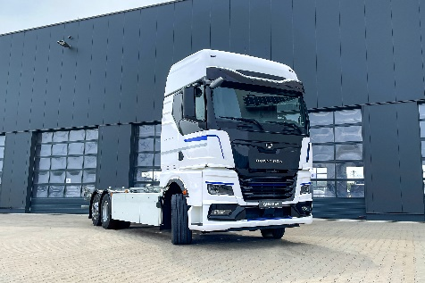 | Heavy-Duty Truck QUANTRON QHM-BEV 28-350
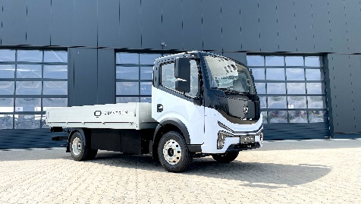 | Light-Transporter QUANTRON QARGO 4 EV
 | Andreas Haller, Founder and Executive Chairman Quantron AG

The original photos are available in both low and high resolutions here: Quantron AG press releases (https://www.quantron.net/en/q-news/press-releases/)

About Quantron AG
Quantron AG is a platform provider and specialist in sustainable mobility for people and goods; in particular, for trucks, buses and vans with all-electric drive trains and H₂fuel cell technology. As a high-tech spin-off of the renowned Haller KG, the Augsburg/Bavaria-based company combines more than 140 years of commercial vehicle experience with the very latest e-mobility know-how, and positions itself globally as a partner to existing OEMs.
With the Quantron-as-a-Service Ecosystem (QaaS), QUANTRON offers an overall concept that includes all facets of the mobility value-added chain: QUANTRON INSIDE includes a wide range of new vehicles as well as conversions for existing and used vehicles from diesel to battery and hydrogen-electric drives with the highly innovative QUANTRON INSIDE technology. With a Europe-wide network of 700 service partners,QUANTRON CUSTOMER SOLUTIONS guarantees digital and physical after-sales solutions along with a range of services for maintenance, repairs and spare parts, telematics and in-cloud solutions for remote diagnosis and fleet management. Customers receive individual advice on, among other things, tailored charging and tank solutions, rental, financing and leasing offers. Training courses and workshops are also offered in the QUANTRON Academy. In future, QUANTRON ENERGY & POWER STATIONS will realise the production of green hydrogen and electricity as a platform. To this end, Quantron AG has teamed up with a number of strong global partners. At the same time, this Clean Transportation Alliance is also an important building block for supplying vehicles with the required green charging and H2 tank infrastructure.
QUANTRON stands for the core values RELIABLE, ENERGETIC, BRAVE . The team of experts at the innovation driver for e-mobility is making a significant contribution to sustainable, environmentally friendly passenger and freight transport.
Visit Quantron AG on our social media channels onLinkedIn and YouTube. More informationen available at www.quantron.net

Contact persons:
Jörg Zwilling, Director Global Communication & Business Development, j.zwilling@quantron.net
Stephanie Miller, Marketing & Communications Quantron AG, press@quantron.net

