PRESS RELEASE 26 June 2023
QUANTRON Goes Global, Offers Revolutionary Zero-Emission Solutions, Opportunities for North American Investors
The technology and range leader evolves from a pure “Hardware Play” to “Platform Play” with fleet management using AI and an increased focus on North American presence

- QUANTRON, a leader in zero-emission transport solutions and a Ballard Power investment, is scaling up global operations
- After a very successful A-round, QUANTRON has now kicked-off its B-round funding and is targeting US and Canadian investors who seek a carbon reduction impact in their investment strategy with an integrated business model
- QUANTRON and Goldstone Technologies Limited (GTL) recently formed a joint venture that will expand to Canada and the US. The joint venture, named ROQIT, builds a unique transaction platform with various digital solutions for meeting the needs of zero-emission fleets
- Their new AI-driven mobility solution develops a transaction platform that will serve as the digital backbone of Quantron-as-a-Service (QaaS) in the future
- The targeted market for fleet management up to 2032 is estimated to be around 70 billion US dollars

Quantron AG, Europe’s technology and range leader for H2 trucks and ecosystem operation, is scaling up global operations and unlocking a clean mobility future with an ecosystem fueled by hydrogen. Building on exciting momentum over the last few months, QUANTRON has recently announced commitments with FirstElement Fuel and Goldstone Technologies Limited (GTL). The zero-emission solution leader also debuted its Class 8 hydrogen fuel-cell truck in the US at the Advanced Clean Transportation (ACT) Expo in Anaheim, California in April 2023.
QUANTRON came to the US in October 2022 with a strong focus on hydrogen solutions for long-haul transport. The US represents a significant portion of QUANTRON’s long-term business plan. The truck will be a leader in range with 80kg of tank capacity at launch with plans to grow to 120kg. This builds on QUANTRON’s plan to become a global H2 leader and offer an OEM agnostic ecosystem, with FCEV trucks ready for delivery, in Europe and North America, in early 2024. Since the ACT Expo, QUANTRON has had numerous discussions with prospective fleet customers and QaaS partners both in the US and Canada.
“QUANTRON has been building a strong ecosystem for Quantron-as-a-Service with our US Class 8 hydrogen fuel-cell truck and FirstElement Fuel hydrogen supply and distribution alliance,” said Michael Perschke, Global CEO of Quantron AG at the Occasion of COLLISION Conference in Toronto. “Together, QUANTRON is meeting the great demand for zero-emission solutions and specifically hydrogen fuel-cell electric semi-trucks in North America. QUANTRON’s FCEV approach provides more range, scalability, and support infrastructure. This need will just continue to grow with recent announcements of clean air standards for heavy-duty vehicles and clean zero-emission technologies. We are excited to be meeting these needs.”
To further accelerate its growth, QUANTRON has officially kicked off its B-round funding with lead advisor STIFEL, seeking 200 – 250 million euro equity investment and 100 million euro in growth funding, recording strong registrations of interest from strategic and energy investors.
QUANTRON’s recent announcement with GTL is focusing on further investment in North American presence, building an AI powered fleet and zero-emission platform. ROQIT is an important third leg of the stool for QUANTRON’s North American QaaS capability, and the ecosystem continues to build.
“Since the ACT Expo we have received strong interest from both the US and Canada,” said Rick Haas, CEO of QUANTRON US. “We are also seeing a trend of interest in FCEV Trucks powered by green H2. Canada is a strong market for H2 and Fuel Cell powered trucks - especially due to long distances, challenging climate conditions and also a growing supply of H2 produced e g with Hydro power. We’re eager to grow into this market.”
QUANTRON has formed a variety of alliances and joint ventures along the H2 value chain, including an H2 fueling joint venture to cover Europe.
The aim of ROQIT is to develop a digital transaction platform that will serve as the backbone of QaaS in the future. In addition, AI-driven software solutions will be developed that can be used independently of the manufacturer, such as large fleet customers.
The integrated platform consists of five digital pillars: fleet management, insurance-as-a-service, hydrogen economy, greenhouse gas accounting (GHG quotas) and data insights. The software offers a fleet overview dashboard, driver management, journey information, geo-fencing, charging or refueling infrastructure management, smart navigator, carbon credit tracking, roadside assistance, reporting module and a mobile driver app. No other active digital solution offers a greater range of services and transparency.
In addition to exciting business growth, QUANTRON is expanding its financial team with a new chief financial officer, Beate Reiman. He is a very experienced and successful financial expert who, as a first focus, will provide the company with targeted support for the next round of financing.

Images (Please click on the image preview to download):
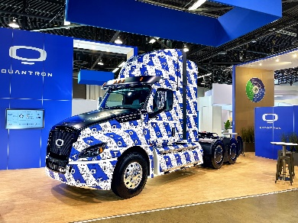 | The hydrogen-electric QUANTRON Class 8 US Truck
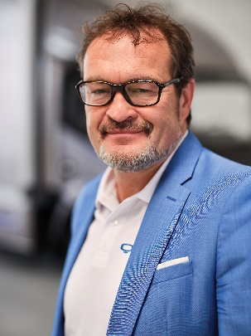 | Michael Perschke, CEO Quantron AG
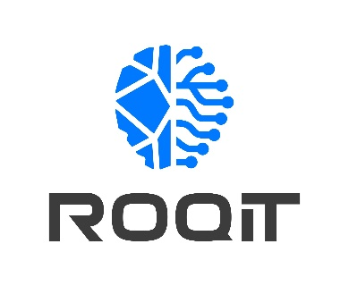 | ROQIT Logo

You can find the original images in both high and low resolutions here: Press releases from Quantron AG (https://www.quantron.net/en/q-news/press-releases/)
Quantron AG
Quantron AG is a platform provider and specialist in sustainable mobility for people and goods; in particular, for trucks, buses and vans with all-electric drive trains and H₂fuel cell technology. As a high-tech spin-off of the renowned Haller GmbH, the Augsburg/Bavaria-based company combines more than 140 years of commercial vehicle experience with the very latest e-mobility know-how, and positions itself globally as a partner to existing OEMs.
With the Quantron-as-a-Service Ecosystem (QaaS), QUANTRON offers an overall concept that includes all facets of the mobility value-added chain: QUANTRON INSIDE includes a wide range of new vehicles as well as conversions for existing and used vehicles from diesel to battery and hydrogen-electric drives with the highly innovative QUANTRON INSIDE technology. With a Europe-wide network of 700 service partners,QUANTRON CUSTOMER SOLUTIONS guarantees digital and physical after-sales solutions along with a range of services for maintenance, repairs and spare parts, telematics and in-cloud solutions for remote diagnosis and fleet management. Customers receive individual advice on, among other things, tailored charging and tank solutions, rental, financing and leasing offers. Training courses and workshops are also offered in the QUANTRON Academy. In future, QUANTRON ENERGY & POWER STATIONS will realise the production of green hydrogen and electricity as a platform. To this end, Quantron AG has teamed up with a number of strong global partners. At the same time, this Clean Transportation Alliance is also an important building block for supplying vehicles with the required green charging and H2 tank infrastructure.
QUANTRON stands for the core values RELIABLE, ENERGETIC, BRAVE. The team of experts at the innovation driver for e-mobility is making a significant contribution to sustainable, environmentally friendly passenger and freight transport.
Visit Quantron AG on our social media channels onLinkedIn and YouTube. More informationen available at www.quantron.net
Goldstone Technologies Limited
Goldstone Technologies Limited (GTL) is a specialist Full-Stack Business Intelligence, Data Analytics and IT Services Consulting firm. While we are very good at integrating and consolidating data to produce insights and building/managing/optimising Cloud Infrastructure, applications and platforms, we pride ourselves on how we help our customers use data and technology to make a difference.
In addition to the focused Client Solutions we offer, the market specific Industry Solutions and the Software Platforms we recommend, we also offer a host of Strategic Services to drive improved planning, reduced costs and greater adoption and utilisation, enabling clients to greatly reduce their time to value.
Our focus is on the value our clients get from our solutions, not just the solutions themselves.

Your contact Quantron US, Inc.:
Richard Ansell, Vice President Marketing/PR Quantron US, Inc., r.ansell@quantron.net

Your contact Quantron AG:
Jörg Zwilling, Director Global Communications & Business Development, j.zwilling@quantron.net
Stephanie Miller, Marketing & Communications, press@quantron.net

