PRESS RELEASE June 15th 2023
Fleet management with artificial intelligence: QUANTRON and Goldstone Technologies present joint venture named ROQIT at the Greentech Festival
- QUANTRON and Goldstone Technologies Limited (GTL) form a joint venture to build a unique transaction platform with various digital solutions for meeting the needs of zero-emission fleets
- Their new AI-driven mobility solution to be presented at the Greentech Festival from 15th to 16th June in Berlin
- The targeted market for fleet management up to 2032 is estimated to be around 70 billion US dollars

The clean tech company Quantron AG, a specialist in sustainable passenger and goods transport, is presenting a new line of business at the Greentech Festival from 15th to 16th June in Berlin.
Together with Goldstone Technologies (GTL), a leading Indian company for business intelligence, data and analytics, Quantron AG from Augsburg is entering into a joint venture known under the name ROQIT. The aim of the joint venture is to develop a digital transaction platform that will serve as the digital backbone of Quantron-as-a-Service (QaaS) in the future. In addition, AI-driven software solutions will be developed for the rapidly ramping up zero-emission fleet management market, that can be used independently of the manufacturer.
Minister of State Dr. Florian Herrmann, Head of the Bavarian State Chancellery, sees great opportunities with AI in the mobility sector: "Mobility of the future will only become a reality through the broad application of AI. It is only through AI-based efficiency and optimization solutions that we will be able to implement zero-emissions solutions globally. With the High-Tech Agenda, the Free State of Bavaria is investing a total of 5.5 billion Euros in future fields such as AI, quantum technology or CleanTech. In this way, we are creating a unique ecosystem; the best conditions for the forward-looking joint venture between QUANTRON and Goldstone Technologies and for the broad roll-out of AI in the mobility sector."
The joint venture will operate from Augsburg and Hyderabad, India. A US facility is to follow by the third quarter of 2023 in order to address the global market for zero-emission solutions.
Jayesh Ranjan, Principal Secretary of the Industries & Commerce (I&C) and Information Technology (IT) Departments of the Telangana government, stated: "This joint venture between Goldstone Technologies and Quantron AG is a testament to the global potential of Hyderabad's IT industry and the state's commitment to sustainable growth. We are confident that this collaboration will lead to the development of innovative zero-emission solutions that will address the growing demand for clean and efficient transportation in India and around the world. The collaboration between GTL and Quantron AG is an excellent example of how international cooperation can lead to innovative solutions that address global challenges."
The integrated platform will consist of five digital pillars, namely fleet management, insurance-as-a-service, hydrogen economy, greenhouse gas accounting (GHG quotas) and data insights. The software offers a fleet overview dashboard, driver management, journey information, geo-fencing, charging or refuelling infrastructure management, smart navigator, carbon credit tracking, roadside assistance, reporting module and a mobile driver app. No other active digital solution offers a greater range of services and transparency.
“The factors that distinguish this Digital Platform are that it is Partner Agnostic, Modular and OEM Independent. Data Insights, which is a crucial pillar, is estimated to reach a global market value of $71 Bn (INR 5.9 Lakh Crores) by 2032. Our contribution to this partnership will be to help customers drive impactful change through data-backed analytics to enhance their business through BI and Analytics Full Stack capabilities and Service Offerings”, according to Pavan Chavali, Managing Director of GTL.
The joint venture of GTL and QUANTRON can already offer AI-supported solutions for fleet management for ensuring vehicle fleets can be operated more sustainably and efficiently.
The demand for software-based efficiency and optimisation solutions is particularly noticeable in Europe, USA, India and Middle East. The first customers of the joint venture are QUANTRON AG and ETO Motors from Hyderabad, India.
Michael Perschke, CEO of Quantron AG: “We are looking forward to this partnership with GTL in a bid to address the Fleet Management market which is projected to exceed $70 Billion by 2032, combined with the Hydrogen Economy market that anticipates over $320 Billion in global investments by 2030. The Indian ecosystem also presents a huge opportunity in this area, which would provide us the necessary expertise to make inroads into the global marketplace.”
Images (click on image preview to download):
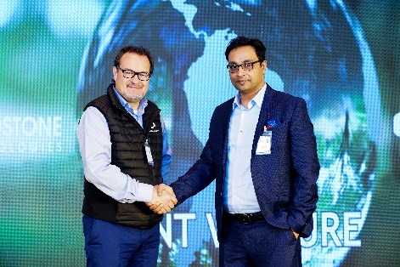 | Indo-German cooperation between QUANTRON and GTL  From left: Michael Perschke, CEO Quantron AG, and Pavan Chavali, Managing Director GTL
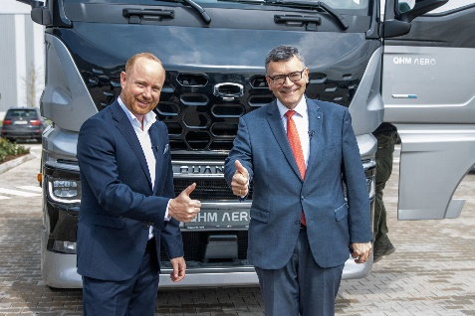 | From left: Andreas Haller, Founder and Executive Chairman of Quantron AG, and Dr. Florian Herrmann, Head of the Bavarian State Chancellery and State Minister for Federal Affairs and Media
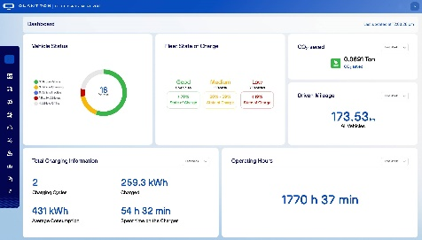 | ROQIT Fleet Management Dashboard
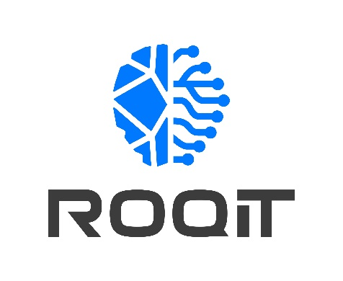  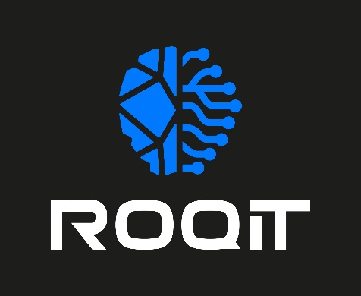 | ROQIT logo

The original photos are available in both high and low resolutions here: Press releases from Quantron AG (https://www.quantron.net/en/q-news/press-releases/)
Quantron AG
Quantron AG is a platform provider and specialist in sustainable mobility for people and goods; in particular, for trucks, buses and vans with all-electric drive trains and H₂fuel cell technology. As a high-tech spin-off of the renowned Haller GmbH, the Augsburg/Bavaria-based company combines more than 140 years of commercial vehicle experience with the very latest e-mobility know-how, and positions itself globally as a partner to existing OEMs.
With the Quantron-as-a-Service Ecosystem (QaaS), QUANTRON offers an overall concept that includes all facets of the mobility value-added chain: QUANTRON INSIDE includes a wide range of new vehicles as well as conversions for existing and used vehicles from diesel to battery and hydrogen-electric drives with the highly innovative QUANTRON INSIDE technology. With a Europe-wide network of 700 service partners,QUANTRON CUSTOMER SOLUTIONS guarantees digital and physical after-sales solutions along with a range of services for maintenance, repairs and spare parts, telematics and in-cloud solutions for remote diagnosis and fleet management. Customers receive individual advice on, among other things, tailored charging and tank solutions, rental, financing and leasing offers. Training courses and workshops are also offered in the QUANTRON Academy. In future, QUANTRON ENERGY & POWER STATIONS will realise the production of green hydrogen and electricity as a platform. To this end, Quantron AG has teamed up with a number of strong global partners. At the same time, this Clean Transportation Alliance is also an important building block for supplying vehicles with the required green charging and H2 tank infrastructure.
QUANTRON stands for the core values RELIABLE, ENERGETIC, BRAVE . The team of experts at the innovation driver for e-mobility is making a significant contribution to sustainable, environmentally friendly passenger and freight transport.
Visit Quantron AG on our social media channels onLinkedIn and YouTube. More informationen available at www.quantron.net

Goldstone Technologies Limited
Goldstone Technologies Limited (GTL) is a specialist Full-Stack Business Intelligence, Data Analytics and IT Services Consulting firm. While we are very good at integrating and consolidating data to produce insights and building/managing/optimising Cloud Infrastructure, applications and platforms, we pride ourselves on how we help our customers use data and technology to make a difference.
In addition to the focused Client Solutions we offer, the market specific Industry Solutions and the Software Platforms we recommend, we also offer a host of Strategic Services to drive improved planning, reduced costs and greater adoption and utilisation, enabling clients to greatly reduce their time to value.
Our focus is on the value our clients get from our solutions, not just the solutions themselves.

Contact persons:
Jörg Zwilling, Director Global Communication & Business Development, j.zwilling@quantron.net
Stephanie Miller, Marketing & Communications Quantron AG, press@quantron.net

