PRESS RELEASE June 29th, 2023
QUANTRON secures the largest bus order in the company's history in Turin
- Six QUANTRON CIZARIS 12 EV in service from October 2023 in Turin
- Customer is Miccolis, a public limited company based in Bari
- The climate-friendly buses enable a battery-electric operational range of up to 370km per vehicle and a combined reduction of 409,2 tons of CO2 per year.
Quantron AG, a clean tech company and specialist in sustainable passenger and freight transport, made a successful bid in a recent e-bus tender in Italy. From October 2023, six QUANTRON CIAZRIS 12 EV will be operational in Turin tasked to support the city's public transport system. The new electric buses will be put into service on a newly opened bus route that will start operating in October this year. Their use will save around 409.2 tons of CO2 per year.
The customer is Miccolis, a public limited company based in Bari, which is active in local public transport network, school transport as well as the commercial sector. The company currently operates around 500 buses in different areas of Italy. For Miccolis, QUANTRON's emission-free vehicles are an important step on the way to achieving a more sustainable and climate-neutral fleet.
The QUANTRON CIAZRIS 12 EV electric buses are equipped with powerful 363 kWh batteries that facilitate a reliable range of up to 370 km. The 12 metre-long bus offers sufficient space for up to 89 passengers.
"We are extremely proud to have won the e-bus tender in Italy," said Alexander Stucke, Head of Sales Bus at Quantron AG. "With the QUANTRON CIAZRIS 12 EV electric buses, Miccolis will make a positive contribution regarding emission reduction in Turin."
Fabrizio Simoni, Managing Director of Quantron Italy, added: "It is an honour to have Europe's first CIZARIS vehicles operational in Turin, a city that is a symbol of transport and mobility".
In addition, four fully electric minibuses were recently delivered to the municipalities on the island of Elba in order to decarbonise local transport operations. Quantron Italy, market leader in electric-powered minibuses and school buses, has converted these vehicles using the Quantron EV150 kit.
"We are very proud to make this beautiful island even more pristine," said Fabrizio Simoni.

Images (click on image preview to download):
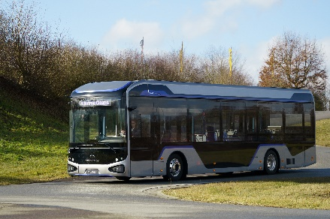 | QUANTRON CIZARIS 12 EV
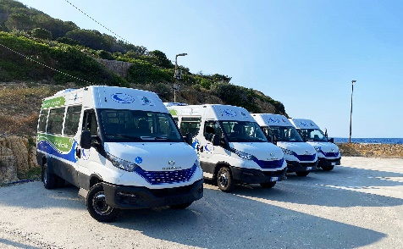 | The minibuses converted by Quantron Italy for use by the municipalities on the Island of Elba
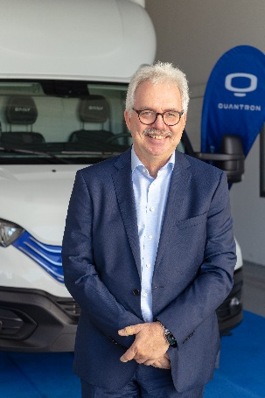 | Alexander Stucke, Head of Sales Bus Quantron AG
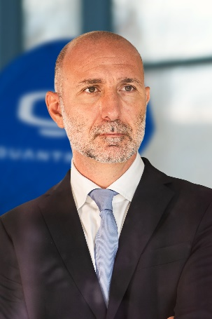 | Fabrizio Simoni, Managing Director Quantron Italy

The original photos are available in both low and high resolutions here: Quantron AG press releases (https://www.quantron.net/q-news/pr-berichte/)

Quantron AG
Quantron AG is a platform provider and specialist in sustainable mobility for people and goods; in particular, for trucks, buses and vans with all-electric drive trains and H₂fuel cell technology. As a high-tech spin-off of the renowned Haller GmbH, the Augsburg/Bavaria-based company combines more than 140 years of commercial vehicle experience with the very latest e-mobility know-how, and positions itself globally as a partner to existing OEMs.
With the Quantron-as-a-Service Ecosystem (QaaS), QUANTRON offers an overall concept that includes all facets of the mobility value-added chain: QUANTRON INSIDE includes a wide range of new vehicles as well as conversions for existing and used vehicles from diesel to battery and hydrogen-electric drives with the highly innovative QUANTRON INSIDE technology. With a Europe-wide network of 700 service partners,QUANTRON CUSTOMER SOLUTIONS guarantees digital and physical after-sales solutions along with a range of services for maintenance, repairs and spare parts, telematics and in-cloud solutions for remote diagnosis and fleet management. Customers receive individual advice on, among other things, tailored charging and tank solutions, rental, financing and leasing offers. Training courses and workshops are also offered in the QUANTRON Academy. In future, QUANTRON ENERGY & POWER STATIONS will realise the production of green hydrogen and electricity as a platform. To this end, Quantron AG has teamed up with a number of strong global partners. At the same time, this Clean Transportation Alliance is also an important building block for supplying vehicles with the required green charging and H2 tank infrastructure.
QUANTRON stands for the core values RELIABLE, ENERGETIC, BRAVE . The team of experts at the innovation driver for e-mobility is making a significant contribution to sustainable, environmentally friendly passenger and freight transport.
Visit Quantron AG on our social media channels onLinkedIn and YouTube. More informationen available at www.quantron.net

Contact persons:
Jörg Zwilling, Director Global Communication & Business Development, j.zwilling@quantron.net
Stephanie Miller, Marketing & Communications Quantron AG, press@quantron.net

