PRESS RELEASE
6th June 2023
Excellence between science and technology – QUANTRON visits Hochschule Pforzheim “Engineering and Management – Future Mobility” master students

- Quantron AG and the Hochschule Pforzheim demonstrate excellence in the interlocking of business, technology and academic work
- Both battery-electric commercial vehicles and hydrogen-powered fuel cell vehicles as trucks for long-distance and heavy-duty operations will play a crucial role in the decarbonisation of the transport sector
- Hochschule Pforzheim trains up-and-coming talent to act as future CEOs and CFOs as well as problem solvers for supporting customers in the transport sector in the transition to zero-emission solutions. QUANTRON serves as an inspiring role model.
Clean-tech company and specialist for sustainable passenger and goods transport Quantron AG demonstrated during its visit to the Hochschule Pforzheim what the sustainable goods and passenger transport of the future will look like and presented its vision of a physical and digital 360° platform as a kilometre-based "as-a-Service” model for customers.
Within the framework of the "Future Mobility" module organised by Professor Dr. Guy Fournier, Martin Lischka (CMO - Director Marketing, Brand & Strategy, Quantron AG) gave a guest lecture at the Pforzheim University to students of "Engineering and Management" master´s programme. For one complete day, practical insights were given into the sustainable future of the transport sector. The core of the lectures by Professor Guy Fournier and Martin Lischka was working out the most important physical and digital cornerstones of a platform business model for logistics using the real example of QUANTRON as a company in the transport & technology industry.
Both battery-electric commercial vehicles and hydrogen-powered fuel cell vehicles as trucks for long-distance and heavy-duty operations will play a crucial role in the decarbonisation of the transport sector. In order to accelerate the path to achieving zero emissions, QUANTRON is building a 360° ecosystem together with strong partners. This ecosystem combines vehicles with QUANTRON INSIDE technology, green energy in the form of electricity or hydrogen (QUANTRON ENERGY & POWER STATION) and solutions in the areas of insurance, maintenance & repair, after sales as well as digital telematics solutions for ensuring efficient fleet management (QUANTRON CUSTOMER SOLUTION).
Using the Quantron-as-a-Service (QaaS) platform, customers can obtain all services from a single source and utilise them on a pay-per-km basis. The comprehensive offer makes the switch for customers easier and accelerates the transformation of the transport sector towards achieving zero emissions.
Master's student Lucas Schubert is a fine example of demonstrating just how well the cooperation between the university and business works. In 2023, he completed his master's degree in Engineering and Management and wrote his thesis in cooperation with Quantron AG. The focus of his work was on building an ecosystem for hydrogen trucks and the strategic development of a platform business model whereby customers can book all services in the mobility value chain via a digital platform and use trucking-as-a-service in the form of a subscription model. However, the successful conclusion of his thesis is not the end of the cooperation. After completing his master's degree, Lucas Schubert started as an "Assistant to the Board" executive at Quantron AG and supports the management board in his role as an assistant. Further proof of the excellence and interlocking between the academic basis and the commercial side of a company.
Professor Guy Fournier, Senior Professor for the master's course module “Future Mobility”, emphasized the importance of working with clean-tech companies such as QUANTRON: “The possibility of closely interlinking technology, business administration along with the academic and practical content of our master's degree in Future Mobility in cooperation with QUANTRON is an ideal combination. We are proud to bring back alumni and thus perhaps the CEOs and CFOs of tomorrow to their alma mater as guest speakers and to offer students sustainable teaching with great practical relevance.”
Martin Lischka added: “As a TOP university in Germany, Hochschule Pforzheim shares our vision of sustainable and environmentally-friendly mobility and, in particular, the decarbonisation of transport for people and goods. The academic excellence which students have as opportunity to acquire in Pforzheim university ensures that future managers are focused on a greener future. The master's students are now fully aware that both fuel cell trucks and fully electric commercial vehicles can make an essential contribution to reducing CO₂ emissions and shape the future of transport in a sustainable way. The future belongs to platform business models such as 360° QaaS which can be seen in examples from other industries such as Amazon, Netflix and AirBnB, leaders in their respective platform segments.”
The first hydrogen-electric vehicles from QUANTRON are scheduled for delivery in 2023. A broad portfolio of electric vans, trucks and buses are already on the roads internationally and QUANTRON is expanding into other countries and regions such as the USA, India and the Middle East.
Images (click on image preview to download):
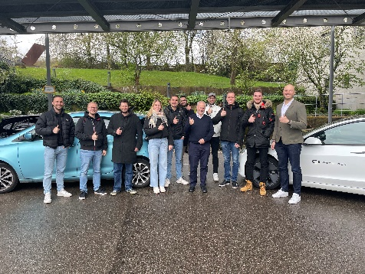 | BEV test drives with the students as the practical part of the visit
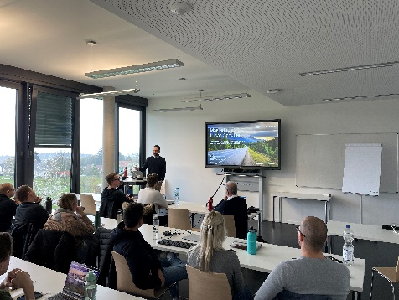 | Ecosystem presentation for hydrogen trucks
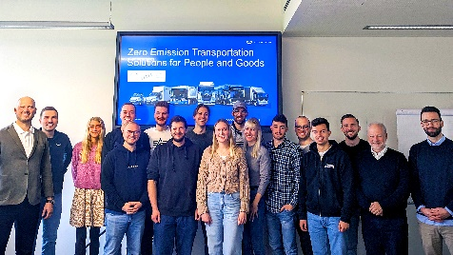 | QUANTRON visits "Engineering and Management” masters students at HS Pforzheim
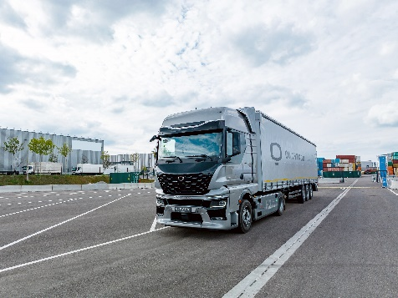 | QUANTRON QHM FCEV AERO truck with a range of up to 1500 km (116 kg hydrogen tank)
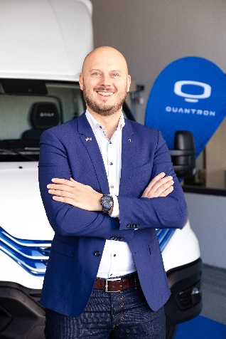 | Martin Lischka, CMO – Director Marketing, Brand & Strategy, Quantron AG
The original photos are available in both low and high resolutions here: Quantron AG press releases (https://www.quantron.net/q-news/pr-berichte/)
About Quantron AG
Quantron AG is a platform provider and specialist in sustainable mobility for people and goods; in particular, for trucks, buses and vans with all-electric drive trains and H₂fuel cell technology. As a high-tech spin-off of the renowned Haller GmbH, the Augsburg/Bavaria-based company combines more than 140 years of commercial vehicle experience with the very latest e-mobility know-how, and positions itself globally as a partner to existing OEMs.
With the Quantron-as-a-Service Ecosystem (QaaS), QUANTRON offers an overall concept that includes all facets of the mobility value-added chain: QUANTRON INSIDE includes a wide range of new vehicles as well as conversions for existing and used vehicles from diesel to battery and hydrogen-electric drives with the highly innovative QUANTRON INSIDE technology. With a Europe-wide network of 700 service partners,QUANTRON CUSTOMER SOLUTIONS guarantees digital and physical after-sales solutions along with a range of services for maintenance, repairs and spare parts, telematics and in-cloud solutions for remote diagnosis and fleet management. Customers receive individual advice on, among other things, tailored charging and tank solutions, rental, financing and leasing offers. Training courses and workshops are also offered in the QUANTRON Academy. In future, QUANTRON ENERGY & POWER STATIONS will realise the production of green hydrogen and electricity as a platform. To this end, Quantron AG has teamed up with a number of strong global partners. At the same time, this Clean Transportation Alliance is also an important building block for supplying vehicles with the required green charging and H2 tank infrastructure.
QUANTRON stands for the core values RELIABLE, ENERGETIC, BRAVE . The team of experts at the innovation driver for e-mobility is making a significant contribution to sustainable, environmentally friendly passenger and freight transport.
Visit Quantron AG on our social media channels onLinkedIn and YouTube. More informationen available at www.quantron.net

Contact persons:
Jörg Zwilling, Director Global Communication & Business Development, j.zwilling@quantron.net
Stephanie Miller, Marketing & Communications Quantron AG, press@quantron.net

About Pforzheim University:
Pforzheim University is one of the largest universities of applied sciences in Baden-Württemberg, Germany, with around 6,000 students and 500 people in academic lecture, research and administration. In its three faculties - Design, Business and Law, and Technology - Pforzheim University combines creativity with business education and technical precision. Interdisciplinarity, internationality, technology and know-how transfer are essential elements of our success. Our employees and students are offered not only specialized training, but also holistic personnel development.
The Master of Science (M. Sc.) Engineering and Management program trains industrial engineers. Graduates are bridge builders who are able to interlink different areas of knowledge and tasks, as well as to think and act in an interdisciplinary manner.
Visit us: https://engineeringpf.hs-pforzheim.de/en/master_programs/engineering_and_management/engineering_and_management?mtm_kwd=Engineering%20PF%20-%20Engineering%20and%20Management&cHash=eb3f7a811883f8cd7f596f1fc0425e06
Contact persons:
Prof. Dr. Guy Fournier, Prof. for Sustainable Mobility, Scientific Advisor, Work package leader "All impact evaluation and transformation towards an Automated Vehicle in Intelligent Transport System/Connected, cooperative & Automated Mobility) and Quality and Risk Manager of the Horizon Europe project ULTIMO (Safe, Resilient Transport and Smart Mobility services for passengers and goods): https://www.hs-pforzheim.de/en/profile/guyfournier
Prof. Dr. Ansgar Kühn, head of the study program "Industrial Engineering / Engineering and Management (M. Sc.)" (MEM) of the Faculty of Engineering at Pforzheim University https://www.hs-pforzheim.de/en/profile/ansgarkuehn
Jule Marie Muck, Public Relations Department Industrial Engineering: jule.muck@hs-pforzheim.de

