PRESS RELEASE
23rd June 2023
Quantron AG introduces Employee Stock Option Plan and appoints new Supervisory Board member
- At an Extraordinary General Meeting of Quantron AG on 22nd June 2023, the introduction of an Employee Stock Option Plan (ESOP) was voted on
- Mohamed Oun, Head of Accounting and Finance at Mesientos Limited (investment arm of the Oilinvest Group), succeeds Robert Schäble as a member of the Supervisory Board

Quantron AG, a leading company in clean tech and sustainable transportation of people and goods, held an Extraordinary General Meeting on 22nd June 2023. The main focus of the meeting was voting on the introduction of an Employee Stock Option Plan (ESOP). In addition, a new member was elected to the Supervisory Board, Mohamed Oun.
Quantron AG attaches great importance to the professional advancement of its employees. With the introduction of the ESOP programme, they have the opportunity to participate directly in the success of the company. The initiative underscores the company's efforts to constantly strengthen its commitment for ensuring mutual success and employee motivation.
Another item on the agenda was the replacement of one member of the Supervisory Board. From 22nd June onwards, Mohamed Oun, Head of Accounting and Finance at Mesientos Limited, will take over from Robert Schäble who is leaving the Supervisory Board at his own request. Mesientos Limited is an investment arm of the Oilinvest Group which operates around 2,450 petrol stations in Europe through its subsidiary Tamoil. It is also a Hydrogen Fuelling Joint Venture Partner of Quantron AG.
Andreas Haller, Founder and Executive Chairman of Quantron AG: "I would like to express my sincere thanks to Robert Schäble who has supported us with his tremendous commitment as a member of the Supervisory Board since QUANTRON was founded. At the same time, I am pleased to welcome Mohamed Oun as a new member. We are very much looking forward to working together.”

Images (click on image preview to download):
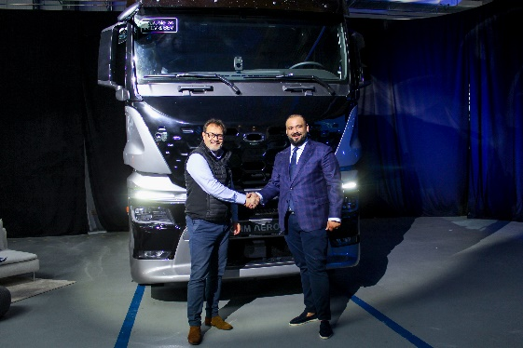 | From left: Michael Perschke, CEO of Quantron AG, and Mohamed Oun, new member of the Supervisory Board of Quantron AG

The original photos are available in both low and high resolutions here: Quantron AG press releases (https://www.quantron.net/q-news/pr-berichte/)

Quantron AG
Quantron AG is a platform provider and specialist in sustainable mobility for people and goods; in particular, for trucks, buses and vans with all-electric drive trains and H₂fuel cell technology. As a high-tech spin-off of the renowned Haller GmbH, the Augsburg/Bavaria-based company combines more than 140 years of commercial vehicle experience with the very latest e-mobility know-how, and positions itself globally as a partner to existing OEMs.
With the Quantron-as-a-Service Ecosystem (QaaS), QUANTRON offers an overall concept that includes all facets of the mobility value-added chain: QUANTRON INSIDE includes a wide range of new vehicles as well as conversions for existing and used vehicles from diesel to battery and hydrogen-electric drives with the highly innovative QUANTRON INSIDE technology. With a Europe-wide network of 700 service partners,QUANTRON CUSTOMER SOLUTIONS guarantees digital and physical after-sales solutions along with a range of services for maintenance, repairs and spare parts, telematics and in-cloud solutions for remote diagnosis and fleet management. Customers receive individual advice on, among other things, tailored charging and tank solutions, rental, financing and leasing offers. Training courses and workshops are also offered in the QUANTRON Academy. In future, QUANTRON ENERGY & POWER STATIONS will realise the production of green hydrogen and electricity as a platform. To this end, Quantron AG has teamed up with a number of strong global partners. At the same time, this Clean Transportation Alliance is also an important building block for supplying vehicles with the required green charging and H2 tank infrastructure.
QUANTRON stands for the core values RELIABLE, ENERGETIC, BRAVE . The team of experts at the innovation driver for e-mobility is making a significant contribution to sustainable, environmentally friendly passenger and freight transport.
Visit Quantron AG on our social media channels onLinkedIn and YouTube. More informationen available at www.quantron.net

Contact persons:
Jörg Zwilling, Director Global Communication & Business Development, j.zwilling@quantron.net
Stephanie Miller, Marketing & Communications Quantron AG, press@quantron.net

