PRESS RELEASE July 3rd 2023
QUANTRON expands its senior management team and welcomes Beate Reimann as CFO to prepare for its capital market readiness
- Beate Reimann named Chief Financial Officer (CFO) – joining with more than 25 years of global Finance experience
- Darka Marquardt appointed as Director People & Culture to lead the global growth and talent development
- Donato Azzarone nominated as Director Quantron Energy and prepare QUANTRON’s H2 footprint and H2 roaming network
Clean tech enterprise, Quantron AG, specialist in sustainable passenger and goods transport, has announced the appointment of Beate Reimann as its new CFO along with the expansion of its management team to include two more international members. With this strategic decision, QUANTRON has strengthened its expertise in the areas of finance, personnel development and energy while simultaneously positioning itself for the implementation of further global growth plans.
Beate Reimann named Chief Financial Officer (CFO)
Beate Reimann has assumed the position of Chief Financial Officer (CFO) at Quantron AG on 1st July 2023, thereby providing the company with targeted support in the next round of financing.
She brings over 25 years of experience of heading international financial organisations and a proven track record of delivering financial results and successfully implementing change management strategies and efficiency improvements in manufacturing, engineering, sales and distribution organisations. Most recently she was CFO and Head of Information and Communication Technology at NSK Europe in Maidenhead, England. Prior to this, Beate Reimann had held positions at ITW Ltd, Avnet Technology Solutions Inc and Rolls Royce Power Systems AG, among others, where she was able to gain valuable experience with lifecycle solutions in the form of Value Care Agreements. She will play a vital role in preparing Quantron AG for its capital market & IPO readiness.
Andreas Haller, Founder and Executive Chairman of Quantron AG: "I would like to thank Herbert Robel who, in addition to his role as CHRO at QUANTRON, also temporarily took on the position of CFO and did an excellent job. I am also very pleased to welcome Beate Reimann to the Management Board of Quantron AG as the new CFO. Her international experience and expertise will make a valuable contribution to the further development of our global financial strategy."
Expansion of management level in the areas of HR and Quantron Energy
Darka Marquardt complements the QUANTRON management team through her role as Director People & Culture. She has over 20 years of experience in senior HR positions as well as in international HR management. She places a particular focus on national and international personnel and organisational management. At QUANTRON, one of her key points of interest will be internationalisation along with the establishment of subsidiaries in Europe and internal talent development as well as the internal talent development.
Donato Azzarone is the new director of Quantron Energy. He is a nuclear engineer by trade and has more than 20 years of experience in the energy sector ranging from oil and gas through to renewable energies, particularly photovoltaics and wind energy. He has developed, managed and operated several energy projects in North Africa and Middle East. At QUANTRON, he is tasked with onboarding H2 production partners and developing a European HRS roaming partner network that will guarantee QUANTRON customers Europe-wide H2 availability.
Michael Perschke, CEO Quantron AG: "With three such competent experts on board, we are consolidating QUANTRON's position as a powerhouse in the field of sustainable mobility. The focus is now very much on the scaling and internationalisation of our business model, and we have now been able to recruit further top talents for QUANTRON for this eventuality as well as developing our inhouse talents for a global career in the cleantech sector and become a attractive employer in the Cleantech sector globally”.

Images (click on image preview to download):
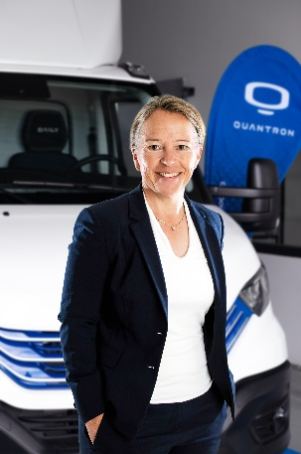 | Beate Reimann, Chief Financial Officer Quantron AG
 | Darka Marquardt, Director People & Culture Quantron AG
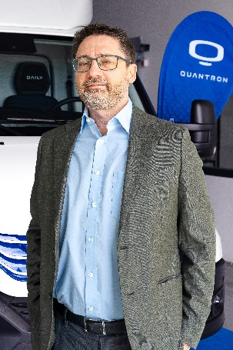 | Donato Azzarone, Director Quantron Energy

The original photos are available in both low and high resolutions here: Quantron AG press releases (https://www.quantron.net/en/q-news/press-releases/)

Quantron AG
Quantron AG is a platform provider and specialist in sustainable mobility for people and goods; in particular, for trucks, buses and vans with all-electric drive trains and H₂fuel cell technology. As a high-tech spin-off of the renowned Haller GmbH, the Augsburg/Bavaria-based company combines more than 140 years of commercial vehicle experience with the very latest e-mobility know-how, and positions itself globally as a partner to existing OEMs.
With the Quantron-as-a-Service Ecosystem (QaaS), QUANTRON offers an overall concept that includes all facets of the mobility value-added chain: QUANTRON INSIDE includes a wide range of new vehicles as well as conversions for existing and used vehicles from diesel to battery and hydrogen-electric drives with the highly innovative QUANTRON INSIDE technology. With a Europe-wide network of 700 service partners,QUANTRON CUSTOMER SOLUTIONS guarantees digital and physical after-sales solutions along with a range of services for maintenance, repairs and spare parts, telematics and in-cloud solutions for remote diagnosis and fleet management. Customers receive individual advice on, among other things, tailored charging and tank solutions, rental, financing and leasing offers. Training courses and workshops are also offered in the QUANTRON Academy. In future, QUANTRON ENERGY & POWER STATIONS will realise the production of green hydrogen and electricity as a platform. To this end, Quantron AG has teamed up with a number of strong global partners. At the same time, this Clean Transportation Alliance is also an important building block for supplying vehicles with the required green charging and H2 tank infrastructure.
QUANTRON stands for the core values RELIABLE, ENERGETIC, BRAVE . The team of experts at the innovation driver for e-mobility is making a significant contribution to sustainable, environmentally friendly passenger and freight transport.
Visit Quantron AG on our social media channels onLinkedIn and YouTube. More informationen available at www.quantron.net

Contact persons:
Jörg Zwilling, Director Global Communication & Business Development, j.zwilling@quantron.net
Stephanie Miller, Marketing & Communications Quantron AG, press@quantron.net

