PRESS RELEASE July 12th, 2023
QUANTRON hands over climate-friendly electric bus as part of the funding decision ceremony by Prime Minister Söder and Transport Minister Bernreiter
- Bavaria's Prime Minister Dr. Markus Söder and Bavaria's Minister of Transport Christian Bernreiter presented positive funding certificates for climate-friendly buses and charging infrastructure to two companies
- QUANTRON showcased its battery-electric city bus QUANTRON CIZARIS 12 EV during the event in Munich and handed it over to the family-owned company Omnibus Amann e. K. in Pfaffenhofen an der Ilm
- The QUANTRON bus with fully electric drive will be used for regular service and will save 68,2 tons of CO2 per year.

On July 12, 2023, Bavaria's Prime Minister Dr. Markus Söder and Bavaria's Minister of State for Housing, Construction and Transportation, Christian Bernreiter, presented funding decisions for the conversion of public transport to climate-friendly drives to two companies from Munich and Pfaffenhofen an der Ilm. During the event in Munich, the all-electric QUANTRON CIZARIS 12 EV city bus from clean tech company Quantron AG was showcased as an example of sustainable passenger transport. The vehicle was officially handed over to the family-owned company Omnibus Amann e. K. in Pfaffenhofen an der Ilm as part of the event and will be used in regular service operations.
This year, the State of Bavaria is investing around 95 million euros in the conversion of local public transport to climate-friendly drives and the expansion of the charging infrastructure. More than 20 bus depots throughout Bavaria are to benefit by receiving a total of 400 climate-friendly buses and charging stations. This step is a significant contribution to reducing CO2 emissions in the transport sector and improving air quality in Bavaria.
Andreas Haller, Founder and Executive Chairman of Quantron AG: “We are proud to be part of this forward-looking project and to contribute to reducing emissions in local public transport with our electric bus. The funding from the Free State of Bavaria is an important step in shaping the transport revolution.”
The QUANTRON CIZARIS 12 EV offers an environmentally friendly alternative for inner-city passenger transport. The vehicle handed over at the event is equipped with a powerful 422 kWh battery that provides a reliable range of over 400 km. With its 29 seats and an extra area for wheelchair users or baby carriages, it will be used in regular service operations. This will save around 68,2 tons of CO2 per year.

Images (Please click on the image preview to download):
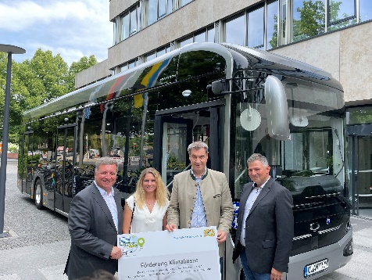 | Handover of the funding decision climate buses by Markus Söder and Christian Bernreiter to Omnibus Amann e. K. in front of the battery-electric QUANTRON CIZARIS 12 EV
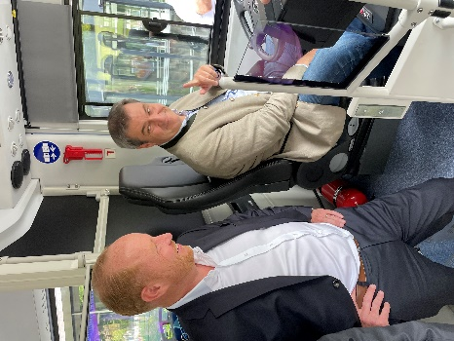 | From left: Andreas Haller, Founder and Executive Chairman of Quantron AG, and Markus Söder, Bavarian Minister President, in the zero-emission QUANTRON CIZARIS 12 EV bus
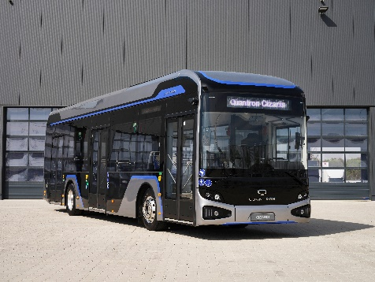 | The battery-electric city bus QUANTRON CIZARIS 12 EV

You can find the original images in both high and low resolutions here: Press releases from Quantron AG (https://www.quantron.net/en/q-news/press-releases/)
About Quantron AG
Quantron AG is a platform provider and specialist for sustainable mobility for people and goods; in particular for trucks, buses and vans with fully electric powertrains and H₂ fuel cell technology. As a high-tech spinoff of the renowned Haller GmbH, the German company from Augsburg in Bavaria combines over 140 years of commercial vehicle experience with state-of-the-art e-mobility know-how and positions itself globally as a partner to existing OEMs.
With the Quantron-as-a-Service Ecosystem (QaaS), QUANTRON offers an overall concept that covers all facets of the mobility value chain: QUANTRON INSIDE includes a wide range of both new vehicles and conversions for existing and used vehicles from diesel to battery and hydrogen electric powertrains using the highly innovative QUANTRON INSIDE technology. QUANTRON CUSTOMER SOLUTIONS ensures digital and physical aftersales solutions with a Europe-wide network of 700 service partners, as well as a service offering for maintenance, repair and spare parts, telematics and in-cloud solutions for remote diagnostics and fleet management. Customers receive individual solutions: rental, financing and leasing offers such as training courses and workshops at the QUANTRON Academy. In the future, QUANTRON ENERGY & POWER STATION will realize the production of green hydrogen and electricity as a platform. To this end, Quantron AG has joined forces with strong global partners. This Clean Transportation Alliance also forms an important building block for the supply of vehicles with the necessary green charging and H₂ refueling infrastructure.
QUANTRON stands for the core values Reliable, Energetic, Brave. The team of experts at the innovation driver for e-mobility is making a significant contribution to sustainable, environmentally friendly passenger and freight transport. You can find more information at www.quantron.net
Visit the Quantron AG on its social media channels on LinkedIn and YouTube.
Your contact:
Jörg Zwilling, Director Global Communications & Business Development, j.zwilling@quantron.net
Stephanie Miller, Marketing & Communications Quantron AG, press@quantron.net

