PRESS RELEASE August 24th, 2023
QUANTRON reports successful first seven months with international expansion as part of its globalization strategy
- Quantron AG reports cumulative order intake of 20 million Euro for the first seven months of the year
- Order backlog and customer approved funding requests cumulatively exceed 100 million Euro
- QUANTRON expands with the foundation of Quantron Italy S.r.l. and now has partners and affiliate offices in eight countries in Europe, Middle East, India & USA
- QUANTRON and GTL establish a joint venture called ROQIT with locations in Augsburg (GER) and Hyderabad (IND) to build a digital transaction platform for the needs of zero emission fleets

Quantron AG, specialist for sustainable passenger and goods transport, has successfully completed the second quarter of 2023. Given the rapid developments in the industry and the increasing international demand for zero-emission mobility solutions, the clean tech company is confident of achieving its growth targets.
In the first seven months of the year, the company recorded an order intake of 20 million Euro and an order backlog and approved funding applications at customers of cumulatively more than 100 million Euro.
Foundation of Quantron Italy S.r.l
At the end of May, QUANTRON announced the acquisition of EYES Group s.r.l. from FRIEM S.p.A. and the establishment of Quantron Italy S.r.l.. Quantron Italy is based in Milan, where the initial focus will be on zero-emission vehicles for the last mile and buses. It has already delivered four all-electric minibuses to municipalities on the island of Elba and won a tender for 6 electric city buses in Turin. Managing Director of Quantron Italy is Fabrizio Simoni, a automotive executive with more than 20 years of experience in international organisations

Quantron USA at ACT Expo in California
At the largest trade show for climate-friendly commercial vehicles in the U.S. - the Advanced Clean Transportation (ACT) show in Anaheim, California - the U.S. subsidiary Quantron USA, Inc. presented for the first time its concept for the U.S. market as well as the first prototype of its hydrogen-electric Class 8 truck. At the start of production, QUANTRON anticipates an unprecedented range for vehicles in this class in the U.S. of approximately 750 to 850 miles with a tank capacity of 100 kg of hydrogen. QUANTRON thus offers a real alternative to diesel-powered heavy trucks in the USA. The truck will be developed and manufactured at the US site in Michigan, near Detroit.
Reinforcement in QUANTRON management and supervisory board
Beate Reimann has taken over the position as Chief Financial Officer (CFO) of Quantron AG as of July 1st 2023 and will specifically support the company in the launched B-financing round together with STIFEL Investment Bank. She brings over 20 years of experience in leading international finance organizations as well as a proven track record in delivering financial results. She will play an important role in preparing Quantron AG for its capital market and IPO.
In addition, Mohamed Oun, Head of Accounting and Finance at Mesientos Limited - a subsidiary of Oilinvest B.V., was elected to the Supervisory Board of Quantron AG. He replaces Robert Schäble, who is leaving the Supervisory Board at his own request. Mesientos Limited is an investment arm of the Oilinvest Group, which operates around 2,450 service stations in Europe through its subsidiary Tamoil.
Greentech Festival Berlin: QUANTRON and GTL present ROQIT
Together with Goldstone Technologies (GTL), a leading listed Indian company for business intelligence and IT services, Quantron AG entered into a joint venture under the name ROQIT. The aim of the joint venture is to develop a digital transaction platform as the digital backbone of Quantron-as-a-Service (QaaS).
In addition, AI-supported software solutions are being developed for the rapidly ramping up zero-emission fleet management market, which can be used independently of manufacturers. The integrated platform was first presented at the Greentech Festival in Berlin in May. It is composed of five digital pillars: Fleet Management, Insurance-as-a-Service, Hydrogen Economy, Greenhouse Gas Balancing (GHG Quotas) and Data Insights.
During his visit to QUANTRON's booth during the Greentech Festival, German Finance Minister Christian Lindner emphasized the importance of sustainable innovations and was enthusiastic about QUANTRON's broad portfolio, which includes both battery and hydrogen-electric drives: "I am committed to technology openness in Germany and Europe. As you probably know, we focus on battery electric vehicles, but there are also alternatives. I think there are different use cases and that's why we need a diversity of technologies."
Full-year 2023 outlook
Michael Perschke, CEO: "The year 2023 is our transformation year and is marked by the ramp-up of our QUANTRON QLI FCEV and our QUANTRON QHM FCEV AERO trucks- our 2 flagship Fuel Cell products that we developed together with Ballard Power. We are executing excellently on this challenge and plan to deliver as many as 25-40 Fuel Cell vehicles to our customers this year. In addition, we are in the middle of our B-round of financing and have already been able to sign various "Registration of Interest" and MoUs. The B round will secure our scaling beyond 2024. We will use the proceeds for our "Hydrogen Offensive" and are proud that partners like Ballard Power, Fund 4 Sustainability and NEUMAN ESSER Group support our strategy and are part of our ecosystem. We will announce another investor in early September."
Andreas Haller, Chairman: "On July 15, 2023 we celebrated the 4th birthday of Quantron AG and I am proud of what we as a team have achieved so far. We can now call ourselves the technology market leader in hydrogen powered fuel cell trucks and I am proud of the QUANTRON team and our global partnerships."

Images (click on image preview to download):
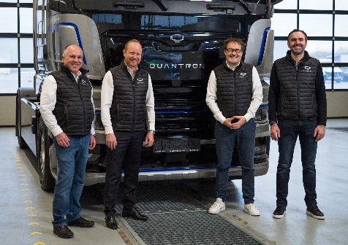 | QUANTRON Executive Board;  from left: Herbert Robel (CHRO), Andreas Haller (Founder and Executive Chairman), Michael Perschke (CEO) and René Wollmann (CTO)
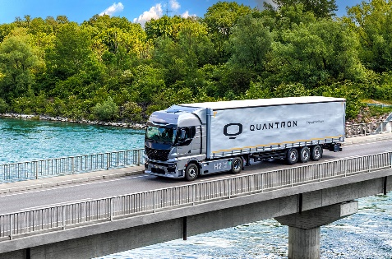 | Hydrogen-electric heavy-duty truck QUANTRON QHM FCEV AERO
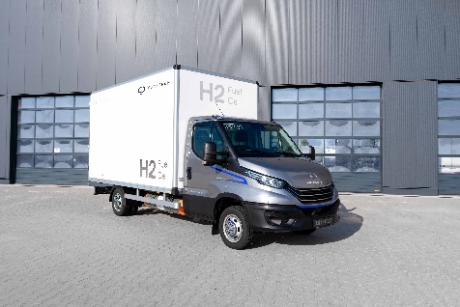 | Hydrogen-electric light truck QUANTRON QLI FCEV

The original photos are available in both low and high resolutions here: Quantron AG press releases (https://www.quantron.net/q-news/pr-berichte/)

About Quantron AG
Quantron AG is a platform provider and specialist in sustainable mobility for people and goods; in particular ,for trucks, buses and vans with all-electric drive trains and H₂fuel cell technology. As a high-tech spin-off of the renowned Haller KG, the Augsburg/Bavaria-based company combines more than 140 years of commercial vehicle experience with the very latest e-mobility know-how, and positions itself globally as a partner to existing OEMs.
With the Quantron-as-a-Service Ecosystem (QaaS), QUANTRON offers an overall concept that includes all facets of the mobility value-added chain: QUANTRON INSIDE includes a wide range of new vehicles as well as conversions for existing and used vehicles from diesel to battery and hydrogen-electric drives with the highly innovative QUANTRON INSIDE technology. With a Europe-wide network of 700 service partners,QUANTRON CUSTOMER SOLUTIONS guarantees digital and physical after-sales solutions along with a range of services for maintenance, repairs and spare parts, telematics and in-cloud solutions for remote diagnosis and fleet management. Customers receive individual advice on, among other things, tailored charging and tank solutions, rental, financing and leasing offers. Training courses and workshops are also offered in the QUANTRON Academy. In future, QUANTRON ENERGY & POWER STATIONS will realise the production of green hydrogen and electricity as a platform. To this end, Quantron AG has teamed up with a number of strong global partners. At the same time, this Clean Transportation Alliance is also an important building block for supplying vehicles with the required green charging and H2 tank infrastructure.
QUANTRON stands for the core values RELIABLE, ENERGETIC, BRAVE . The team of experts at the innovation driver for e-mobility is making a significant contribution to sustainable, environmentally friendly passenger and freight transport.
Visit Quantron AG on our social media channels onLinkedIn and YouTube. More informationen available at www.quantron.net

Contact persons:
Jörg Zwilling, Director Global Communication & Business Development, j.zwilling@quantron.net
Stephanie Miller, Marketing & Communications Quantron AG, press@quantron.net

