PRESS RELEASE August 16th, 2023
QUANTRON wins Augora Consulting as partner for sustainable mobility in Romania
- Augora Consulting offers customized transport solutions throughout the EU. Through the cooperation with QUANTRON, its offer will be expanded to include the first zero-emission vehicles
- The focus will be on battery electric light-transporters and buses

Clean tech company Quantron AG, specialist in sustainable passenger and goods transport, announces that Augora Consulting SRL is now partner for its zero-emission vehicles in Romania. Augora Consulting was founded in 2008 and has since established itself as a leader in the Romanian transportation industry. The focus is to be on the distribution of battery electric light vans like the QUANTRON QARGO 4 EV and e-buses.
A large network of own trucks and subcontractors enables Augora Consulting to offer customized transport solutions for customers throughout the European Union. By partnering with QUANTRON, the company will expand its offering to include a wide range of zero-emission vehicles that meet the needs of the changing transportation industry and contribute to a cleaner environment.
“As a former Augsburg resident, I am particularly pleased to be partner of Quantron AG and to be shaping the future of electric mobility in Romania," said Jakob Wekerle, CEO of Augora Consulting. "The partnership allows us to provide zero-emission mobility solutions to our customers for the first time, making a valuable contribution to the decarbonization of the transportation sector.”
Andreas Haller, founder and Executive Chairman of the Board of Quantron AG, added: “We are looking forward to the joint cooperation. Romania is one of the largest markets for light commercial vehicles and heavy trucks. We see great potential here for our zero-emission vehicles and are confident that Augora Consulting's expertise will help drive the deployment of sustainable transport solutions in Romania.”
Images (Please click on the image preview to download):
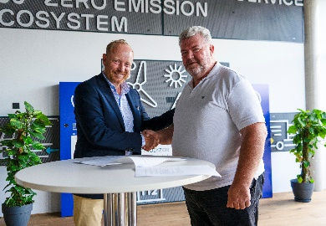 | From left: Andreas Haller, founder and Executive Chairman of the Board Quantron AG und Jakob Wekerle, CEO Augora Consulting
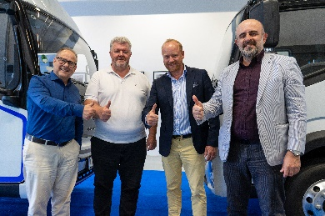 | From left: Utz Rachner, Global Sales Director Quantron AG, Jakob Wekerle, CEO Augora Consulting, Andreas Haller, founder and Executive Chairman of the Board Quantron AG, and Giorgi Achiniani, International Market Manager Quantron AG
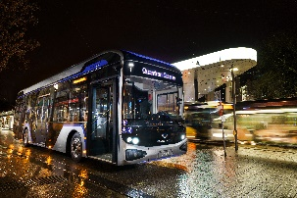 | The battery electric city bus QUANTRON CIZARIS 12 EV
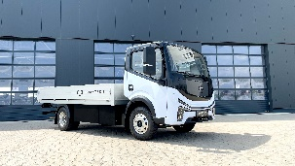 | The battery electric light-truck QUANTRON QARGO 4 EV

You can find the original images in both high and low resolutions here: Press releases from Quantron AG (https://www.quantron.net/en/q-news/press-releases/)
About Quantron AG
Quantron AG is a platform provider and specialist for sustainable mobility for people and goods; in particular for trucks, buses and vans with fully electric powertrains and H₂ fuel cell technology. As a high-tech spinoff of the renowned Haller GmbH, the German company from Augsburg in Bavaria combines over 140 years of commercial vehicle experience with state-of-the-art e-mobility know-how and positions itself globally as a partner to existing OEMs.
With the Quantron-as-a-Service Ecosystem (QaaS), QUANTRON offers an overall concept that covers all facets of the mobility value chain: QUANTRON INSIDE includes a wide range of both new vehicles and conversions for existing and used vehicles from diesel to battery and hydrogen electric powertrains using the highly innovative QUANTRON INSIDE technology. QUANTRON CUSTOMER SOLUTIONS ensures digital and physical aftersales solutions with a Europe-wide network of 700 service partners, as well as a service offering for maintenance, repair and spare parts, telematics and in-cloud solutions for remote diagnostics and fleet management. Customers receive individual solutions: rental, financing and leasing offers such as training courses and workshops at the QUANTRON Academy. In the future, QUANTRON ENERGY & POWER STATION will realize the production of green hydrogen and electricity as a platform. To this end, Quantron AG has joined forces with strong global partners. This Clean Transportation Alliance also forms an important building block for the supply of vehicles with the necessary green charging and H₂ refueling infrastructure.
QUANTRON stands for the core values Reliable, Energetic, Brave. The team of experts at the innovation driver for e-mobility is making a significant contribution to sustainable, environmentally friendly passenger and freight transport. You can find more information at www.quantron.net
Visit the Quantron AG on its social media channels on LinkedIn and YouTube.
Your contact:
Jörg Zwilling, Director Global Communications & Business Development Quantron AG, j.zwilling@quantron.net
Stephanie Miller, Marketing & Communications Quantron AG, press@quantron.net

