PRESS RELEASE September 18th, 2023
QUANTRON receives order for 38 zero-emission trucks worth 16 million euros, which will be offered on a hire-purchase basis
- The battery-electric heavy commercial vehicles will be delivered to HAMA Trucks in Augsburg, Germany
- The vehicles are tractor units and rigid trucks of the QUANTRON QHM BEV model
- All vehicles were granted funding by the German Federal Ministry of Transport and Digital Infrastructure (BMVD)
- The customer will profit from an innovative service/lease model
- The first delivery is planned for this year.

Quantron AG, specialist in sustainable passenger and freight transport, has received an order from HAMA Trucks in Augsburg for 38 battery-electric heavy commercial vehicles worth a total of 16 million euros. The first delivery is scheduled for the end of this year.
The vehicles are the QUANTRON QHM BEV model with a 450 kWh battery system and a range of up to 300 km. These will be delivered in both tractor and rigid variants, capable of using swap-bodies. All vehicles are equipped with an aerodynamics package, specially developed by QUANTRON to achieve even longer range.
All 38 vehicles were granted funding by the German Federal Ministry of Transport and Digital Infrastructure (BMVD). The customer benefits directly from the 80% subsidy from the BMDV and at the same time receives financing with an included maintenance contract over the agreed term in an innovative service/lease agreement.
Harald Mayer, Managing Director of HAMA Trucks explains: "We are proud to enter into this partnership with QUANTRON. The battery electric tractor units enable us to offer our customers sustainable transport solutions. As a result, we can help reduce the environmental impact in the mobility sector."
Andreas Haller, founder and Executive Chairman of Quantron AG added: "The delivery of the trucks is another step in our mission to promote sustainable mobility and drive environmentally friendly solutions in the transport sector. We look forward to shaping the mobility of the future together with HAMA Trucks."

Images (Please click on the image preview to download):
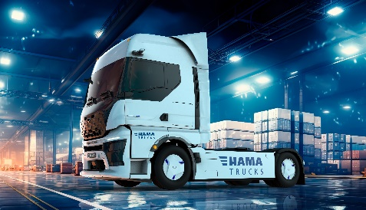 | The battery-electric truck QUANTRON QHM BEV for HAMA Trucks
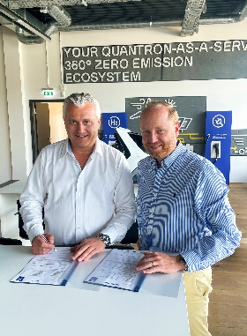 | Harald Mayer, Managing Director of HAMA Trucks, and Andreas Haller, founder and Executive Chairman of Quantron AG

You can find the original images in both high and low resolutions here: Press releases from Quantron AG (https://www.quantron.net/en/q-news/press-releases/)
About Quantron AG
Quantron AG is a platform provider and specialist for sustainable mobility for people and goods; in particular for trucks, buses and vans with fully electric powertrains and H₂ fuel cell technology. As a high-tech spinoff of the renowned Haller GmbH, the German company from Augsburg in Bavaria combines over 140 years of commercial vehicle experience with state-of-the-art e-mobility know-how and positions itself globally as a partner to existing OEMs.
With the Quantron-as-a-Service Ecosystem (QaaS), QUANTRON offers an overall concept that covers all facets of the mobility value chain: QUANTRON INSIDE includes a wide range of both new vehicles and conversions for existing and used vehicles from diesel to battery and hydrogen electric powertrains using the highly innovative QUANTRON INSIDE technology. QUANTRON CUSTOMER SOLUTIONS ensures digital and physical aftersales solutions with a Europe-wide network of 700 service partners, as well as a service offering for maintenance, repair and spare parts, telematics and in-cloud solutions for remote diagnostics and fleet management. Customers receive individual solutions: rental, financing and leasing offers such as training courses and workshops at the QUANTRON Academy. In the future, QUANTRON ENERGY & POWER STATION will realize the production of green hydrogen and electricity as a platform. To this end, Quantron AG has joined forces with strong global partners. This Clean Transportation Alliance also forms an important building block for the supply of vehicles with the necessary green charging and H₂ refueling infrastructure.
QUANTRON stands for the core values Reliable, Energetic, Brave. The team of experts at the innovation driver for e-mobility is making a significant contribution to sustainable, environmentally friendly passenger and freight transport. You can find more information at www.quantron.net
Visit the Quantron AG on its social media channels on LinkedIn and YouTube.
Your contact:
Jörg Zwilling, Director Global Communications & Business Development Quantron AG, j.zwilling@quantron.net
Stephanie Miller, Marketing & Communications Quantron AG, press@quantron.net

