PRESS RELEASE September 12th, 2023
QUANTRON signs the ZEV Declaration, supported by the Accelerating to Zero Coalition
- The ZEV Declaration aims to achieve 100% zero-emission new car and van sales in leading markets by 2035 and globally by 2040 at the latest.
- QUANTRON is proud to be part of this global initiative with its broad portfolio of zero-emission transportation solutions, driving a more sustainable future for the transport sector.

Quantron AG, specialist in sustainable passenger and freight transportation, announces that it has signed the Zero Emissions Vehicle Declaration (ZEV Declaration) and joins a global community supported by the Accelerating to Zero Coalition (A2Z Coalition). With this step, the clean tech company underscores its commitment to drive the global shift to zero-emission transportation.

The ZEV Declaration was launched at COP26 in Glasgow by a leadership group of more than 100 countries, companies, and organizations. It aims to achieve 100% zero-emission new car and van sales in leading markets by 2035 and globally by 2040 at the latest. Over 220 organizations, including 115+ national and regional governments and six of the largest OEMs, have already signed on.

The signatories of the ZEV Declaration commit to ensuring that only zero-emission vehicles are sold in leading markets worldwide no later than 2040 and by 2035 in leading markets. By the end of 2022, 66 governments have already taken action to stop the sale of new internal combustion engine vehicles. This includes 20 national governments, 28 regional and local authorities, and 18 EU countries covered by the EU target.

Additionally, to support the growing number of signatories and connect the world's leading zero-emission transportation organizations, the Accelerating to Zero Coalition (A2Z Coalition) was established in 2022. It serves as a platform where signatories can coordinate, align and strengthen their activities to achieve their ambitious goals.

QUANTRON is proud to now be a part of this global initiative to drive a more sustainable and emission-free future for the transportation sector. The company looks forward to contributing its expertise and innovations to accelerate the transition to zero-emission vehicles worldwide.

Michael Perschke, CEO of Quantron AG stated: „We welcome the opportunity to sign the ZEV Declaration. QUANTRON is zero-emission from its inception, it is part of our DNA. It feels like a natural act to sign the ZEV Declaration, since this is exactly our purpose: We deliver holistic solutions to the transport industry and help them to wean fleets off fossil fuels. We have the broadest zero-emission vehicle portfolio in the industry, due to our technology agnostic approach, offering BEV and FCEV.“
QUANTRON has already delivered 200 zero-emission vehicles to customers, including the first battery electric truck in the Kingdom of Saudi Arabia through its partner Electromin (a Petromin Corporation company). This puts QUANTRON at the forefront to drive the transition of global fleets to sustainable alternative technologies.
“As Secretariat of the Accelerating to Zero Coalition, we are encouraged by QUANTRON’s signing of the ZEV Declaration, which signals positive momentum in this global transition to a zero-emission transportation sector,” says Rachel Muncrief, acting executive director of the International Council on Clean Transportation. “Active collaboration across all segments of ZEV Declaration signatories will be crucial to achieve our Paris-aligned targets, and as a new signatory, QUANTRON has a critical role to play.”
Images (Please click on the image preview to download):
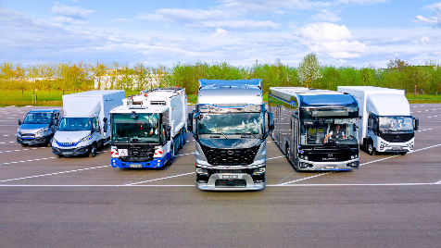 | QUANTRON Portfolio
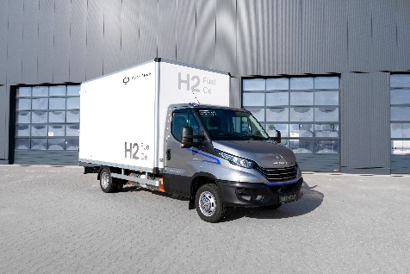 | Light-Transporter QUANTRON QLI FCEV
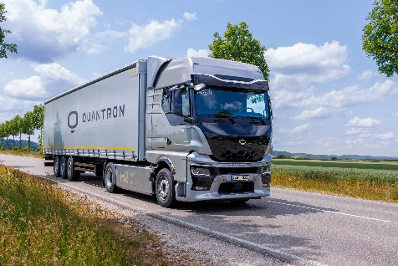 | Heavy-Duty Truck QUANTRON QHM FCEV AERO
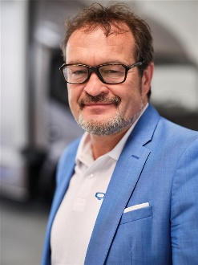 | Michael Perschke, CEO Quantron AG

You can find the original images in both high and low resolutions here: Press releases from Quantron AG (https://www.quantron.net/en/q-news/press-releases/)
About Quantron AG
Quantron AG is a platform provider and specialist for sustainable mobility for people and goods; in particular for trucks, buses and vans with fully electric powertrains and H₂ fuel cell technology. As a high-tech spinoff of the renowned Haller GmbH, the German company from Augsburg in Bavaria combines over 140 years of commercial vehicle experience with state-of-the-art e-mobility know-how and positions itself globally as a partner to existing OEMs.
With the Quantron-as-a-Service Ecosystem (QaaS), QUANTRON offers an overall concept that covers all facets of the mobility value chain: QUANTRON INSIDE includes a wide range of both new vehicles and conversions for existing and used vehicles from diesel to battery and hydrogen electric powertrains using the highly innovative QUANTRON INSIDE technology. QUANTRON CUSTOMER SOLUTIONS ensures digital and physical aftersales solutions with a Europe-wide network of 700 service partners, as well as a service offering for maintenance, repair and spare parts, telematics and in-cloud solutions for remote diagnostics and fleet management. Customers receive individual solutions: rental, financing and leasing offers such as training courses and workshops at the QUANTRON Academy. In the future, QUANTRON ENERGY & POWER STATION will realize the production of green hydrogen and electricity as a platform. To this end, Quantron AG has joined forces with strong global partners. This Clean Transportation Alliance also forms an important building block for the supply of vehicles with the necessary green charging and H₂ refueling infrastructure.
QUANTRON stands for the core values Reliable, Energetic, Brave. The team of experts at the innovation driver for e-mobility is making a significant contribution to sustainable, environmentally friendly passenger and freight transport. You can find more information at www.quantron.net
Visit the Quantron AG on its social media channels on LinkedIn and YouTube.
Your contact:
Jörg Zwilling, Director Global Communications & Business Development, j.zwilling@quantron.net
Stephanie Miller, Marketing & Communications Quantron AG, press@quantron.net

