PRESS RELEASE September 7th, 2023
Supervisory Board reaffirms Quantron AG strategy and investment into Fuel Cell Products and related H2 Fueling JV
- QUANTRON's Supervisory Board expresses satisfaction with this year's business development
- Order intake of 20 million euros, cumulative order backlog and approved funding applications of over 100 million euros in the first seven months of the year
- Delivery of the first five H2-powered light trucks (QUANTRON QLI FCEV)
- Introduction of ROQIT, a digital transaction platform in cooperation and under a new joint venture with Goldstone Technologies (GTL)
- Outlook for 2024: QUANTRON expects significant increase in sales

On August 31, 2023, the Supervisory Board of Quantron AG, specialist for sustainable passenger and freight transport, met to discuss the latest topics relevant to the company. On this occasion, Beate Reimann was also personally introduced as Chief Financial Officer (CFO) of Quantron AG inter alia supporting QUANTRON in its future funding rounds.
The Supervisory Board is extremely satisfied with this year's development of the clean tech company. In the first seven months of the year, the company recorded incoming orders of 20 million euros. The accumulated order backlog and approved applications for funding requests amount to more than 100 million euros. Furthermore, the planned Employee Stock Option Plan (ESOP) for employees of Quantron AG and the company's achievements in recent months were discussed.
The first QUANTRON FCEV light-vehicles and e-buses on the road
On September 1, Quantron AG received a visit from its strategic partner and investor Ballard Power Systems by its global CEO Randy MacEwen. The occasion was the announcement of the delivery of the first five light trucks with hydrogen fuel cell drive. For this purpose, Ballard's high-performance fuel cell modules were integrated into QUANTRON's vehicles. The QUANTRON QLI FCEV is the first H2 vehicle in the light fuel cell commercial vehicle segment up to 7.5 t in Europe and the market leader in fuel cell technology in this class. In addition to the QUANTRON QLI FCEV light vehicle, Ballard fuel cells are also used in the QUANTRON QHM FCEV heavy vehicles with the 44t QUANTRON QHM FCEV currently being the EU-range and performance champion.
Furthermore, QUANTRON handed over a QUANTRON CIZARIS 12 EV battery-electric city buses to the family-owned company Omnibus Amann e. K. in Pfaffenhofen an der Ilm as part of a subsidy presentation by Bavarian Minister President Söder and Bavarian Minister of Transport Bernreiter. The bus will be used for regular service there.
Development of a digital transaction platform called ROQIT in a new Joint Venture
ROQIT is a joint venture between QUANTRON and Goldstone Technologies (GTL), a leading listed Indian business intelligence and IT services company. The goal is to develop a digital transaction platform as the digital backbone of Quantron-as-a-Service (QaaS). It will also develop AI-powered software solutions for the rapidly ramping zero-emission fleet management market that can be deployed vendor-independently. The integrated platform is composed of five digital pillars: Fleet Management, Insurance-as-a-Service, Hydrogen Economy, Greenhouse Gas Accounting (GHG Quotas) and Data Insights.
Visits from politics and the automotive industry
In recent months, QUANTRON has received visits from automotive associations and several politicians such as German Federal Minister of Digital Affairs and Transport, Dr. Volker Wissing. The guests were able to experience the emission-free transport solutions of Quantron AG live on site and showed their enthusiasm for the innovative technology.
New Supervisory Board Member & Confirmation of formation of an H2 Fueling JV
Quantron AG welcomes Mohamed Oun as a new member of the supervisory board and also approves the formation of an H2 Fueling JV to secure the H2 supply for QUANTRONs Fuel Cell Trucks. More details will be announced in September 2023.
Outlook for 2024
Quantron AG takes an optimistic perspective on the upcoming year. Given the strong demand for zero-emission commercial vehicles and the ramp-up of its QHM FCEV, the company expects a significant increase in sales in 2024 with a minimum target of 80-100 Mill Euro. In addition, Quantron AG plans to further expand its international presence in Europe and is determined to advance innovative technologies in the field of hydrogen together with new strategic partners and its Joint Ventures.

Images and video (Please click on the image preview to download):
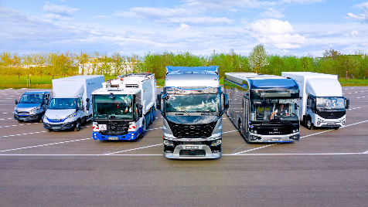 | QUANTRON Portfolio
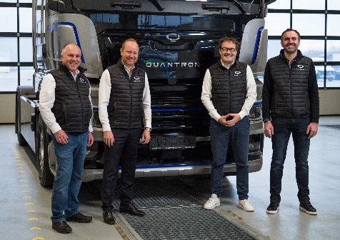 | QUANTRON Executive Board; from left: Herbert Robel (CHRO), Andreas Haller (Founder and Executive Chairman), Michael Perschke (CEO) and René Wollmann (CTO)
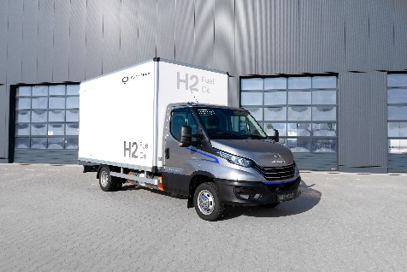 | Light-Transporter QUANTRON QLI FCEV
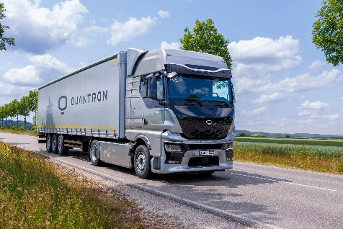 | Heavy-Duty Truck QUANTRON QHM FCEV AERO
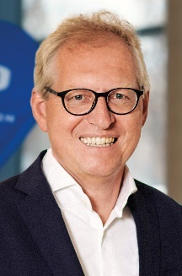 | Klaus Schmitt,  Quantron AG Supervisory Board Chairman
video interview with Klaus Schmitt

You can find the original images in both high and low resolutions here: Press releases from Quantron AG (https://www.quantron.net/en/q-news/press-releases/)
About Quantron AG
Quantron AG is a platform provider and specialist for sustainable mobility for people and goods; in particular for trucks, buses and vans with fully electric powertrains and H₂ fuel cell technology. As a high-tech spinoff of the renowned Haller GmbH, the German company from Augsburg in Bavaria combines over 140 years of commercial vehicle experience with state-of-the-art e-mobility know-how and positions itself globally as a partner to existing OEMs.
With the Quantron-as-a-Service Ecosystem (QaaS), QUANTRON offers an overall concept that covers all facets of the mobility value chain: QUANTRON INSIDE includes a wide range of both new vehicles and conversions for existing and used vehicles from diesel to battery and hydrogen electric powertrains using the highly innovative QUANTRON INSIDE technology. QUANTRON CUSTOMER SOLUTIONS ensures digital and physical aftersales solutions with a Europe-wide network of 700 service partners, as well as a service offering for maintenance, repair and spare parts, telematics and in-cloud solutions for remote diagnostics and fleet management. Customers receive individual solutions: rental, financing and leasing offers such as training courses and workshops at the QUANTRON Academy. In the future, QUANTRON ENERGY & POWER STATION will realize the production of green hydrogen and electricity as a platform. To this end, Quantron AG has joined forces with strong global partners. This Clean Transportation Alliance also forms an important building block for the supply of vehicles with the necessary green charging and H₂ refueling infrastructure.
QUANTRON stands for the core values Reliable, Energetic, Brave. The team of experts at the innovation driver for e-mobility is making a significant contribution to sustainable, environmentally friendly passenger and freight transport. You can find more information at www.quantron.net
Visit the Quantron AG on its social media channels on LinkedIn and YouTube.
Your contact:
Jörg Zwilling, Director Global Communications & Business Development Quantron AG, j.zwilling@quantron.net
Stephanie Miller, Marketing & Communications Quantron AG, press@quantron.net

