PRESS RELEASE September 26th, 2023
QUANTRON announces partnership with New Day Hydrogen at Move America Conference in Austin, Texas
- QUANTRON unveils a partnership with New Day Hydrogen, dedicated to advancing the hydrogen refueling infrastructure essential for North America's sustainable future
- QUANTRON is platinum sponsor for the 2023 Move America conference
- As part of its B-Round Quantron AG is meeting Tier 1 investors during MOVE for accelerating its global footprint with focus on North America

Quantron AG, specialist in sustainable passenger and freight transport, is platinum sponsor of the 2023 Move America conference in Austin, Texas on Sept. 26 – 27. As the primary tech mobility and start-up show, the event brings together people and companies that are redefining urban transportation across the country. Along with the conference, QUANTRON announces a partnership with New Day Hydrogen, which aims to help build the infrastructure needed for hydrogen refueling throughout the United States and Canada.
Multiple members of QUANTRON’s executive team will be participating in key roles at the Move America conference. Quantron AG’s global CEO, Michael Perschke, will give a speech with Dr. Karthik of Goldstone Technologies on “Building a Digital Ecosystem to Manage Decarbonization in the Heavy-Duty Transportation Segment.” QUANTRON and Goldstone Technologies recently formed a joint venture under the name ROQIT. The aim of the joint venture is to develop a digital transaction platform as the digital backbone of its 360-degree ecosystem Quantron-as-a-Service (QaaS). It is composed of five digital pillars: Fleet Management, Insurance-as-a-Service, Hydrogen Economy, Greenhouse Gas Balancing (GHG Quotas) and Data Insights.
New Day Hydrogen Partnership
Rick Haas, CEO of Quantron US, will also be participating on a panel for the event: “Keep on Trucking – Charting the Course to Decarbonization.” Quantron US, a subsidiary of the German clean tech company, Quantron AG, is making significant strides in the US market. The latest partnership with New Day Hydrogen makes hydrogen fueling economical for fleets of heavy-duty electric vehicles as they take their first, incremental steps towards zero emissions. QUANTRON, as part of its B-Round fundraising, is also meeting with a number of Tier 1 investors at Move America as it accelerates its global footprint with focus on North America.
“As we are moving the mobility industry towards hydrogen, we often get the question: what comes first - the vehicles or the infrastructure? This partnership helps provide a solution that offers both”, said Haas. “We’re offering a range-leading hydrogen-fueled truck along with a full 360° service offering for customers through our QaaS model. New Day Hydrogen will be a key piece of this offering with their ability to build on-site hydrogen electrolyzers so that truck fleets will have the confidence and security of being able to supply and manage their own hydrogen needs. It is a natural partnership that allows us to take the next step in this exciting work.”
“We are excited to be partnering with QUANTRON, together addressing the zero-emission vehicle and infrastructure needs of commercial fleets,” said New Day Hydrogen’s COO, Buford Barr. “Hydrogen is a clear zero-emissions option, especially for fleets who have identified operational challenges with batteries and charging.”
Images (Please click on the image preview to download):
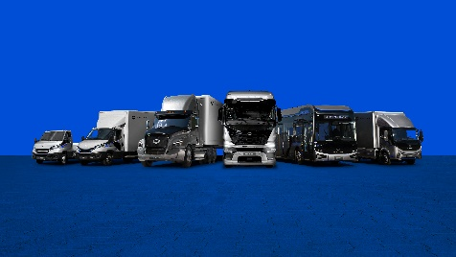 | QUANTRON Portfolio
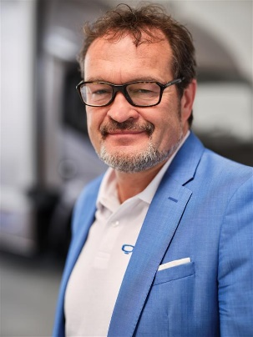 | Michael Perschke, global CEO Quantron AG
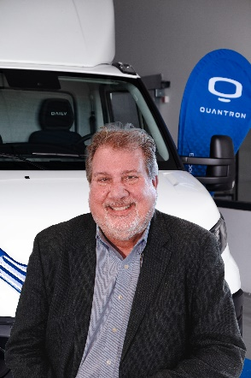 | Rick Haas, CEO Quantron US, Inc.

You can find the original images in both high and low resolutions here: Press releases from Quantron AG (https://www.quantron.net/en/q-news/press-releases/)
About Quantron AG
Quantron AG is a platform provider and specialist for sustainable mobility for people and goods; in particular for trucks, buses and vans with fully electric powertrains and H₂ fuel cell technology. As a high-tech spinoff of the renowned Haller GmbH, the German company from Augsburg in Bavaria combines over 140 years of commercial vehicle experience with state-of-the-art e-mobility know-how and positions itself globally as a partner to existing OEMs.
With the Quantron-as-a-Service Ecosystem (QaaS), QUANTRON offers an overall concept that covers all facets of the mobility value chain: QUANTRON INSIDE includes a wide range of both new vehicles and conversions for existing and used vehicles from diesel to battery and hydrogen electric powertrains using the highly innovative QUANTRON INSIDE technology. QUANTRON CUSTOMER SOLUTIONS ensures digital and physical aftersales solutions with a Europe-wide network of 700 service partners, as well as a service offering for maintenance, repair and spare parts, telematics and in-cloud solutions for remote diagnostics and fleet management. Customers receive individual solutions: rental, financing and leasing offers such as training courses and workshops at the QUANTRON Academy. In the future, QUANTRON ENERGY & POWER STATION will realize the production of green hydrogen and electricity as a platform. To this end, Quantron AG has joined forces with strong global partners. This Clean Transportation Alliance also forms an important building block for the supply of vehicles with the necessary green charging and H₂ refueling infrastructure.
QUANTRON stands for the core values Reliable, Energetic, Brave. The team of experts at the innovation driver for e-mobility is making a significant contribution to sustainable, environmentally friendly passenger and freight transport. You can find more information at www.quantron.net
Visit the Quantron AG on its social media channels on LinkedIn and YouTube.

About New Day Hydrogen
New Day Hydrogen makes hydrogen fueling economical for hard-to-decarbonize fleets as they take their first, incremental steps towards zero emissions. With our proprietary HubStarter system, we show fleets transitioning as few as five trucks the path to beating diesel in applications where batteries just don’t fit. Generating hydrogen on-site and starting at the scale of our customers, but with the capability to expand quickly as the market grows and our customers add more hydrogen vehicles to their fleet. For more information, visit www.newdayhydrogen.com or follow us on LinkedIn at www.linkedin.com/company/new-day-hydrogen-inc.
Your contact:
Jörg Zwilling, Director Global Communications & Business Development Quantron AG, j.zwilling@quantron.net
Stephanie Miller, Marketing & Communications Quantron AG, press@quantron.net

