PRESS RELEASE September 1st, 2023
QUANTRON and Ballard Power Systems introduce fuel cell powered trucks ready for delivery
- Ballard, a market leader of PEM fuel cell systems, and the German specialist for sustainable passenger and freight transport, Quantron AG, have been developing zero-emission fuel cell electric commercial vehicle platforms in a partnership since September 2021
- The heavy-duty truck QUANTRON QHM FCEV and the light-duty truck QUANTRON QLI FCEV are the first examples of this fruitful collaboration – both class-leading in range and technical package
- The QUANTRON QLI FCEV is a bestseller and technology leader in the fuel cell market for light commercial vehicles up to 7,5 t
- Five hydrogen powered light transporters have already been delivered to an European customer

The partnership between Ballard Power Systems, a global leader in fuel cell technology, and Quantron AG, a specialist in sustainable passenger and freight transportation, is entering its next phase. Since the announcement of the strategic cooperation in September 2021, the two companies have launched industry-leading developments. Together, the companies have delivered their first fuel cell electric vehicles, combining QUANTRON's vehicle engineering expertise with Ballard's state-of-the-art fuel cell technology.
The core of the Canadian-German partnership is the integration of Ballard's high-performance FCmove™ fuel cell modules in QUANTRON vehicles. These include the 44-ton QUANTRON QHM FCEV heavy-duty truck – the current European range Champion with 54 KG H2 at 700 bar - and the QUANTRON QLI FCEV light truck. Both zero-emission vehicles feature significantly longer range and short refueling time compared to battery electric models. A notable feature of QUANTRON's intelligent design is the complete integration of all fuel cell components into the frame structure of the QUANTRON QHM FCEV and the QLI FCEV, which means that no compromises have to be made in terms of trailer length and payload as well as allowing standard bodybuilder build-up structures as in their Diesel counterparts.
The QUANTRON QHM FCEV was presented for the first time at the IAA Transportation 2022 trade fair and met with an enthusiastic response. Media such as the German Newspaper Der Tagesspiegel spoke of "David is faster than Goliath" in comparison to established vehicle manufacturers, illustrating how significant achievements can be made through strategic partnerships of expert companies in their respective field.
Tim Sautter, Team Lead Q-Light & Corporate PM: “We are extremely proud to have achieved this important milestone together with Ballard. The collaboration between the engineering teams in Augsburg (Bavaria) and Vancouver (Canada) has been exceptional. We shortened the overall process from feasibility study to delivery to 18 months, bringing the QUANTRON QLI FCEV on the road and in customers hands in record time. This led to a superior product, where the fuel cell system is optimized for the individual vehicle based on customer use-cases.”
Randy MacEwen, CEO, Ballard Power Systems: “We’re excited to see the partnership with QUANTRON expand into the light-duty vehicle segment and increase fuel cell deployment into the critical last-mile transport market. Combining QUANTRON and Ballard’s respective technical strengths and market expertise, our teams are committed to accelerate the adoption of hydrogen mobility in the freight sector by bringing high-performing fuel cell engines to market.”
Hydrogen as source of clean energy has become increasingly important in recent years, especially in the commercial vehicle sector. For this reason, Ballard became one of the founding members of the Clean Transportation Alliance, launched by QUANTRON, aiming to establish zero emission transport solutions with a special focus on the hydrogen value chain. The Clean Transportation Alliance features tech companies from the production, transport and dispensing of green hydrogen. Ballard will continue to play an important role in the alliance, driving the adoption of fuel cell systems in next generation transport solutions forward.
An European customer already took delivery of the first five units with one unit having accomplished 15.000 km in daily operations in a trial with the customer.
Michael Perschke, CEO of Quantron AG: “We take immense pride in our accomplishment, having jointly developed market-ready FCEV vehicles. Both Ballard and QUANTRON mastered this in record time. This is not only first to market in the 7.5 t FCEV light vehicle segment, but we take the lead in the fuel cell technology market. We have an order and offer pipeline of up to 100 units.”

Images (Please click on the image preview to download):
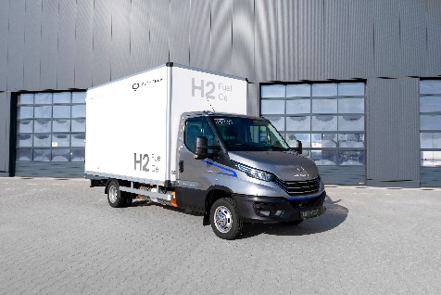 | Light-Transporter QUANTRON QLI FCEV
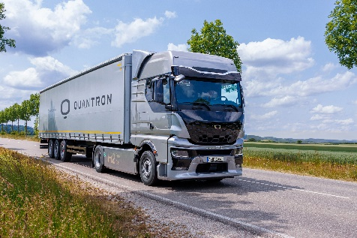 | Heavy-Duty Truck QUANTRON QHM FCEV AERO
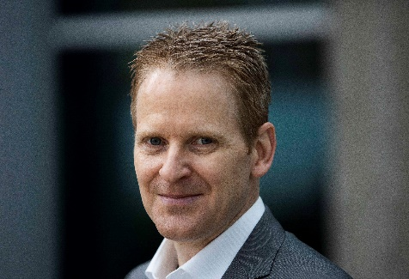 | Randy MacEwen, CEO Ballard Power Systems
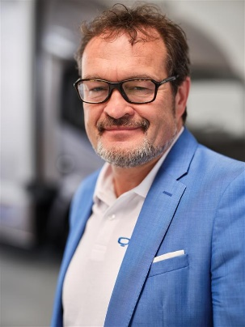 | Michael Perschke, CEO Quantron AG
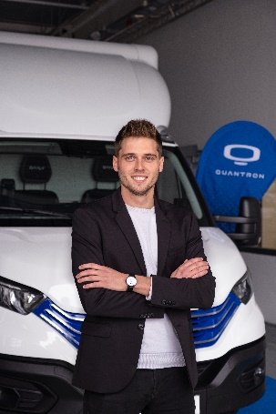 | Tim Sautter, Team Lead Q-Light & Corporate PM

You can find the original images in both high and low resolutions here: Press releases from Quantron AG (https://www.quantron.net/en/q-news/press-releases/)
About Quantron AG
Quantron AG is a platform provider and specialist for sustainable mobility for people and goods; in particular for trucks, buses and vans with fully electric powertrains and H₂ fuel cell technology. As a high-tech spinoff of the renowned Haller GmbH, the German company from Augsburg in Bavaria combines over 140 years of commercial vehicle experience with state-of-the-art e-mobility know-how and positions itself globally as a partner to existing OEMs.
With the Quantron-as-a-Service Ecosystem (QaaS), QUANTRON offers an overall concept that covers all facets of the mobility value chain: QUANTRON INSIDE includes a wide range of both new vehicles and conversions for existing and used vehicles from diesel to battery and hydrogen electric powertrains using the highly innovative QUANTRON INSIDE technology. QUANTRON CUSTOMER SOLUTIONS ensures digital and physical aftersales solutions with a Europe-wide network of 700 service partners, as well as a service offering for maintenance, repair and spare parts, telematics and in-cloud solutions for remote diagnostics and fleet management. Customers receive individual solutions: rental, financing and leasing offers such as training courses and workshops at the QUANTRON Academy. In the future, QUANTRON ENERGY & POWER STATION will realize the production of green hydrogen and electricity as a platform. To this end, Quantron AG has joined forces with strong global partners. This Clean Transportation Alliance also forms an important building block for the supply of vehicles with the necessary green charging and H₂ refueling infrastructure.
QUANTRON stands for the core values Reliable, Energetic, Brave. The team of experts at the innovation driver for e-mobility is making a significant contribution to sustainable, environmentally friendly passenger and freight transport. You can find more information at www.quantron.net
Visit the Quantron AG on its social media channels on LinkedIn and YouTube.

About Ballard Power Systems
Ballard Power Systems’ (NASDAQ: BLDP; TSX: BLDP) vision is to deliver fuel cell power for a sustainable planet. Ballard zero-emission PEM fuel cells are enabling electrification of mobility, including buses, commercial trucks, trains, marine vessels, and stationary power. To learn more about Ballard, please visit www.ballard.com.

Your contact:
Jörg Zwilling, Director Global Communications & Business Development Quantron AG, j.zwilling@quantron.net
Stephanie Miller, Marketing & Communications Quantron AG, press@quantron.net

