PRESS RELEASE October 31st, 2023

QUANTRON Design Award 2024 for innovative hydrogen powered trucks of the future – start of application phase

- The application phase for QUANTRON Design Award 2024 is starting now.
- European leading design universities and students supported by their professors, are invited to take part in envisioning the future of sustainable logistics, powered by hydrogen fuel cell trucks.
- The contest was announced in the Drivers & Business Club in Munich with guests from media, racing and business excellence.
- The winners of the contest will be evaluated by a jury team of world class designers and members of QUANTRON and announced during the Q-Days March 2024.
- All design activities and project presentations will be executed in partnership with Vizcom and Gravity Sketch.

The application phase for QUANTRON Design Award 2024 is starting now. World class universities with focus on Europe are invited to participate with their bachelor’s or master’s students of Automotive Design, Transportation & Mobility Design, Industrial Design or similar. These include IAAD, AFAD, Polimi, Pforzheim, Art Center College of Design, CCS, Coventry University, Carleton University, Hochschule Reutlingen, STARTE, Creapole, Hochschule München, IED, SPD, Umea University, FH Salzburg, OCAD etc. After accessing the following link students can register for the application. Application for Design Award 2024
The announcement of the QUANTRON Design Award 2024 took place at the Drivers & Business Club in Munich, with the presence of press, media, investors, VIP guests, and QUANTRON fans from the industry. The coordinator of the design award, Koorosh Shojaei, along with Martin Lischka (CMO, Marketing, Brand & Strategy), presented the purpose of the design award and the complete planning and roadmap of the contest leading up to the award ceremony to the audience of the Drivers & Business Club in Munich.
The task for the students is to create a concept for a futuristic truck powered by hydrogen, for the European market realising long haul transportation with zero emissions. Requested is a modular solution having both driver cabin available and full autonomous capabilities without the traditional cabin. Aerodynamics and efficiency should be playing a strong role. Due to the shortage of the drivers worldwide and higher work/life balance in the future the drivers should be able to drive various trucks using the same controlling station based at home or at QUANTRON’s remote driving hubs.
The handover of the design award for the most innovative and sustainable fuel cell truck will be executed during Q-Days Sustainability Night in March 2024 together with a special prize opportunity. The top 3 winning teams will be granted a monetary stipend while having continuous visibility through various social media platforms. Each winning member will be awarded by QUANTRON’s partner Vizcom, with a pro subscription of Vizcom AI tool for the defined period. Gravity Sketch will be granting each winning member, five hours of online group training with a Gravity Sketch expert.
Martin Lischka, CMO - Director Marketing, Brand and Strategy, expresses: “It is key for us to be at the forefront of the symbiosis between technology and design to realize innovation and progress bundled with efficiency. We are keen challenging the status quo of the design for the whole commercial vehicle industry to realize the next level. QUANTRON is part of the future of zero emission solutions movement powered by green hydrogen and is giving young talents from world class design universities the chance and a platform through the QUANTRON Design Award 2024 initiative. We are already excited to show the future vision of trucks realizing decarbonization of the transport sector and thrilled to drive the project together with our design lead Koorosh Shojaei and our partners Vizcom and Gravity Sketch.”
Vizcom represents the forefront of product visualization, empowering both individual designers and design organizations with the latest advancements in AI technology. It uniquely strikes a balance between harnessing the potential of AI and preserving the essential elements of creative control, authenticity, and ownership throughout the design journey. Tailored to cater specifically to the needs of professionals in industrial, footwear, and automotive design, Vizcom stands as a pioneering tool that harmoniously blends cutting-edge technology with the intricacies of design expertise.
Jordan Taylor, CEO & Co of Vizcom states: “We are thrilled to sponsor the 2023 QUANTRON Design Award. As a company deeply committed to the future of design, we are both honored and excited to be part of this celebration of creativity, innovation, and excellence. Our mission has always been to empower creators with the tools they need to bring their visions to life. By sponsoring the QUANTRON Design Award, we are reaffirming our commitment to this goal. We not only get to acknowledge and appreciate the incredible talent within the design community, but also to inspire and be inspired by the groundbreaking work being done in our field. We look forward to seeing the remarkable designs that will be showcased and to the continued partnership with QUANTRON in elevating the design landscape.”
Oluwaseyi Sosanya, CEO of Gravity Sketch states: “Gravity Sketch is excited to partner with Quantron AG and Vizcom for the QUANTRON Design Award! I'm consistently more impressed with the work I am seeing in academia than that of our industry partners. Students are leading the charge of more creative and sustainable design solutions, which both play important roles in our company mission and vision! This collaboration highlights our shared values in: creativity, innovation and style. We are looking forward to this event and can't wait to see everyone there!”
The Gravity Sketch Student Ambassador Program affords talented design students the opportunity to gain Gravity Sketch skills, build their portfolio, network with top designers and brands and position themselves for their dream career in design. The “Spring 2024 Program” starts from January 2024 - May 2024.

For more information click the link below: Spring 2024 Program

Images (Please click on the image preview to download):
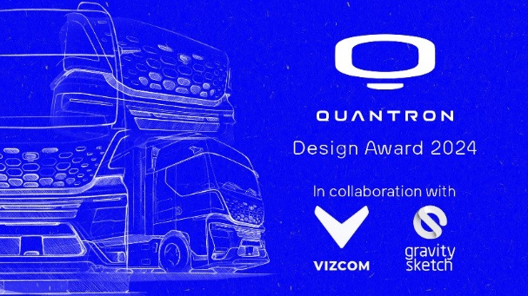 | QUANTRON Design Award 2024 - Official poster in collaboration with Vizcom and Gravity Sketch
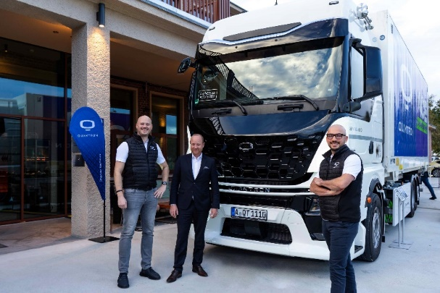 | QUANTORN QHM AERO truck with QUANTRON management Martin Lischka (CMO, Brand & Strategy), Andreas Haller (Founder and Executive Chairman), Koorosh Shojaei (Design Lead)
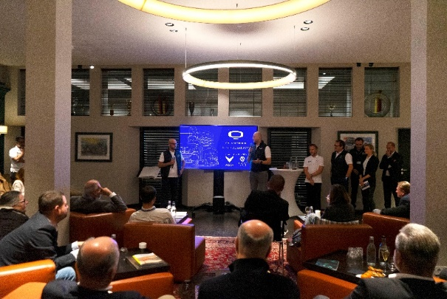 | Official launch of the QUANTRON Design Award 2024 presented by the coordinator of the design award, Koorosh Shojaei, along with Martin Lischka (CMO, Brand & Strategy) at the Drivers & Business Club in Munich
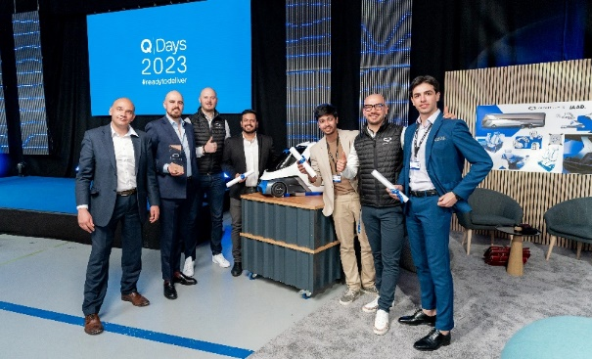 | Award Ceremony Q-Days 2023 - Master thesis project with Automotive Design Students from IAAD University in Turin
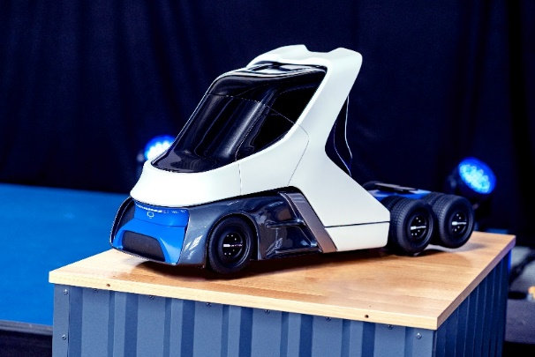 | Physical 1/5 scale model of the case study project 2023 - US Class 8 truck hydrogen fuel cell powered

You can find the original images in both high and low resolutions here: Press releases from Quantron AG (https://www.quantron.net/en/q-news/press-releases/)
About Quantron AG

Quantron AG is a platform provider and specialist for sustainable transportation for people and goods; in particular for trucks, buses and vans with fully electric powertrains and H₂ fuel cell technology. As a high-tech spinoff of the renowned Haller GmbH, the German company from Augsburg in Bavaria combines over 140 years of commercial vehicle experience with state-of-the-art e-mobility know-how and positions itself globally as a partner to existing OEMs.
With the Quantron-as-a-Service Ecosystem (QaaS), QUANTRON offers an overall concept that covers all facets of the mobility value chain: QUANTRON INSIDE includes a wide range of both new vehicles and conversions for existing and used vehicles from diesel to battery and hydrogen electric powertrains using the highly innovative QUANTRON INSIDE technology. QUANTRON CUSTOMER SOLUTIONS ensures digital and physical aftersales solutions with a Europe-wide network of 700 service partners, as well as a service offering for maintenance, repair and spare parts, telematics and in-cloud solutions for remote diagnostics and fleet management. Customers receive individual solutions: rental, financing and leasing offers such as training courses and workshops at the QUANTRON Academy. In the future, QUANTRON ENERGY & POWER STATION will realize the production and distribution of green hydrogen and electricity as a platform. To this end, Quantron AG has joined forces with strong global partners. This Clean Transportation Alliance also forms an important building block for the supply of vehicles with the necessary green charging and H₂ refueling infrastructure.
QUANTRON stands for the core values Reliable, Energetic, Brave. The team of experts at the innovation driver for e-mobility is making a significant contribution to sustainable, environmentally friendly passenger and freight transport. You can find more information at www.quantron.net .
Visit the Quantron AG on its social media channels on LinkedIn and YouTube.

Your contact:
Jörg Zwilling, Director Global Communications & Business Development Quantron AG, j.zwilling@quantron.net
Stephanie Miller, Marketing & Communications Quantron AG, press@quantron.net

