PRESS RELEASE Riyadh, Saudi Arabia, October 16th, 2023

QUANTRON and Petromin realise with 50 units the largest deployment of zero-emission trucks in the Kingdom of Saudi Arabia
- QUANTRON and Petromin Corporation announce the delivery of the first 50 battery-electric QUANTRON QARGO 4 EV in the Kingdom of Saudi Arabia
- In the initial phase, these trucks will support the fleet decarbonisation efforts of strategic customers like PepsiCo and Red Sea Global, amongst others.
- Decarbonisation of mobility is a high priority in the Kingdom of Saudi Arabia
- Successful trial phase with the first QUANTRON QARGO 4 EV in the Kingdom since November 2022
- The QUANTRON QARGO 4EV has been specially designed to make urban transport and last-mile deliveries as convenient and sustainable as possible.
Quantron AG, a clean tech company and specialist in sustainable passenger and freight transport, together with its partner Electromin (wholly owned by the Petromin Corporation) announces the delivery of the first 50 QUANTRON QARGO 4 EV light trucks in the Kingdom of Saudi Arabia. The vehicles have been prepared for deployment with customers like PepsiCo and Red Sea Global. This is the largest delivery of battery-electric trucks in the Kingdom of Saudi Arabia representing a significant milestone towards decarbonisation of mobility, in line with the Saudi Vision 2030 sustainability goals.
Saudi Vision 2030 is a clear plan to diversify Saudi Arabia’s economy and address concerns about urbanization and climate change. The Saudi government has proposed a variety of solutions aimed at reducing energy consumption per capita whilst strongly prioritizing the exploitation of renewable energy sources. Moreover, the government is investing in improvements to the transportation system and the development of tourism, entertainment, and other important industries.
QUANTRON’s partner in the Kingdom of Saudi Arabia Petromin, is a leading multi-national organization in the Kingdom of Saudi Arabia, standing as a strong transformative force, enabling the movement of people, products and services through sustainable and innovative mobility solutions. In a joint project, Petromin pilots Saudi Arabia’s first fleet of zero emission battery electric trucks.
The battery-electric QUANTRON QARGO 4EV has been specially designed to make urban transport and last-mile deliveries as convenient and sustainable as possible. With ranges of more than 250km based on CATL battery with 81kWh which can be recharged in one hour, the QUANTRON QARGO 4 EV is the optimum solution for decarbonized transportation needs of metropolitan areas. Due to the wide range of mounting and assembly options, the vehicle can be used very flexibly in a wide variety of applications (e.g., dry goods, fresh food, municipal services, furniture transport and more). Among the first customers in the Kingdom of Saudi Arabia are PepsiCo and Red Sea Global, demonstrating a strong commitment towards sustainability. These customers will operate the trucks in day-to-day operations, substituting diesel trucks, thereby achieving an estimated carbon saving of 31.5 kilograms per 100 km (calculated based on a mixed load, driving time of approx. 3.6 hours and 10 stops for loading and off-loading of cargo).
Kalyana Sivagnanam, Group CEO of Petromin Corporation: “By joining forces, Electromin and QUANTRON have forged a powerful alliance that capitalizes on their unique skill sets and positions them at the forefront of the e-mobility revolution in KSA. This synergistic partnership enables the pooling of resources, knowledge, and experience, paving the way for the creation of innovative, sustainable mobility solutions that will revolutionize transportation in the Kingdom.”
Mark Notkin, Head of Electromin and Chief Innovation Officer of Petromin Group: “Electromin and QUANTRON's collaboration represents a transformative step forward in the e-mobility landscape of Saudi Arabia. With the shared commitment to zero-emission solutions, this partnership will unlock a new era of sustainable transportation, offering clients and partners an expanded range of cutting-edge products and services that will shape the future of mobility in the Kingdom and beyond.”
Michael Perschke, CEO of Quantron AG: "We are delighted and proud to announce that QUANTRON is a partner of choice to Petromin in this truly pioneering project led by Anil Reddi, director Quantron-as-a-Service, driving the ambitious decarbonisation goals of the Kingdom of Saudi Arabia forward. This is a significant step for us towards internationalisation and entry into the Middle East. It's merely the beginning of a journey where QUANTRON and Petromin will leverage their complementary expertise to revolutionise the mobility landscape in the Kingdom of Saudi Arabia.”

Images (Please click on the image preview to download):
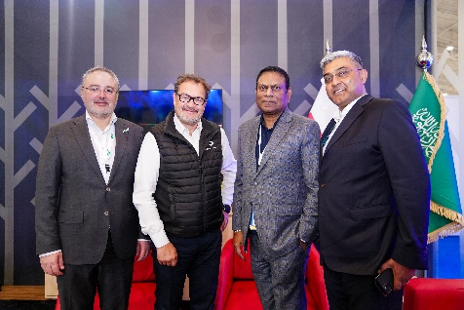 | From left: Mark Notkin (Head of Electromin and Chief Innovation Officer of Petromin Group), Michael Perschke (CEO Quantron AG),  Kalyana Sivagnanam (Group CEO Petromin Corporation), Anil Reddi (Director Quantron-as-a-Service)
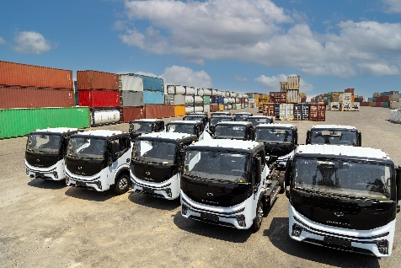 | 50 units of QUANTRON QARGO 4 EV fleet arriving at the harbor of Jeddah in the Kingdom of Saudi Arabia
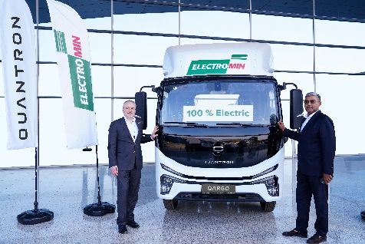 | Mark Notkin (Head of Electromin and Chief Innovation Officer of Petromin Group) and Anil Reddi (Director Quantron-as-a-Service) with the QUANTRON QARGO 4 EV
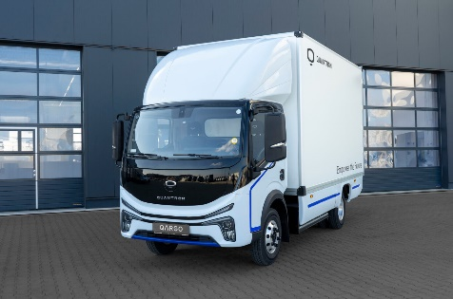 | QUANTRON QARGO 4 EV truck with up to 250km of electric range based on 81kWh CATL LFP-battery

You can find the original images in both high and low resolutions here: Press releases from Quantron AG (https://www.quantron.net/en/q-news/press-releases/)

About Petromin Corporation:
Petromin is the leading Saudi company in the advanced lubricants, automotive technology, multi-modal mobility, and sustainable transportation segment, with an unmatched reputation for the highest quality products and services in the industry today. The company has been operating in the Kingdom of Saudi Arabia, since 1968, when it started building its reputation for producing the highest quality lubricants in the region. With more than 6000 employees, Petromin exports its products to over 40 countries in the GCC, Middle East, Africa, and Asia. Petromin offers fast and reliable vehicle maintenance services which have benefited a considerable proportion of drivers in Saudi Arabia. It is backed by an extensive network of service centers that provide unparalleled coverage across the Kingdom.
Follow Petromin on social:
Twitter: @Petromincorp
Instagram: @Petromincorp
Facebook: @Petromincorp

About Electromin:
Electromin is the leading Saudi turnkey, technology driven e-mobility solutions provider for passenger vehicles, commercial and government fleets, public transit and large infrastructure projects. Electromin is building a charging network to offer a seamless charging experience for EV drivers across the Kingdom. Industry experts from around the world ensure that Electromin can provide the knowledge and experience to the KSA market.
Visit Electromin website at: https://electromin.com/
About Quantron AG
Quantron AG is a platform provider and specialist for sustainable mobility for people and goods; in particular for trucks, buses and vans with fully electric powertrains and H₂ fuel cell technology. As a high-tech spinoff of the renowned Haller GmbH, the German company from Augsburg in Bavaria combines over 140 years of commercial vehicle experience with state-of-the-art e-mobility know-how and positions itself globally as a partner to existing OEMs.
With the Quantron-as-a-Service Ecosystem (QaaS), QUANTRON offers an overall concept that covers all facets of the mobility value chain: QUANTRON INSIDE includes a wide range of both new vehicles and conversions for existing and used vehicles from diesel to battery and hydrogen electric powertrains using the highly innovative QUANTRON INSIDE technology. QUANTRON CUSTOMER SOLUTIONS ensures digital and physical aftersales solutions with a Europe-wide network of 700 service partners, as well as a service offering for maintenance, repair and spare parts, telematics and in-cloud solutions for remote diagnostics and fleet management. Customers receive individual solutions: rental, financing and leasing offers such as training courses and workshops at the QUANTRON Academy. In the future, QUANTRON ENERGY & POWER STATION will realize the production of green hydrogen and electricity as a platform. To this end, Quantron AG has joined forces with strong global partners. This Clean Transportation Alliance also forms an important building block for the supply of vehicles with the necessary green charging and H₂ refueling infrastructure.
QUANTRON stands for the core values Reliable, Energetic, Brave. The team of experts at the innovation driver for e-mobility is making a significant contribution to sustainable, environmentally friendly passenger and freight transport. You can find more information at www.quantron.net
Visit the Quantron AG on its social media channels on LinkedIn and YouTube.
Your contact:
Jörg Zwilling, Director Global Communication & Business Development, j.zwilling@quantron.net
Stephanie Miller, Marketing & Communications Quantron AG, press@quantron.net

