PRESS RELEASE 9th October 2023
World premiere: QUANTRON delivers hydrogen trucks to the first IKEA market worldwide
- German Quantron AG supplies IKEA Austria with five hydrogen fuel cell trucks of the model QUANTRON QLI FCEV
- In Austria, 56 QUANTRON battery-electric vehicles are already successfully in operation for IKEA, saving about 450 tons of CO2 per year
- The 5 FCEV trucks are expected to save another 160 tons of CO2 per year

IKEA Austria, together with Quantron AG, sets an example for sustainable logistics and is the first IKEA market worldwide to introduce hydrogen fuel cell trucks. Quantron AG, a specialist in sustainable passenger and freight transport, is supplying the QUANTRON QLI FCEV model vehicles. The zero-emission transporters will be fueled with green hydrogen from energy supplier Wien Energie.
“By introducing the hydrogen trucks - as the first IKEA market worldwide - we succeed in Austria in taking a big step in implementing environmentally friendly processes. In this way, as a pioneer in the field of sustainable logistics, we want to show that a transformation to zero-emission delivery is already possible today”, says Alpaslan Deliloglu, CEO and Chief Sustainability Officer at IKEA Austria.
The fuel cell vehicles were developed in collaboration with Ballard Power Systems, the Canadian global leader in fuel cell technology. The entire process from feasibility study to delivery took only 18 months, enabling the QUANTRON QLI FCEV to hit the road in record time.
The innovative Quantron Inside technology offers a user-friendly complete package with innovative e-axle, customized high-performance battery, fuel cell and tank system integration, and unique energy management and aerodynamics for maximum efficiency. One tank of fuel is sufficient for a range of up to 400 km, allowing distances of more than 500 km per day.
“We are delighted that our long-standing collaboration with IKEA has reached another level with the launch of a new generation of innovative QUANTRON products. The QLI FCEV is the first H2 vehicle in the fuel cell commercial vehicle segment up to 7.5 t in Europe and the market leader in fuel cell technology in this class. We have been supporting IKEA Austria on its mission of decarbonization since August 2021. IKEA Austria has 45 QLI BEV trucks in use in the greater Vienna area and a further eleven in other Austrian cities.”, explains Andreas Haller, founder and Executive Chairman of Quantron AG.
The use of the battery-electric QUANTRON vehicles saves around 450 tons of CO2 annually. The FCEV trucks have a longer range for deliveries even outside urban areas and are expected to reduce CO2 emissions by another 160 tons per year. By 2025, IKEA Austria plans to make 100% of its last-mile deliveries emission-free. The company announced to expand its fleet of H2 trucks to 40 units by 2025.

Images (Please click on the image preview to download):
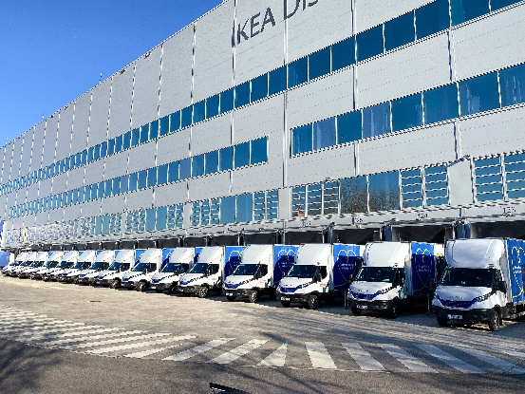 | QUANTRON QLI Zero Emission Fleet
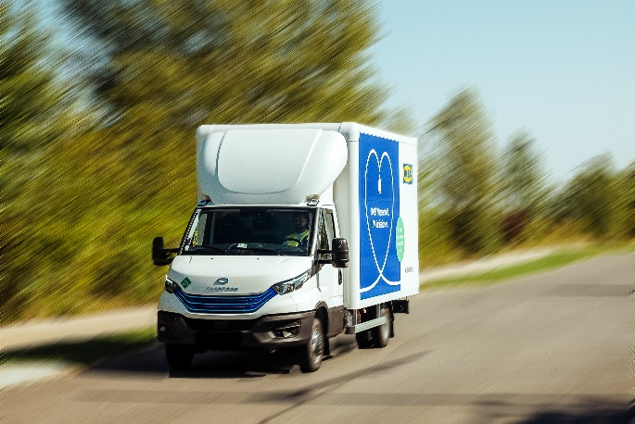 | QUANTRON QLI FCEV
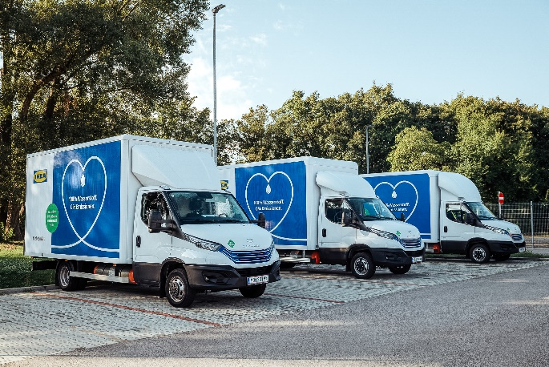 | QUANTRON QLI FCEV Zero Emission Fleet Ikea Austria
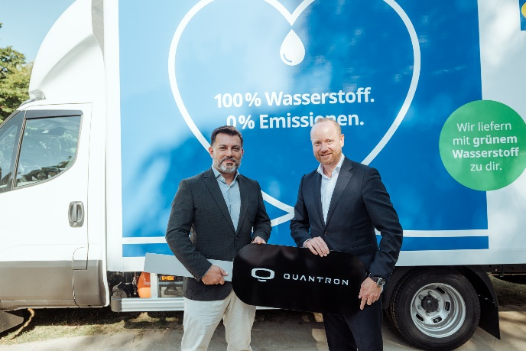 | From left:  Alpaslan Deliloglu, CEO & Chief Sustainability Officer Ikea Austria  Andreas Haller, Founder & Executive Chairman of the board Quantron AG

You can find the original images in both high and low resolutions here: Press releases from Quantron AG (https://www.quantron.net/en/q-news/press-releases/)
About Quantron AG
Quantron AG is a platform provider and specialist for sustainable mobility for people and goods; in particular for trucks, buses and vans with fully electric powertrains and H₂ fuel cell technology. As a high-tech spinoff of the renowned Haller GmbH, the German company from Augsburg in Bavaria combines over 140 years of commercial vehicle experience with state-of-the-art e-mobility know-how and positions itself globally as a partner to existing OEMs.
With the Quantron-as-a-Service Ecosystem (QaaS), QUANTRON offers an overall concept that covers all facets of the mobility value chain: QUANTRON INSIDE includes a wide range of both new vehicles and conversions for existing and used vehicles from diesel to battery and hydrogen electric powertrains using the highly innovative QUANTRON INSIDE technology. QUANTRON CUSTOMER SOLUTIONS ensures digital and physical aftersales solutions with a Europe-wide network of 700 service partners, as well as a service offering for maintenance, repair and spare parts, telematics and in-cloud solutions for remote diagnostics and fleet management. Customers receive individual solutions: rental, financing and leasing offers such as training courses and workshops at the QUANTRON Academy. In the future, QUANTRON ENERGY & POWER STATION will realize the production of green hydrogen and electricity as a platform. To this end, Quantron AG has joined forces with strong global partners. This Clean Transportation Alliance also forms an important building block for the supply of vehicles with the necessary green charging and H₂ refueling infrastructure.
QUANTRON stands for the core values Reliable, Energetic, Brave. The team of experts at the innovation driver for e-mobility is making a significant contribution to sustainable, environmentally friendly passenger and freight transport. You can find more information at www.quantron.net
Visit the Quantron AG on its social media channels on LinkedIn and YouTube.
Your contact:
Jörg Zwilling, Director Global Communications & Business Development Quantron AG, j.zwilling@quantron.net
Stephanie Miller, Marketing & Communications Quantron AG, press@quantron.net

