PRESS RELEASE
26th October 2023

QUANTRON, the European Fuel Cell truck technology leader, provides Fuel Cell trucks to the ACE Championship – the pioneering global single-seater junior electric race series – to secure zero emission transport
- Quantron AG – the European technology leader on Fuel Cell Heavy Duty Trucks partners with the Zero Emission Race series ACE – the Formula 2 and 3 of electric single-seater racing
- The QUANTRON QHM FCEV AERO truck will from season 2024/25 become gradually the official zero emission truck of the series with focus on Europe first
- The collaborations will be realizing zero emission transport during 2024 events in international venues

2024 marks the beginning of the ACE Championship, a new all-electric racing series promoting young motorsport talents while simultaneously championing green solutions. Quantron AG, a specialist in sustainable passenger and freight transportation, shares this ethos, making them the ideal heavy duty truck partner to accompany the series with their zero-emission transportation solutions – starting next year.
The ACE Championship pursues the mission to redefine motorsport into a more equal, diverse and inclusive modern form. It is empowering young talents aged 15 to 25 throughout the multifaceted roles of the motor racing world, irrespective of their background, gender or socio-economic status. To minimize its environmental footprint, the ACE Championship exclusively employs battery-powered racing cars. And they go even further, extending their commitment to environmentally friendly solutions behind the scenes.
This is where QUANTRON comes into play. The German Clean Tech company supports in the effort to decarbonize motorsports by organizing ACE Championship’s logistics with their zero-emission trucks.
The hydrogen-power vehicles have all the perfect characteristics for the long distances made between the various event locations across iconic European race tracks. The QUANTRON QHM FCEV AERO truck sets standards for heavy long-distance transport with a rage of up to 700km, and the 54kg hydrogen tanks are fully integrated in the chassis.
In addition, H₂ consumption is optimized by a specially developed intelligent Q-ENERGY management system. This realizes the maximum efficiency in the interaction between E-axle, fuel cell, high-voltage battery as well as HV auxiliary consumers.
Dilbagh Gill, Founder and CEO of ACE Championship, says: “The ACE Championship is about innovation in motorsport and about opportunity. We are looking at the ACE Championship to provide representation to people who are interested in driving, as well as engineers around the world who have not had the opportunity to date and giving them a chance to level up.
“As a zero emission race series it is mandatory to also move our teams and vehicles zero emission and only the Quantron FCEV truck can deliver the speed and cycle times needed to transport all our teams and cars from racetrack to team locations in the shortest possible time.”
Nick Heidfeld, Co-Founder for ACE Championship adds: “When Dilbagh talked to me about this programme I was interested straight away – a electric junior racing championship has not been done before. We want ACE Championship to be fair, affordable and to attract youngsters into the series from all regions of the world to make the step into motorsport. In ACE Championship, we are trying to create something which gives young drivers the possibility to get into the sport on good circuits and move forward in their careers”.
Michael Perschke, CEO of Quantron AG, explains: “We are delighted to announce this partnership with such innovative and inclusive team. ACE Championship and QUANTRON share similar missions, aiming to empower diverse young communities while making our contribution to decarbonization. The Europe-wide racing series is a great opportunity for us to show that our H2 powered QHM FCEV is the ideal solution to serve the teams over long distances with the fastest turnaround times. It is a kind of “Race to Road” partnership and I am happy to work with Dilbagh, Nick and Rene Wollmann again on such a challenge. A Dream Team with a strong track record in Zero Emissions.”
Images (Please click on the image preview to download):
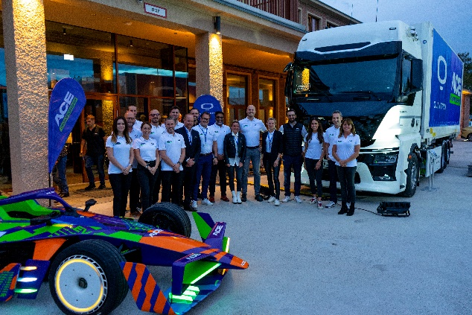 | ACE Championship & QUANTRON Partnership
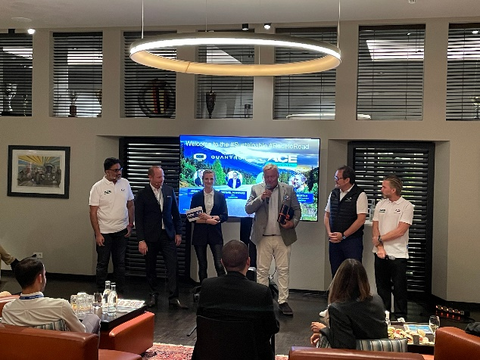 | ACE Championship & QUANTRON Partnership Presentation  From left: Dilbagh Gill (Founder & CEO ACE), Andreas Haller (Founder & Executive Chairman QUANTRON), Sara Friedrich (Event Manager QUANTRON), Christoph Walther (President Drivers & Business Club), Michael Perschke (CEO QUANTRON), Nick Heidfeld (Developement Driver ACE)
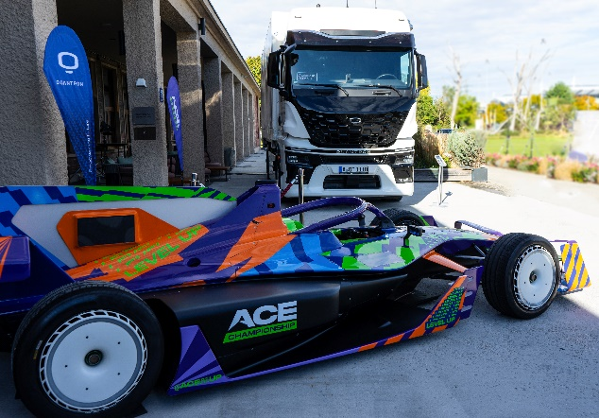 | Fully electric ACE race vehicle & H2 powered QUANTRON QHM FCEV AERO
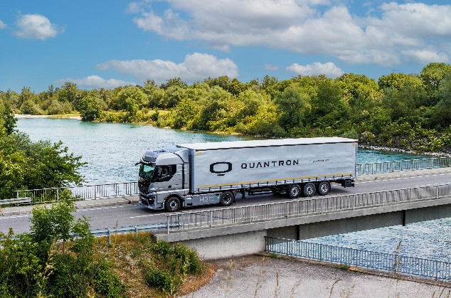 | Hydrogen-electric QUANTRON QHM FCEV AERO

Technical Data QUANTRON QHM FCEV AERO
Max. e-axle power cont. / peak | 420 / 550 kW
Range simulated | >700 km
Fuell cell power | 240 kW
Battery capacity | 124 kWh
H2-capacity | 54 kg

You can find the original images in both high and low resolutions here: Press releases from Quantron AG (https://www.quantron.net/en/q-news/press-releases/)
About Quantron AG
Quantron AG is a platform provider and specialist for sustainable mobility for people and goods; in particular for trucks, buses and vans with fully electric powertrains and H₂ fuel cell technology. As a high-tech spinoff of the renowned Haller GmbH, the German company from Augsburg in Bavaria combines over 140 years of commercial vehicle experience with state-of-the-art e-mobility know-how and positions itself globally as a partner to existing OEMs.
With the Quantron-as-a-Service Ecosystem (QaaS), QUANTRON offers an overall concept that covers all facets of the mobility value chain: QUANTRON INSIDE includes a wide range of both new vehicles and conversions for existing and used vehicles from diesel to battery and hydrogen electric powertrains using the highly innovative QUANTRON INSIDE technology. QUANTRON CUSTOMER SOLUTIONS ensures digital and physical aftersales solutions with a Europe-wide network of 700 service partners, as well as a service offering for maintenance, repair and spare parts, telematics and in-cloud solutions for remote diagnostics and fleet management. Customers receive individual solutions: rental, financing and leasing offers such as training courses and workshops at the QUANTRON Academy. In the future, QUANTRON ENERGY & POWER STATION will realize the production of green hydrogen and electricity as a platform. To this end, Quantron AG has joined forces with strong global partners. This Clean Transportation Alliance also forms an important building block for the supply of vehicles with the necessary green charging and H₂ refueling infrastructure.
QUANTRON stands for the core values Reliable, Energetic, Brave. The team of experts at the innovation driver for e-mobility is making a significant contribution to sustainable, environmentally friendly passenger and freight transport. You can find more information at www.quantron.net
Visit the Quantron AG on its social media channels on LinkedIn and YouTube.

Your contact:
Jörg Zwilling, Director Global Communications & Business Development Quantron AG, j.zwilling@quantron.net
Stephanie Miller, Marketing & Communications Quantron AG, press@quantron.net

