PRESS RELEASE November 13th, 2023
Oilinvest and QUANTRON accelerate deployment of fuel cell commercial vehicles and expand Hydrogen-based ecosystem
Oilinvest and Quantron AG have signed a strategic partnership agreement to build hydrogen-based refueling infrastructure to supply Fuel Cell Electric heavy trucks (FCEV). The partnership gave way to a new joint venture named HEMTRON, which is based in Hamburg, Germany, to help accelerate the decarbonisation of road freight in Europe.
Oilinvest subsidiaries operate around 2,450 filling stations under the Tamoil brand in Europe including Italy, the Netherlands, Spain, Switzerland, and the HEM brand in filling stations in Germany. Together with third party and newly established (greenfield) locations, this extensive network provides a foundation for the proliferation of zero-emission fuel cell electric vehicles. Starting in Germany, HEMTRON is tasked to secure consistent growth and supply of hydrogen refueling stations at customer-oriented locations near transportation hubs such as logistics centers and highways.
“Through this strategic partnership with QUANTRON, we aim to offer our customers a commercially viable solution and reduce carbon emissions with green hydrogen as an alternative to diesel for commercial road transport”, said Ahmed Elkerrami, Chief Executive Officer of Oilinvest Group. He added, “We aim to aggregate our initiatives that secure an increase in non-fossil fuels projects. This partnership will support our strategy to become a net-zero company by 2050 and we look forward to include more partners to join this Hydrogen Fuelling Alliance”.
Michael Perschke, CEO of Quantron AG on QUANTRON's Hydrogen Offensive said, “Green hydrogen will be a key energy carrier of the future to accelerate the decarbonization especially in heavy duty trucking. With the help of Oilinvest's fuel retailing expertise and refueling station network, we are creating a foundation for our customers to switch from diesel to zero-emission FCEV vehicles. Due to our current first mover advantage in range and power in the 44t sector as well as our QLI FCEV, which have already started delivering, we now also want to be a first mover in dedicated H2 fueling infrastructure, dedicated to the needs of light as well as heavy duty trucks. HEMTRON is also an integral part of our Quantron-as-a-Service offering. We can envision becoming the IONITY of H2 Fueling with our partners such as Heavy Duty OEMs, Hydrogen producers and other stakeholder. Our venture is set-up to be an open platform and we invite other truck OEMs, energy companies and also other Oil & HRS network partner to join in an open H2 Roaming Alliance.”
Andreas Haller, founder and Executive Chairman of Quantron AG, said, “We want to make a breakthrough in hydrogen as an energy carrier for heavy-duty transport. That's why we want to actively engage partners – be it other oil and energy companies, technology partners or even other fuel cell truck manufacturers – we need critical mass and this joint venture is a milestone.”
Both QUANTRON and Oilinvest are founding members of an alliance to expand Europewide hydrogen refueling infrastructure, enabling widespread adoption of environmentally friendly FCEV vehicles.
Images (Please click on the image preview to download):
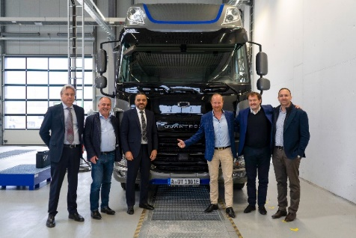 | From left: David Pezzulli, (Managing Director of Mesientos), Herbert Robel (CHRO & Co-Founder Quantron AG), Ahmed Elkerrami (CEO Oilinvest Group), Andreas Haller (Founder & Executive Chairman Quantron AG), Michael Perschke (CEO Quantron AG), Timothy Sullivan (Business Liaison Officer at OBV).
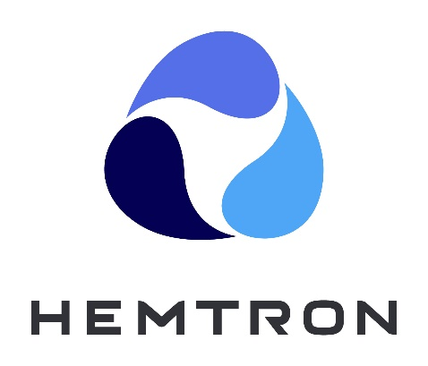 | HEMTRON logo
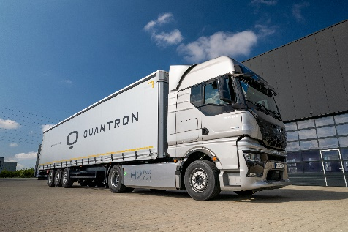 | Hydrogen-electric QUANTRON QHM FCEV AERO

You can find the original images in high and low resolution here: Press releases from Quantron AG (https://www.quantron.net/en/q-news/press-releases/)
Further information about HEMTRON can be found in this video (https://youtu.be/FkBQdtN1Js8).
About Quantron AG
Quantron AG is a platform provider and specialist for sustainable mobility for people and goods; in particular for trucks, buses and vans with fully electric powertrains and H₂ fuel cell technology. As a high-tech spinoff of the renowned Haller GmbH, the German company from Augsburg in Bavaria combines over 140 years of commercial vehicle experience with state-of-the-art e-mobility know-how and positions itself globally as a partner to existing OEMs.
With the Quantron-as-a-Service Ecosystem (QaaS), QUANTRON offers an overall concept that covers all facets of the mobility value chain: QUANTRON INSIDE includes a wide range of both new vehicles and conversions for existing and used vehicles from diesel to battery and hydrogen electric powertrains using the highly innovative QUANTRON INSIDE technology. QUANTRON CUSTOMER SOLUTIONS ensures digital and physical aftersales solutions with a Europe-wide network of 700 service partners, as well as a service offering for maintenance, repair and spare parts, telematics and in-cloud solutions for remote diagnostics and fleet management. Customers receive individual solutions: rental, financing and leasing offers such as training courses and workshops at the QUANTRON Academy. In the future, QUANTRON ENERGY & POWER STATION will realize the production of green hydrogen and electricity as a platform. To this end, Quantron AG has joined forces with strong global partners. This Clean Transportation Alliance also forms an important building block for the supply of vehicles with the necessary green charging and H₂ refueling infrastructure.
QUANTRON stands for the core values Reliable, Energetic, Brave. The team of experts at the innovation driver for e-mobility is making a significant contribution to sustainable, environmentally friendly passenger and freight transport. You can find more information at www.quantron.net
Visit the Quantron AG on its social media channels on LinkedIn and YouTube.

About Oilinvest
The Oilinvest Group is a major player in the European downstream oil industry. Playing a vital role at every stage of the value chain, our two main brands Tamoil and HEM employ around 1000 people, sell in excess of 10 million tons of fuel products every year and generate an annual gross turnover of €12.7 billion. Our head office is at The Hague, the Netherlands. For more information visit: www.oilinvest.com

Your contact:
Jörg Zwilling, Director Global Communications & Business Development, j.zwilling@quantron.net
Stephanie Miller, Marketing & Communications Quantron AG, press@quantron.net

