PRESS RELEASE November 23, 2023

QUANTRON Fuel Cell development and delivery gain market traction and first QUANTRON QLI FCEV in customer hands with IKEA Austria – 10 months of a successful journey of QUANTRON’s Hydrogen Offensive

- From January to October 2023, QUANTRON AG recorded more than 70 orders with a value of 30.5 million Euro. The offer volume amounts to over 3,000 units with a value of over 987 million Euro.
- Over 40 units were delivered in the DACH region, including the world's first five hydrogen-powered QUANTRON QLI FCEV to IKEA Austria
- QUANTRON is entering the Middle East with the delivery of 50 QUANTRON QARGO 4 EV – the largest fleet of emission-free transporters ever – to Saudi Arabia
- Oilinvest and QUANTRON have formed a joint venture called HEMTRON to set up an extensive hydrogen sourcing & refueling network throughout Europe as an industry first
- QUANTRON has been selected by Ford Trucks International, as the lead development partner for a fuel cell 44 tonne truck – using the Quantron Inside H2 components
- QUANTRON collaborates with a new business partner in Poland
- The development and delivery of QHM FCEV got delayed due to supply-chain challenges

Quantron AG, specialist in sustainable passenger and freight transport, proudly reflects on the past ten months. From January to October 2023, over 3000 quotations worth 987 million Euro were generated by the company. During this period, the company secured more than 70 orders worth over 30.5 million Euro.
Vehicle delivery milestones: From Europe to the Middle East
In 2023, over 90 vehicles have been delivered so far, including more than 40 vehicles in the DACH-region. A significant milestone among them is the delivery of five hydrogen fuel cell vehicles to IKEA Austria. The light transporters of the QUANTRON QLI FCEV model are the world's first hydrogen-powered vehicles to be used for IKEA. The Swedish company has announced its intention to expand its hydrogen fleet to a total of 40 vehicles by 2025 in the Austrian market.
Along with the European market, QUANTRON has achieved success in the Middle East. Collaborating with the Petromin Corporation (the parent company of QUANTRON partner Electromin), QUANTRON has realized the largest deployment of emission-free trucks in the Kingdom of Saudi Arabia. A total of 50 QUANTRON QARGO 4 EV trucks have been delivered. These vehicles will be used by strategic customers such as PepsiCo and Red Sea Global.
“The trust of major customers like IKEA Austria in QUANTRON demonstrates that we are on the right path. For two years, we have been assisting the company in achieving its decarbonization goals with our battery and now hydrogen-electric vehicles”, said Andreas Haller, founder and Executive Chairman of QUANTRON AG. “We are also very proud to be gaining recognition outside of Europe, allowing us to execute our first delivery in Saudi Arabia. For the coming year, we plan to further expand our position as a global market leader.”
Expansion of the H2 ecosystem: HEMTRON
Oilinvest, a prominent player in the fuel retailing industry, has joined forces with Quantron AG, to build a joint venture called HEMTRON to set up a hydrogen-based refueling network
Oilinvest operates more than 2,450 Tamoil refuelling stations throughout Europe and represented by the HEM brand in Germany. HEMTRON will utilize this extensive service station network to ensure the availability of hydrogen filling stations at customer-oriented locations close to transportation hubs such as logistics centers and highways.
The joint venture is not limited to QUANTRON and Oilinvest but is an open platform in which other automotive OEMs, energy companies and manufacturers of fuel cell trucks can also participate. Together, we want to establish a nationwide infrastructure for hydrogen refueling throughout Europe.
Signed LOI with Ford Trucks
Quantron AG and Ford Trucks have signed a letter of intent for the development of heavy commercial vehicles with fuel cell drive. The innovative Quantron Inside technology will be integrated into Ford Trucks vehicles. In the first phase of the collaboration, QUANTRON will ensure a seamless adaptation of Ford's advanced trucks, which will be built in compliance with new safety regulations from the first quarter of 2024.
New business partner in Poland
As part of its expansion strategy, Quantron AG is cooperating in Poland with an outstanding team that shares its vision for clean and environmentally friendly transportation solutions.
Quantron Polska intends to launch a variety of vehicles on the Polish market in the coming year, including trucks, buses and vans with both hydrogen and battery electric drive systems.
Looking ahead to the new year: “Time to Deliver”
Michael Perschke, CEO of Quantron AG, stated: “The year 2023 was so far on the one hand side great as we entered new markets and started delivering our first fuel cell products and yet at the same time, we also had to resolve many challenges as ‘trailblazer’ being it our fuel cell products with many industry first. This was only possible due to a strong team inside QUANTRON and our partner & investor network and that is what made us achieve great results.”
In 2024, QUANTRON will embark on the next significant phase of its strategic development. The new year will witness the tangible realization of QUANTRON's vision, as even more of their zero-emission vehicles will hit the road, reaffirming the company's dedication to making a sustainable impact on the environment.
Supply chain challenges on fuel cell components
As a trailblazer, QUANTRON is one of the first to use various fuel cell technologies, tanks and other components. As some of QUANTRON’s suppliers are themselves in a ramp-up, the initial deliveries of the QUANTRON QHM FCEV got delayed and part of its fourth-quarter turnover for 2023 will be carried over into the first quarter of 2024.

Images (Please click on the image preview to download):
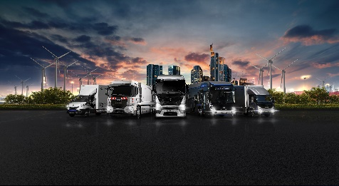 | QUANTRON Portfolio including full range of FCEV and BEV commercial vehicles
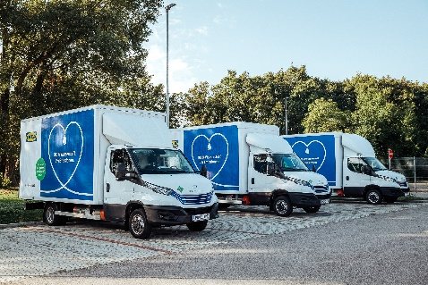 | QUANTRON QLI FCEV hydrogen powered trucks operating for IKEA
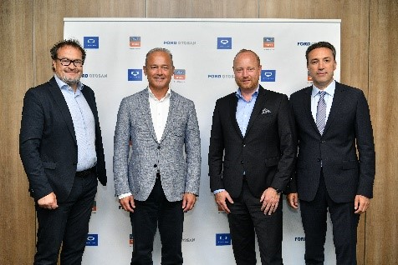 | From left: Michael Perschke (CEO Quantron AG), Güven Özyurt (CEO Ford Otosan), Andreas Haller (Founder & Executive Chairman Quantron AG) and Emrah Duman (Ford Trucks Business Area Leader)
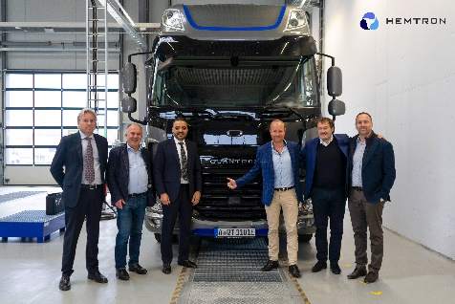 | From left: David Pezzulli, (Managing Director of Mesientos), Herbert Robel (CHRO & Co-Founder Quantron AG), Ahmed Elkerrami (CEO Oilinvest Group), Andreas Haller (Founder & Executive Chairman Quantron AG), Michael Perschke (CEO Quantron AG), Timothy Sullivan (Business Liaison Officer at OBV)
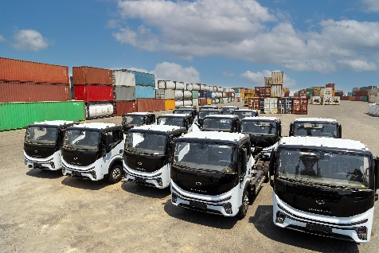 | QUANTRON QARGO 4 EV fleet in the Kingdom of Saudi Arabia
You can find the original images in both high and low resolutions here: Press releases from Quantron AG (https://www.quantron.net/en/q-news/press-releases/)

About Quantron AG
Quantron AG is a platform provider and specialist for sustainable transportation of people and goods; in particular for trucks, buses and vans with fully electric powertrains and H₂ fuel cell technology. As a high-tech spinoff of the renowned Haller GmbH, the German company from Augsburg in Bavaria combines over 140 years of commercial vehicle experience with state-of-the-art e-mobility know-how and positions itself globally as a partner to existing OEMs.
With the Quantron-as-a-Service Ecosystem (QaaS), QUANTRON offers an overall concept that covers all facets of the mobility value chain: QUANTRON INSIDE includes a wide range of both new vehicles and conversions for existing and used vehicles from diesel to battery and hydrogen electric powertrains using the highly innovative QUANTRON INSIDE technology. QUANTRON CUSTOMER SOLUTIONS ensures digital and physical aftersales solutions with a Europe-wide network of 700 service partners, as well as a service offering for maintenance, repair and spare parts, telematics and in-cloud solutions for remote diagnostics and fleet management. Customers receive individual solutions: rental, financing and leasing offers such as training courses and workshops at the QUANTRON Academy. In the future, QUANTRON ENERGY & POWER STATION will realize the production and distribution of green hydrogen and electricity as a platform. To this end, Quantron AG has joined forces with strong global partners. This Clean Transportation Alliance also forms an important building block for the supply of vehicles with the necessary green charging and H₂ refueling infrastructure.
QUANTRON stands for the core values Reliable, Energetic, Brave. The team of experts at the innovation driver for e-mobility is making a significant contribution to sustainable, environmentally friendly passenger and freight transport. You can find more information at www.quantron.net
Visit the Quantron AG on its social media channels on LinkedIn and YouTube.
Your contact:
Jörg Zwilling, Director Global Communications & Business Development Quantron AG, j.zwilling@quantron.net
Stephanie Miller, Marketing & Communications Quantron AG, press@quantron.net

