PRESS RELEASE – Web Summit 2023 Announcements November 15th, 2023
Building a Hydrogen Ecosystem – or how to address the “Chicken & Egg problem” in the H2 Economy with Quantron AG as European trailblazer and open system partner
- Quantron AG is currently leading the H2 powered Fuel Cell Light & Heavy Truck Development with both its QUANTRON QHM FCEV and QUANTRON QLI FCEV which is being already delivered to clients in Europe such as IKEA and confirming QUANTRON’s first mover position
- Moving from a “pure hardware play” to an ecosystem developer Quantron AG announced a H2 Fueling joint venture with an European leading petrol station network operator. During Web Summit 2023, QUANTRON gives an update on its MaaS platform ROQIT
- Michael Perschke (CEO of Quantron AG) is scheduled to speak on November 16th
- QUANTRON's active participation at Web Summit 2023 underscores the Clean Tech Company's dedication to leading the way in digital innovation within the transportation sector also announcing its strategic partners and potential investors in its ROQIT venture

Quantron AG, specialist in sustainable passenger and freight transport, shares the latest developments regarding its digital platform, ROQIT.
Quantron AG is very comfortable in the future of the H2 powered fuel cell truck space. Recently, QUANTRON announced its participation in HEMTRON, the H2 joint venture with Oilinvest, a leading provider of refueling stations in Europe, to build an H2 refueling station infrastructure for the supply of fuel cell electric heavy vehicles (FCEV).
For the H2 economy to succeed in Europe, QUANTRON’s approach with its strategic investors such as Ballard Power Systems (NASDAQ: BLDP) and NEUMAN & ESSER is building a H2 ecosystem to address the “chicken and egg problem”. Only the combination of upstream production of green H2, the supply chain and dispensing infrastructure and market-oriented FCEV trucks and busses will allow an acceleration in the adoption of H2 as an energy carrier in Europe.
In context of the Web Summit 2023 in Lisbon, where QUANTRON's CEO, Michael Perschke, will be on stage on November 16th, a few breaking news will be presented. Focus will be on the key three pillars of Quantron AG’s strategy as well as breaking some global news on its venture ROQIT together with the Indian listed partner Goldstone Technologies Ltd. (GTL).
Through this formidable partnership, ROQIT sets its sights on the projected $70 Billion Fleet Management market by 2032, in alignment with the anticipated $320 Billion global investments in the Hydrogen Economy markets by 2030. Leveraging the abundant resources of the Indian tech ecosystem ROQIT’s MVP will be presented to pilot clients in Q4 - 2023.
A World of Opportunities
With the emergence of the Digital Solution, ROQIT aims to address the 150-250 billion Euro global market for OEM-agnostic Mobility as a Service (MaaS) Solutions by 2030. The global investment in clean energy has surged to 1750 billion USD in 2023, with a remarkable 1.8 USD invested in clean energy for every 1 USD in fossil fuels.
Unlocking the Potential: Development of a Technology Ecosystem and Services Matching Platform
ROQIT, the joint venture between QUANTRON, and GTL, has a clear objective in mind, with Europe, US, the Middle East, and India as focused markets to begin with in 2024.
This groundbreaking platform offers an array of features and services tailored for Fleet Operating Companies, Logistics Companies, and Automobile Companies in the EV and hydrogen mobility sectors – OEM agnostic and with focus on zero emission requirements.
Distribution, Sale, and Commercialization of Software
The partnership will see the commercialization of fleet software solutions as white-label offerings to third parties, further expanding the reach of these transformative technologies, based on an open API architecture to allow collaborative solutions with other industry solutions providers, be it from the energy and charging /fueling sector, fleet and map providers all the way down to tire and downstream service providers.
Michael Perschke, CEO of Quantron AG, explains: “ROQIT exemplifies QUANTRON's commitment to synergy between its class leading fuel cell powered hardware solutions such as its Light & Heavy trucks and the seamless integration of state-of-the-art technology. The transport and supply chain industry is facing today similar challenges as the print and retail sector when we saw the first eCommerce players embracing Amazon and Salesforce to digitize their business processes. We as Quantron AG and ROQIT want to be a catalyzing partner in this transformation and support brands and logistic providers to embrace zero emission and decarbonization as an opportunity rather than a threat.“

Images (Please click on the image preview to download):
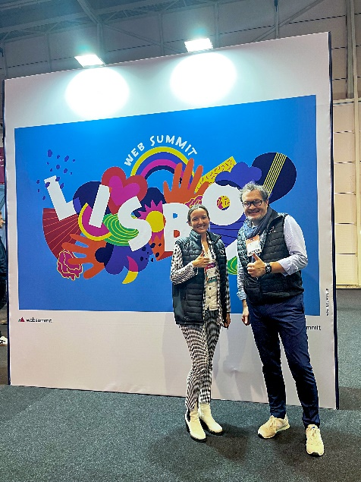 | Lisa Schuler-Liepert (Team Lead Investor Relations & Funding Quantron AG) and Michael Perschke (CEO Quantron AG) at Web Summit 2023 in Lisbon
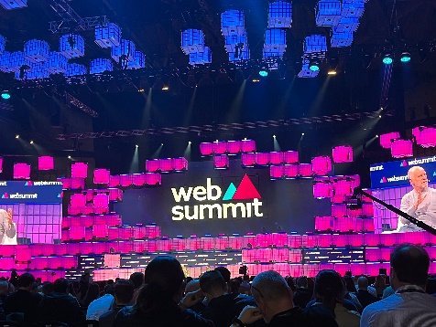 | Web Summit 2023 in Lisbon

You can find the original images in both high and low resolutions here: Press releases from Quantron AG (https://www.quantron.net/en/q-news/press-releases/)

About Quantron AG
Quantron AG is a platform provider and specialist for sustainable transportation of people and goods; in particular for trucks, buses and vans with fully electric powertrains and H₂ fuel cell technology. As a high-tech spinoff of the renowned Haller GmbH, the German company from Augsburg in Bavaria combines over 140 years of commercial vehicle experience with state-of-the-art e-mobility know-how and positions itself globally as a partner to existing OEMs.
With the Quantron-as-a-Service Ecosystem (QaaS), QUANTRON offers an overall concept that covers all facets of the mobility value chain: QUANTRON INSIDE includes a wide range of both new vehicles and conversions for existing and used vehicles from diesel to battery and hydrogen electric powertrains using the highly innovative QUANTRON INSIDE technology. QUANTRON CUSTOMER SOLUTIONS ensures digital and physical aftersales solutions with a Europe-wide network of 700 service partners, as well as a service offering for maintenance, repair and spare parts, telematics and in-cloud solutions for remote diagnostics and fleet management. Customers receive individual solutions: rental, financing and leasing offers such as training courses and workshops at the QUANTRON Academy. In the future, QUANTRON ENERGY & POWER STATION will realize the production and distribution of green hydrogen and electricity as a platform. To this end, Quantron AG has joined forces with strong global partners. This Clean Transportation Alliance also forms an important building block for the supply of vehicles with the necessary green charging and H₂ refueling infrastructure.
QUANTRON stands for the core values Reliable, Energetic, Brave. The team of experts at the innovation driver for e-mobility is making a significant contribution to sustainable, environmentally friendly passenger and freight transport. You can find more information at www.quantron.net
Visit the Quantron AG on its social media channels on LinkedIn and YouTube.
Your contact:
Jörg Zwilling, Director Global Communications & Business Development Quantron AG, j.zwilling@quantron.net
Stephanie Miller, Marketing & Communications Quantron AG, press@quantron.net

