PRESS RELEASE November 2nd, 2023
QUANTRON and Ford Trucks sign LOI for joint development opportunity of H2 vehicles with Quantron Inside technology
- Clean Tech Company Quantron AG and Ford Trucks, the global brand of the heavy commercial vehicle industry, have signed a Letter of Intent (LOI).
- The highly innovative Quantron Inside technology will be evaluated for integration into Ford Trucks’ vehicles to enable emission-free transport solutions. The close technical collaboration aims to accelerate the market introduction of H2 fuel cell trucks based on a FORD F-Max

Quantron AG, a specialist in sustainable passenger and freight transport, and Ford Trucks, the global brand of the heavy commercial vehicle industry, have jointly signed a Letter of Intent (LOI). Within this strategic cooperation, the Quantron Inside technology effective range, innovative e-axle, customized high-power battery, fuel cell and tank integration, unparalleled energy-management and optimized Aerodynamics for maximized efficiency will be evaluated for integration into Ford Trucks’ vehicles, thus enabling emission-free transport solutions. The focus of the collaboration lies in hydrogen fuel cell-powered heavy-duty trucks.
Through the 1st phase of collaboration with Ford Trucks, QUANTRON ensures a seamless adaptation of Ford´s advanced trucks which will be built in compliance with the new security regulations as soon as from Q1, 2024.
Ford Trucks and QUANTRON collaboration opportunity can be defined as vast experience in integrating zero emission drivetrain solutions in commercial vehicles. QUANTRON has already delivered more than 200 vehicles - which are all zero emission. While the majority of these are battery-electric vehicles, QUANTRON built expertise in fuel cell electric vehicles too.
Michael Perschke, CEO of Quantron AG, states: "Partnering with a renowned vehicle manufacturer like Ford Trucks enhances QUANTRON's position as an innovation leader in the field of sustainable transport solutions and being a partner for established Commercial Vehicle OEMs”.
Rene Wollmann, CTO of Quantron AG states further: “Our partners want to accelerate their development of Fuel Cell powered trucks while focusing their own resources on other areas. We are benchmarking the FCEV light vehicle segment up to 7,5t, and in the FCEV heavy-duty segment up to 44t whereas we deliver our uncompromising and unique Quantron Inside technology & components. Our close technical collaboration will contribute to further accelerating the widespread market introduction of fuel cell-electric commercial vehicles."
Ford Trucks Leader Emrah Duman, states “We are excited to have QUANTRON's support as a seasoned partner in our endeavor to offer a fuel-cell electric heavy-duty truck to our customers. This collaboration promises to yield substantial value in the times ahead. Ford Trucks is committed to investing in innovative technologies that will shape the future of the heavy commercial vehicle industry while aligning with our sustainability goals. Our primary focus is on electrification, closely followed by advancements in hydrogen technology. With a diverse pool of promising technological talents and capabilities, our efforts are making rapid and successful strides.’’
The partnership solidifies QUANTRON's strong position as a pioneer in sustainable mobility and underscores both companies' commitment to a greener future in the transportation sector.
As such, Ford Trucks is committed to achieving zero emissions in heavy commercial vehicle production by 2040 to mitigate the effects of climate change.
QUANTRON will be able to further diversify its range of environmentally friendly mobility solutions through the jointly developed vehicles, thus meeting the growing demand.

You can find the original images in both high and low resolutions here: Press releases from Quantron AG (https://www.quantron.net/en/q-news/press-releases/)
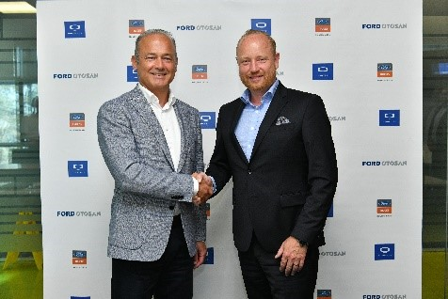 | QUANTRON and Ford Trucks collaboration: Güven Özyurt, CEO Ford Otosan and Andreas Haller, Founder and Executive Chairman Quantron AG
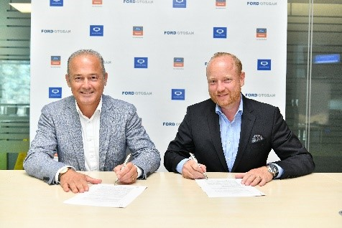 | LOI signing: Güven Özyurt CEO Ford Otosan, and Andreas Haller, Founder and Executive Chairman Quantron AG
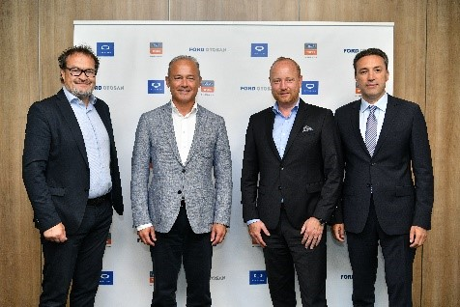 | From left: Michael Perschke (CEO Quantron AG), Güven Özyurt (CEO Ford Otosan), Andreas Haller (Founder & Executive Chairman Quantron AG) and Emrah Duman (Ford Trucks Business Area Leader)

About Quantron AG
Quantron AG is a platform provider and specialist for sustainable transportation of people and goods; in particular for trucks, buses and vans with fully electric powertrains and H₂ fuel cell technology. As a high-tech spinoff of the renowned Haller GmbH, the German company from Augsburg in Bavaria combines over 140 years of commercial vehicle experience with state-of-the-art e-mobility know-how and positions itself globally as a partner to existing OEMs.
With the Quantron-as-a-Service Ecosystem (QaaS), QUANTRON offers an overall concept that covers all facets of the mobility value chain: QUANTRON INSIDE includes a wide range of both new vehicles and conversions for existing and used vehicles from diesel to battery and hydrogen electric powertrains using the highly innovative QUANTRON INSIDE technology. QUANTRON CUSTOMER SOLUTIONS ensures digital and physical aftersales solutions with a Europe-wide network of 700 service partners, as well as a service offering for maintenance, repair and spare parts, telematics and in-cloud solutions for remote diagnostics and fleet management. Customers receive individual solutions: rental, financing and leasing offers such as training courses and workshops at the QUANTRON Academy. In the future, QUANTRON ENERGY & POWER STATION will realize the production and distribution of green hydrogen and electricity as a platform. To this end, Quantron AG has joined forces with strong global partners. This Clean Transportation Alliance also forms an important building block for the supply of vehicles with the necessary green charging and H₂ refueling infrastructure.
QUANTRON stands for the core values Reliable, Energetic, Brave. The team of experts at the innovation driver for e-mobility is making a significant contribution to sustainable, environmentally friendly passenger and freight transport. You can find more information at www.quantron.net
Visit the Quantron AG on its social media channels on LinkedIn and YouTube.

About Ford Trucks:
Ford’s only heavy commercial brand, Ford Trucks produce a range of vehicles including tractors, construction trucks and distribution trucks weighing over 16 tons. Our ‘2019 International Truck of the Year (IToY)’ award-winning F-MAX has brought critical acclaim and high global demand. Ford commercial vehicles’ proven track record of quality, durability and efficiency underpins Ford Trucks’ international product strategy based on the best total cost of ownership promise. At Ford Trucks, we combine more than half a century of design and production experience with expertise in market-specific product development, to engineer the main components of our vehicles, including the all-new engines. We currently operate across Europe, the Middle East, Africa and the CIS, and continue to grow our international network in 3 continents. Hundreds of thousands of trucks all around the world set out each and every day with the confidence that Ford provides. For more information about Ford Trucks and its products worldwide, please visit www.fordtrucksglobal.com.

Your contact:
Jörg Zwilling, Director Global Communications & Business Development Quantron AG, j.zwilling@quantron.net
Stephanie Miller, Marketing & Communications Quantron AG, press@quantron.net
Gökçe Demirel, Ford Otosan Corporate Brand Leader, gdemire3@ford.com.tr

