PRESS RELEASE December 5th, 2023
QUANTRON QHM FCEV AERO complements holistic hydrogen ecosystem with newly opened H2 filling station in Neumünster
- Quantron AG ensures with its trucks the uptake of hydrogen at the H2 filling station opened by Hypion GmbH in Neumünster
- A total of five QUANTRON QHM FCEV AEROs will be supplied for this ecosystem
- The hydrogen-electric truck impresses with a long range of up to 700 km

Last Thursday, Hypion GmbH opened an H2 filling station in Neumünster specially optimized for heavy commercial vehicles. Quantron AG, a specialist in sustainable passenger and freight transportation, provided a hydrogen-powered QUANTRON QHM FCEV AERO truck as a symbol of the self-contained H2 ecosystem at the inauguration. The clean tech company will deliver five of these vehicles to local customers, contributing to the first continuous off-take of hydrogen at this location.
A switch to environmentally friendly fuel cell vehicles can only be successful by implementing holistic ecosystems along the hydrogen value chain. The filling station is the first AFIR-compliant (AFIR - Alternative Fuel Infrastructure Regulation) hydrogen filling station in Europe with a refuelling capacity of 2000kg per day. Its opening at a logistical hub will ensure the supply of hydrogen, while QUANTRON ensures the uptake of hydrogen by local fleet operators by providing the vehicles.
"The QUANTRON QHM FCEV AERO, with its very high range, is a pioneer in the field of heavy, environmentally friendly transport solutions," says Andreas Haller, Founder and Executive Chairman of Quantron AG. "We are proud to contribute these vehicles as an essential element of the H2 ecosystem."
Dr. Stefan Rehm, Managing Director Hypion, adds: “Heavy commercial vehicles in particular play a decisive role in the development of integrated hydrogen systems in the mobility sector. With their help, the necessary market activation and decarbonization of road transport with zero-emission vehicles can be achieved.”
With a range of up to 700 km, the QUANTRON QHM FCEV AERO is the leader in emission-free heavy-duty transportation over long distances. The 54kg hydrogen tanks are fully integrated into the chassis. In addition, H2 consumption is optimized by a specially developed intelligent Q-ENERGY management system. This achieves maximum efficiency in the interaction between the electric axle, fuel cell, high-voltage battery and HV auxiliary consumers.

Images (Please click on the image preview to download):
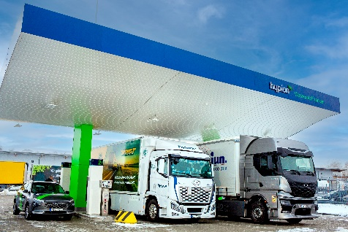 | H2 vehicles at the Hypion filling station in Neumünster
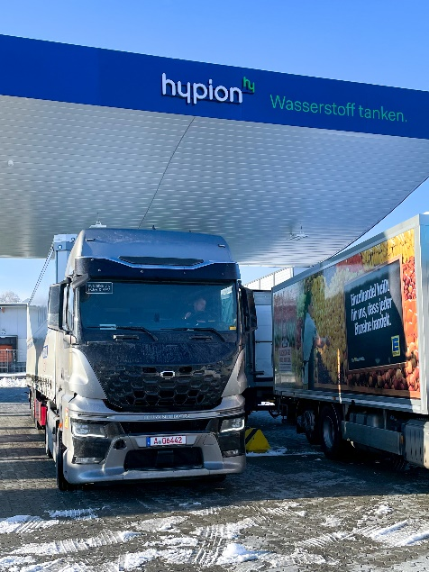 | QUANTRNO QHM FCEV AERO at the Hypion filling station in Neumünster
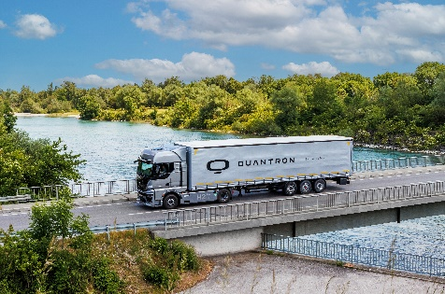 | QUANTRON QHM FCEV AERO

You can find the original images in both high and low resolutions here: Press releases from Quantron AG (https://www.quantron.net/en/q-news/press-releases/)
About Quantron AG
Quantron AG is a platform provider and specialist for sustainable transportation of people and goods; in particular for trucks, buses and vans with fully electric powertrains and H₂ fuel cell technology. As a high-tech spinoff of the renowned Haller GmbH, the German company from Augsburg in Bavaria combines over 140 years of commercial vehicle experience with state-of-the-art e-mobility know-how and positions itself globally as a partner to existing OEMs.
With the Quantron-as-a-Service Ecosystem (QaaS), QUANTRON offers an overall concept that covers all facets of the mobility value chain: QUANTRON INSIDE includes a wide range of both new vehicles and conversions for existing and used vehicles from diesel to battery and hydrogen electric powertrains using the highly innovative QUANTRON INSIDE technology. QUANTRON CUSTOMER SOLUTIONS ensures digital and physical aftersales solutions with a Europe-wide network of 700 service partners, as well as a service offering for maintenance, repair and spare parts, telematics and in-cloud solutions for remote diagnostics and fleet management. Customers receive individual solutions: rental, financing and leasing offers such as training courses and workshops at the QUANTRON Academy. In the future, QUANTRON ENERGY & POWER STATION will realize the production and distribution of green hydrogen and electricity as a platform. To this end, Quantron AG has joined forces with strong global partners. This Clean Transportation Alliance also forms an important building block for the supply of vehicles with the necessary green charging and H₂ refueling infrastructure.
QUANTRON stands for the core values Reliable, Energetic, Brave. The team of experts at the innovation driver for e-mobility is making a significant contribution to sustainable, environmentally friendly passenger and freight transport. You can find more information at www.quantron.net
Visit the Quantron AG on its social media channels on LinkedIn and YouTube.
Your contact:
Jörg Zwilling, Director Global Communications & Business Development Quantron AG, j.zwilling@quantron.net
Stephanie Miller, Marketing & Communications Quantron AG, press@quantron.net

