PRESS RELEASE December 7th, 2023
Green mobility in action: QUANTRON QLI FCEV launches at hylane
- At the hylane press conference on December 7, the first QUANTRON QLI FCEV was symbolically handed over to hylane. The event marked the one-year anniversary of the first fuel cell truck being in operation on German roads via the hylane rental model
- So far, hylane has ordered ten light trucks with fuel cell technology from QUANTRON
- The vehicles are offered to customers by hylane in a pay-per-use model. The first customer for the QUANTRON QLI FCEVs is a company in North Rhine-Westphalia, Germany

At the press conference of hylane, a subsidiary of DEVK Versicherungen, a zero-emission light truck with fuel cell technology from the specialist for sustainable passenger and freight transportation, Quantron AG, was symbolically handed over. The vehicle marks the start of a partnership to decarbonize the last mile. hylane is planning a fleet of zero-emission QUANTRON transporters that will be rented out on a pay-per-use model. The first customer for the QUANTRON QLI FCEV vehicles is a company from North Rhine-Westphalia, Germany, which will use the transporters for last-mile deliveries.
The QUANTRON QLI FCEV is the first fuel cell vehicle in the 5t class on the German market. Equipped with a 45kW fuel cell from QUANTRON's technology partner Ballard Power Systems and a 150kW electric motor, the vehicle offers an impressive range of up to 450 kilometers with a tank capacity of 8.2kg of hydrogen. The refueling time is only about 10 minutes. The hydrogen-powered vehicles are specifically designed for use in regions with insufficient charging infrastructure, where battery electric vehicles are impractical due to their limited range.
The zero-emission properties of the QUANTRON QLI FCEV allow it to be exempt from tolls in Germany, unlike diesel vehicles over 3.5 tons, which will be subject to tolls from July 2024.
Sara Schiffer, Managing Director of hylane: “With the hydrogen transporters from QUANTRON, we are adding vehicles to our fleet that have been specifically designed for use on the 'last mile'. We are convinced that fuel cell technology is ideally suited to meeting the key challenges of urban transportation: The low noise pollution of the transporters will help to make our cities quieter and more livable. Furthermore, the speed of the refueling process is invaluable for our users and their operations. We are also impressed by the weight efficiency of QUANTRON vehicles, which not only improves range but also maximizes payload. This is a key advantage for 'last mile' deliveries, where flexibility and efficiency are top priorities.”
Andreas Haller, founder and Executive Chairman of Quantron AG: “We are very pleased about the partnership. hylane and QUANTRON are united by our commitment to innovative transportation solutions. With the use of the hydrogen-electric QUANTRON QLI FCEV, we are pioneering emission-free freight transportation on the last mile. However, the demand for emission-free solutions is also increasing in the heavy commercial vehicle sector. Hydrogen is an attractive alternative due to its short refueling times and long ranges. hylane and QUANTRON are therefore exploring further cooperation in the heavy truck sector."

Images (Please click on the image preview to download):
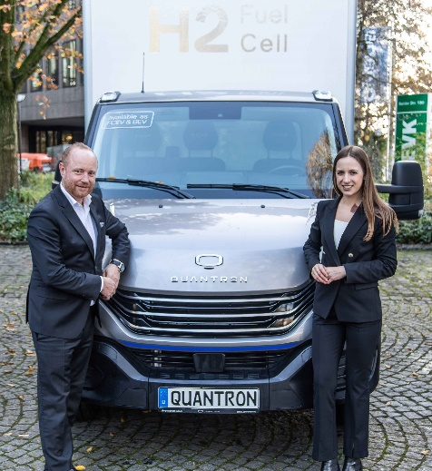 | Andreas Haller, founder and Executive Chairman QUANTRON, and Sara Schiffer, Managing Director hylane, in front of the QUANTRON QLI FCEV
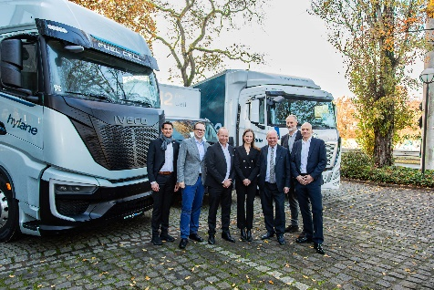 | Group photo at the hylane press conference
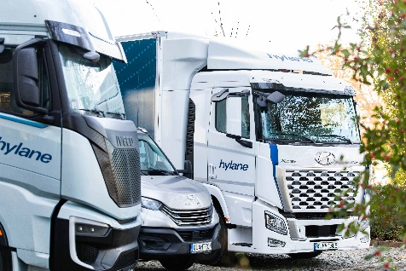 | hylane FCEV vehicle fleet from IVECO, QUANTRON and Hyundai

You can find the original images in both high and low resolutions here: Press releases from Quantron AG (https://www.quantron.net/en/q-news/press-releases/)
About Quantron AG
Quantron AG is a platform provider and specialist for sustainable transportation of people and goods; in particular for trucks, buses and vans with fully electric powertrains and H₂ fuel cell technology. As a high-tech spinoff of the renowned Haller GmbH, the German company from Augsburg in Bavaria combines over 140 years of commercial vehicle experience with state-of-the-art e-mobility know-how and positions itself globally as a partner to existing OEMs.
With the Quantron-as-a-Service Ecosystem (QaaS), QUANTRON offers an overall concept that covers all facets of the mobility value chain: QUANTRON INSIDE includes a wide range of both new vehicles and conversions for existing and used vehicles from diesel to battery and hydrogen electric powertrains using the highly innovative QUANTRON INSIDE technology. QUANTRON CUSTOMER SOLUTIONS ensures digital and physical aftersales solutions with a Europe-wide network of 700 service partners, as well as a service offering for maintenance, repair and spare parts, telematics and in-cloud solutions for remote diagnostics and fleet management. Customers receive individual solutions: rental, financing and leasing offers such as training courses and workshops at the QUANTRON Academy. In the future, QUANTRON ENERGY & POWER STATION will realize the production and distribution of green hydrogen and electricity as a platform. To this end, Quantron AG has joined forces with strong global partners. This Clean Transportation Alliance also forms an important building block for the supply of vehicles with the necessary green charging and H₂ refueling infrastructure.
QUANTRON stands for the core values Reliable, Energetic, Brave. The team of experts at the innovation driver for e-mobility is making a significant contribution to sustainable, environmentally friendly passenger and freight transport. You can find more information at www.quantron.net
Visit the Quantron AG on its social media channels on LinkedIn and YouTube.
Your contact:
Jörg Zwilling, Director Global Communications & Business Development Quantron AG, j.zwilling@quantron.net
Stephanie Miller, Marketing & Communications Quantron AG, press@quantron.net

