PRESS RELEASE January 10th, 2023
Volker Wissing and Hildegard Müller visit clean tech pioneer QUANTRON at the CES in Las Vegas
- QUANTRON is the only tech company in the field of zero-emission transportation at the German Pavilion at the Consumer Electronics Show (CES) in Las Vegas
- Dr. Volker Wissing, German Federal Minister for Digital and Transport, visits the CES, including the stand of Quantron AG
- Hildegard Müller, President of the German Association of the Automotive Industry (VDA), also visits the QUANTRON stand
- QUANTRON and FusionOne sign a Memorandum of Understanding (MoU) at CES to collaborate on clean energy solutions based on hydrogen and the reduction of plastic waste in the USA
- FusionOne joins the CLEAN TRANSPORTATION ALLIANCE and expands its network in the USA

Quantron AG, specialist in sustainable passenger and freight transportation, is the only mobility company representing Germany's innovative strength as a business location alongside other tech companies at the German pavilion at the Consumer Electronics Show (CES). Two high-profile guests – German Federal Minister for Digital and Transport, Dr. Volker Wissing, and the President of the German Association of the Automotive Industry (VDA), Hildegard Müller – were among the first visitors to the QUANTRON stand.
The CES in Las Vegas is the world's largest technology trade fair for innovations. Alongside tech giants such as Google, Schäffler, Qualcomm and Continental, Quantron AG also took part with its subsidiary Quantron US. A Memorandum of Understanding (MoU) was signed with FusionOne in the presence of Dr. Volker Wissing and Hildegard Müller. The technology company FusionOne focuses on pioneering solutions for hydrogen production from plastic waste.
FusionOne joins the Clean Transportation Alliance network founded by QUANTRON, which brings together companies and experts with the aim of decarbonizing road transport. This network of partners is the basis for the innovative Quantron-as-a-Service (QaaS) offering to enable customers to make the risk-free transition to zero-emission transportation solutions in a pay-per-use model.
Andreas Haller, CEO and founder of Quantron AG, commented: “It’s the ultimate environmental ‘Win/Win’. QUANTRON has a portfolio of hydrogen fuel cell vehicles and a network of QaaS strategic partners. Working with FusionOne will add a critical “multiplier” to the goal of improving our environment. The goal of the collaboration is to establish a platform and network for the refueling of fuel cell electric vehicles (‘FCEV’) with a focus on trucks. We plan to support each other to enhance the recognition of hydrogen as a preferred solution for commercial transportation and to drive adoption rates. FusionOne and QUANTRON will work collaboratively to promote the additional benefits of ‘H2 from recycled plastics’ as a superior green energy transportation solution.”
Volker Wissing is convinced by Quantron AG's approach: “Battery-electric mobility is not the only climate-friendly option. There is also hydrogen and fuel cell technology or renewable fuels like e-fuels. As an innovative mobility and tech company from Germany, QUANTRON contributes to securing the decarbonization of road transport by providing H2 vehicles, H2 infrastructure and digital solutions. There is great potential for hydrogen-based mobility both in the EU and the US, which can help us meet our climate change targets.“
Both Volker Wissing and Hildegard Müller made personal visits to Quantron AG's headquarters last year to see the zero-emission mobility solutions for themselves. Wissing emphasized QUANTRON's willingness to innovate and its open-technology approach, which includes both battery and hydrogen-electric drives. He highlighted the company as an outstanding example of the strength of Germany as a business location. At the CES, he accepted the Innovation Champion Award, which recognizes Germany as one of the international “innovation champions”. The award is presented by the Consumer Technology Association (CTA), the organizer of the CES.

Images (Please click on the image preview to download):
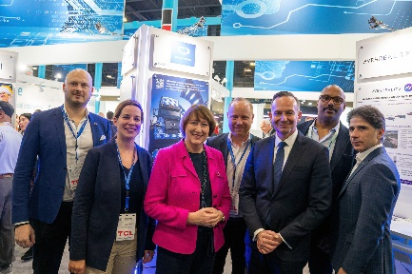  Copyright: BMDV | From left: Martin Lischka (Director Marketing, Brand & Strategy Quantron AG), Damaris Meyer (CFO Quantron US), Hildegard Müller (President VDA), Andreas Haller (CEO & Founder Quantron AG), Volker Wissing (German Federal Minister for Digital and Transport), Matthew Emory (EVP of South East Region USA FusionOne) and John Zorbas (Chairman of the Board of Directors FusionOne)
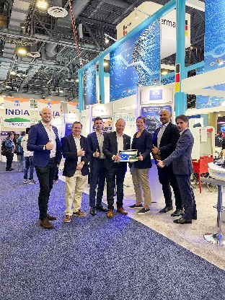  Copyright: Quantron AG | From left: Martin Lischka (Director Marketing, Brand & Strategy Quantron AG), Richard Ansell (VP Marketing/PR Quantron US), Christos Zorbas (Analyst FusionOne), Andreas Haller (CEO & Founder Quantron AG), Damaris Meyer (CFO Quantron US), Matthew Emory (EVP of South East Region USA FusionOne), John Zorbas (Chairman of the Board of Directors FusionOne)
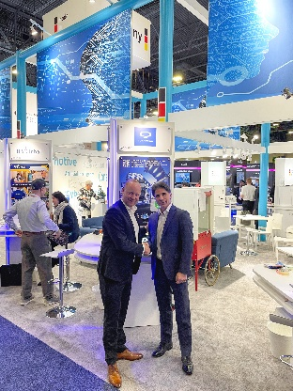  Copyright: Quantron AG | Andreas Haller (CEO and Founder Quantron AG) and John Zorbas (Chairman of the Board of Directors FusionOne)

You can find the original images in both high and low resolutions here: Press releases from Quantron AG (https://www.quantron.net/en/q-news/press-releases/)
About Quantron AG
Quantron AG is a platform provider and specialist for sustainable transportation of people and goods; in particular for trucks, buses and vans with fully electric powertrains and H₂ fuel cell technology. As a high-tech spinoff of the renowned Haller GmbH, the German company from Augsburg in Bavaria combines over 140 years of commercial vehicle experience with state-of-the-art e-mobility know-how and positions itself globally as a partner to existing OEMs.
With the Quantron-as-a-Service Ecosystem (QaaS), QUANTRON offers an overall concept that covers all facets of the mobility value chain: QUANTRON INSIDE includes a wide range of both new vehicles and conversions for existing and used vehicles from diesel to battery and hydrogen electric powertrains using the highly innovative QUANTRON INSIDE technology. QUANTRON CUSTOMER SOLUTIONS ensures digital and physical aftersales solutions with a Europe-wide network of 700 service partners, as well as a service offering for maintenance, repair and spare parts, telematics and in-cloud solutions for remote diagnostics and fleet management. Customers receive individual solutions: rental, financing and leasing offers such as training courses and workshops at the QUANTRON Academy. In the future, QUANTRON ENERGY & POWER STATION will realize the production and distribution of green hydrogen and electricity as a platform. To this end, Quantron AG has joined forces with strong global partners. This Clean Transportation Alliance also forms an important building block for the supply of vehicles with the necessary green charging and H₂ refueling infrastructure.
QUANTRON stands for the core values Reliable, Energetic, Brave. The team of experts at the innovation driver for e-mobility is making a significant contribution to sustainable, environmentally friendly passenger and freight transport. You can find more information at www.quantron.net
Visit the Quantron AG on its social media channels on LinkedIn and YouTube.
Your contact:
Jörg Zwilling, Director Global Communications & Business Development Quantron AG, j.zwilling@quantron.net
Stephanie Miller, Marketing & Communications Quantron AG, press@quantron.net

