PRESS RELEASE February 21st, 2024
Hygenox and QUANTRON sign LOI for cooperation in the green hydrogen sector
- Hygenox GmbH (Hygenox) develops green hydrogen plants and promotes the conversion of industrial processes to sustainable energy
- Quantron AG intends to supply Hygenox with up to eight fuel cell vehicles and thus enable sustainable logistics for its 100 MW hydrogen project in Rüsselsheim am Main, Germany

The specialist for sustainable passenger and freight transportation Quantron AG and Hygenox GmbH have signed a Letter of Intent (LOI), which lays the foundation for a close cooperation in the field of green hydrogen projects across Europe.
Hygenox GmbH has set itself the goal of supporting industrial customers in their transition away from fossil fuels and promoting the switch to sustainable fuels. By establishing a distributed network of green hydrogen production plants, Hygenox offers its customers a reliable supply of environmentally friendly hydrogen both on-site and via service contracts. The Munich-based company is also planning and implementing the conversion of industrial processes to green hydrogen.
Quantron AG intends to supply Hygenox with up to eight climate-friendly fuel cell vehicles of the QUANTRON QHM FCEV and QUANTRON QLI FCEV models in the period 2025/2026. The vehicles will be used for their 100 Megawatt hydrogen project at the Opel plant in Rüsselsheim am Main.
Warwick Hill, Group CEO of Hygenox: "Our business relies on supplying large industrial clients with green hydrogen under our “Fuels-as-a-Service” (FaaS) structure. QUANTRON's hydrogen fuel cell trucks provide us with the ability to reduce our CO2 footprint when delivering fuel to customers.”
Andreas Haller, CEO and founder of Quantron AG: "Hygenox and QUANTRON's joint commitment to environmentally friendly technologies and sustainable mobility reflects our belief that by pooling expertise and resources, we can advance the vision of zero-emission energy generation and use. We look forward to bringing innovative solutions for sustainable mobility to the road together."

Images (Please click on the image preview to download):
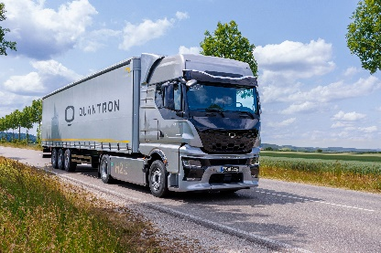 | QUANTRON QHM FCEV
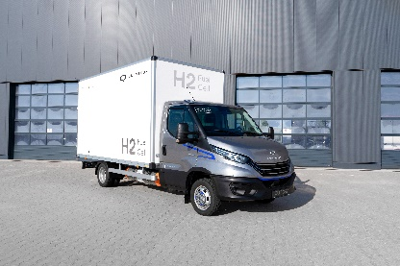 | QUANTRON QLI FCEV

You can find the original images in both high and low resolutions here: Press releases from Quantron AG (https://www.quantron.net/en/q-news/press-releases/)
About Quantron AG
Quantron AG is a platform provider and specialist for sustainable transportation of people and goods; in particular for trucks, buses and vans with fully electric powertrains and H₂ fuel cell technology. As a high-tech spinoff of the renowned Haller GmbH, the German company from Augsburg in Bavaria combines over 140 years of commercial vehicle experience with state-of-the-art e-mobility know-how and positions itself globally as a partner to existing OEMs.
With the Quantron-as-a-Service Ecosystem (QaaS), QUANTRON offers an overall concept that covers all facets of the mobility value chain: QUANTRON INSIDE includes a wide range of both new vehicles and conversions for existing and used vehicles from diesel to battery and hydrogen electric powertrains using the highly innovative QUANTRON INSIDE technology. QUANTRON CUSTOMER SOLUTIONS ensures digital and physical aftersales solutions with a Europe-wide network of service partners, as well as a service offering for maintenance, repair and spare parts, telematics and in-cloud solutions for remote diagnostics and fleet management. Customers receive individual solutions: rental, financing and leasing offers such as training courses and workshops at the QUANTRON Academy. In the future, QUANTRON ENERGY & POWER STATION will realize the production and distribution of green hydrogen and electricity as a platform. To this end, Quantron AG has joined forces with strong global partners. This Clean Transportation Alliance also forms an important building block for the supply of vehicles with the necessary green charging and H₂ refueling infrastructure.
QUANTRON stands for the core values Reliable, Energetic, Brave. The team of experts at the innovation driver for e-mobility is making a significant contribution to sustainable, environmentally friendly passenger and freight transport. You can find more information at www.quantron.net
Visit the Quantron AG on its social media channels on LinkedIn and YouTube.
Your contact:
Jörg Zwilling, Chief Marketing Officer Quantron AG, j.zwilling@quantron.net
Stephanie Miller, Communications Expert Quantron AG, press@quantron.net
For further inquiries or media requests, please contact:
Hygenox Media Contact: Katie Booth, katie.booth@hygenox.com
Hygenox GmbH
Schenkstr. 7, 80339 Munich, Germany
https://www.hygenox.com

