PRESS RELEASE February 8th, 2024
Beate Reimann joins the Board of Management of QUANTRON
- Beate Reinmann (CFO) joins the Board of Management of Quantron AG
- The restructuring at Management Board level represents the consistent implementation of the corporate strategy
- "Time to Deliver" as motto for the year 2024

Quantron AG, specialist for sustainable passenger and freight transportation, announces changes to its Board of Management to set the course for its further international growth. Beate Reimann, Chief Finance Officer (CFO) has been appointed as a new member of the Board.
Beate Reimann has more than 25 years of experience in global companies. Since July 2023, she has been supporting Quantron AG in the next financing round and will play an important role in the globalization and preparation of Quantron AG for the capital market and IPO.
Commenting on her new role on the QUANTRON Executive Board, she explains: "The appointment to the Management Board of QUANTRON AG is a great opportunity for me to contribute my international financial market expertise in a profitable way. During the scale-up process that the company is currently undergoing, my focus will be on the sustainable financial strategy for successful growth and further internationalization. My colleagues on the Management Board and I are working together to drive forward the decarbonization of the transport sector with innovative technology and new business models and to establish QUANTRON as a pioneer for zero-emission mobility solutions in international markets."
The restructuring at Management Board level represents the consistent implementation of the corporate strategy. The motto for 2024 is "Time to Deliver", with new customers taking over QUANTRON's zero-emission vehicles and the first QUANTRON QHM FCEV heavy-duty fuel cell trucks being delivered. The company is also expanding its global presence in international markets.
Andreas Haller, CEO and founder of Quantron AG, emphasizes: "I am very pleased to welcome Beate Reimann as a new member of our Management Board. She will support us with her expertise, especially with regard to the completion of the B round. These changes are decisive steps to accompany our international growth."

Images (Please click on the image preview to download):
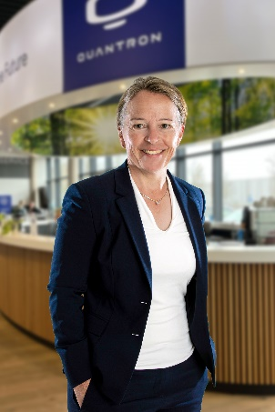 | Beate Reimann, CFO and member of the Management Board of Quantron AG
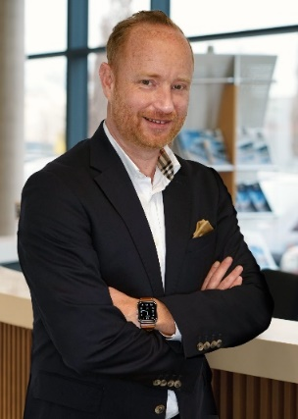 | Andreas Haller,  Founder and CEO of QUANTRON

You can find the original images in both high and low resolutions here: Press releases from Quantron AG (https://www.quantron.net/en/q-news/press-releases/)
About Quantron AG
Quantron AG is a platform provider and specialist for sustainable transportation of people and goods; in particular for trucks, buses and vans with fully electric powertrains and H₂ fuel cell technology. As a high-tech spinoff of the renowned Haller GmbH, the German company from Augsburg in Bavaria combines over 140 years of commercial vehicle experience with state-of-the-art e-mobility know-how and positions itself globally as a partner to existing OEMs.
With the Quantron-as-a-Service Ecosystem (QaaS), QUANTRON offers an overall concept that covers all facets of the mobility value chain: QUANTRON INSIDE includes a wide range of both new vehicles and conversions for existing and used vehicles from diesel to battery and hydrogen electric powertrains using the highly innovative QUANTRON INSIDE technology. QUANTRON CUSTOMER SOLUTIONS ensures digital and physical aftersales solutions with a Europe-wide network of 700 service partners, as well as a service offering for maintenance, repair and spare parts, telematics and in-cloud solutions for remote diagnostics and fleet management. Customers receive individual solutions: rental, financing and leasing offers such as training courses and workshops at the QUANTRON Academy. In the future, QUANTRON ENERGY & POWER STATION will realize the production and distribution of green hydrogen and electricity as a platform. To this end, Quantron AG has joined forces with strong global partners. This Clean Transportation Alliance also forms an important building block for the supply of vehicles with the necessary green charging and H₂ refueling infrastructure.
QUANTRON stands for the core values Reliable, Energetic, Brave. The team of experts at the innovation driver for e-mobility is making a significant contribution to sustainable, environmentally friendly passenger and freight transport. You can find more information at www.quantron.net
Visit the Quantron AG on its social media channels on LinkedIn and YouTube.
Your contact:
Jörg Zwilling, Director Global Communications & Business Development Quantron AG, j.zwilling@quantron.net
Stephanie Miller, Communications Expert Quantron AG, press@quantron.net

