PRESS RELEASE February 6th, 2024
Emission-free mobility through organic waste: QUANTRON expands the Clean Transportation Alliance with Bavarian tech company blueFLUX Energy
- With blueFLUX Energy, the Clean Transportation Alliance (CTA) founded by QUANTRON is being expanded to include an additional waste-to-hydrogen company
- CTA aims to accelerate the transformation of today's diesel fleets in the transportation industry to emission-free solutions
- blueFLUX Energy AG converts decentralized organic residues into sustainable energy sources such as green hydrogen
- QUANTRON combines the supply of green energy with the consumer in the form of a climate-friendly commercial vehicle and offers this to the customer as an innovative Quantron-as-a-Service model

Quantron AG, specialist in sustainable passenger and freight transportation, is expanding its Clean Transportation Alliance (CTA) to include blueFLUX Energy AG, a German company that develops waste-to-hydrogen technology. The CTA was created by QUANTRON to enable the innovative Quantron-as-a-Service model, where the customer receives everything from a single source – green energy, the necessary infrastructure, as well as zero-emission vehicles and insurance solutions. With this offer, QUANTRON facilitates the technology transition to climate-friendly vehicles that require either green electricity or green hydrogen as an energy source.
blueFLUX Energy specializes in the conversion of organic residues into green hydrogen and other sustainable energy sources. The company's innovative technology efficiently processes organic residues from agriculture, municipalities and industry, which also solves the associated disposal problem of these material flows. Thanks to its modular design, production is decentralized in order to generate energy for the region from locally available materials such as municipal sewage sludge, organic waste, digestate, manure, slurry, tree and green cuttings.
Quantron AG plans to purchase hydrogen produced by blueFLUX Energy and integrate it into its Quantron-as-a-Service ecosystem. QUANTRON is pursuing the development of a decentralized hydrogen infrastructure for the operation of emission-free commercial vehicles by its customers. A blueFLUX Energy system can supply the hydrogen for a geographically nearby hydrogen refueling station and thus ensure supply in regions with no prospect of connection to the future pipeline system.
“The partnership with blueFLUX Energy is an example of our approach to accelerate the ramp-up of the hydrogen economy by providing locally produced, green hydrogen in close proximity to our customers”, says Andreas Haller, CEO and founder of Quantron AG. “The fact that the problem of disposal is being addressed at the same time as the production of hydrogen shows the innovative strength of Bavaria and Germany as locations. By working together with our partners in the Clean Transportation Alliance, we want to ensure the availability of green hydrogen and thus promote the acceptance of emission-free vehicles.”
Dr. Ulrich Mach of blueFLUX Energy AG, explains: “QUANTRON's approach combines well with blueFLUX Energy AG's decentralized approach to building an H2 infrastructure. We are all the more pleased to be able to contribute to the solution with blueFLUX technology. The mobility sector in particular will become increasingly important in the coming years due to the issue of quota revenues. blueFLUX is an expert in the materials that generate particularly exciting quota revenues for the introduction of sustainably produced hydrogen into mobility. In combination with low production costs and the decentralized approach, this results in exciting business models for operators.”
In addition to blueFLUX Energy, companies such as the leading manufacturer of fuel cells Ballard Power Systems, Neuman & Esser as a specialist for compressor technology and technical gases and other waste-to-hydrogen companies such as BtX Energy, Plagazi, Green Hydrogen Technology (GHT) and Uniwastec are members of the Clean Transportation Alliance. Working together, they are committed to sustainable and environmentally friendly mobility.

Images (Please click on the image preview to download):
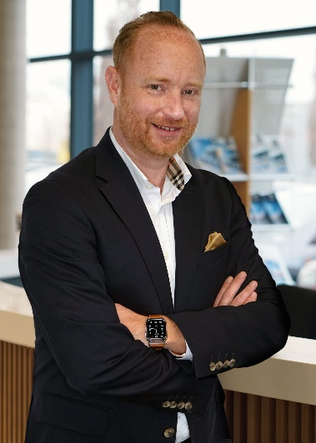 | Andreas Haller, Founder & CEO of QUANTRON
 | Dr. Ulrich Mach, COO at blueFLUX Energy AG

You can find the original images in both high and low resolutions here: Press releases from Quantron AG (https://www.quantron.net/en/q-news/press-releases/)
About Quantron AG
Quantron AG is a platform provider and specialist for sustainable transportation of people and goods; in particular for trucks, buses and vans with fully electric powertrains and H₂ fuel cell technology. As a high-tech spinoff of the renowned Haller GmbH, the German company from Augsburg in Bavaria combines over 140 years of commercial vehicle experience with state-of-the-art e-mobility know-how and positions itself globally as a partner to existing OEMs.
With the Quantron-as-a-Service Ecosystem (QaaS), QUANTRON offers an overall concept that covers all facets of the mobility value chain: QUANTRON INSIDE includes a wide range of both new vehicles and conversions for existing and used vehicles from diesel to battery and hydrogen electric powertrains using the highly innovative QUANTRON INSIDE technology. QUANTRON CUSTOMER SOLUTIONS ensures digital and physical aftersales solutions with a Europe-wide network of 700 service partners, as well as a service offering for maintenance, repair and spare parts, telematics and in-cloud solutions for remote diagnostics and fleet management. Customers receive individual solutions: rental, financing and leasing offers such as training courses and workshops at the QUANTRON Academy. In the future, QUANTRON ENERGY & POWER STATION will realize the production and distribution of green hydrogen and electricity as a platform. To this end, Quantron AG has joined forces with strong global partners. This Clean Transportation Alliance also forms an important building block for the supply of vehicles with the necessary green charging and H₂ refueling infrastructure.
QUANTRON stands for the core values Reliable, Energetic, Brave. The team of experts at the innovation driver for e-mobility is making a significant contribution to sustainable, environmentally friendly passenger and freight transport. You can find more information at www.quantron.net
Visit the Quantron AG on its social media channels on LinkedIn and YouTube.
Your contact:
Jörg Zwilling, Director Global Communications & Business Development Quantron AG, j.zwilling@quantron.net
Stephanie Miller, Communications Expert Quantron AG, press@quantron.net

