PRESS RELEASE February 29th, 2024

QUANTRON proudly announces the BW Auto World 40 under 40 Award amongst their leadership
- Working in QUANTRON means being part of a dynamic and supportive team, having the opportunity to grow both personally and professionally, and making a positive impact on the world.
- Tarkeshwar Rao, one of the leaders of QUANTRON, has made a big step for his career by winning the BW Auto World 40 under 40 Award, representing his company’s approach, too.
- This award is a quest for the most influential leaders of the year from Indian Auto Sector, a hunt for the Top 40 brightest young entrepreneurs, innovators, and game-changers.
- Rao is responsible for QUANTRON’s ROQIT joint venture.
Quantron AG fosters an environment that encourages innovation, creativity, and out-of-the-box thinking. These opportunities are a great example of working on cutting-edge projects and collaborating with talented individuals who are passionate about driving change. QUANTRON prioritizes the professional development of the employees and offers ample windows for career advancement. One of the many outstanding talents that are working at QUANTRON has this year received a significant award from BW Bussinessworld, the India’s largest business magazine.
Tarkeshwar Rao is QUANTRON’s Director Global After Sales & Digital Ecosystem. Additionally, he is responsible for QUANTRON’s new joint venture ROQIT, a collaboration with the Indian software company Aion Tech Solutions, building an AI-driven fleet management ecosystem utilizing latest IT technology and data analytics for maximum efficiency. This project is a great example of self-development and career growth that is made possible within such a dynamic fast-growing young company.
Tarkeshwar Rao, Director Global After Sales & Digital Ecosystem: “Thank you BW and the Jury for this honour, it’s a great privilege. After working for 20 years in the automotive industry, working with QUANTRON is a once in a lifetime opportunity to really make an impact in our world. We are at the forefront in transforming an overall industry and actively shape the new way of doing business. Decarbonizing the transport industry is one of the major challenges of the energy transition. We are leading this change with our innovative products, technology, and digital ecosystem.”
Andreas Haller, CEO and Founder of Quantron AG, said further: “We are happy to have such revolutionary minds like Tarkeshwar. Our strength is our team, and I am convinced that is what makes QUANTRON a flagship for transforming the industry's approach.”
Images (Please click on the image preview to download):
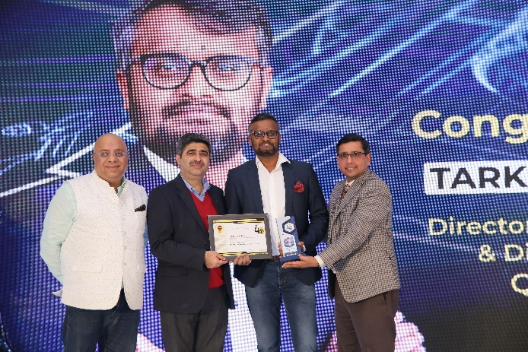 | Tarkeshwar Rao, QUANTRON’s Director Global After Sales & Digital Ecosystem
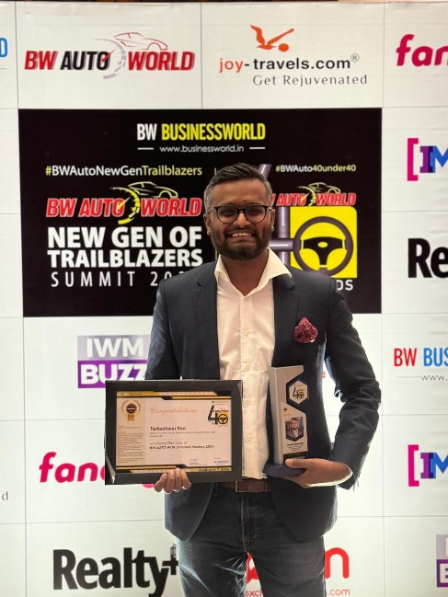 | Tarkeshwar Rao, QUANTRON’s Director Global After Sales & Digital Ecosystem
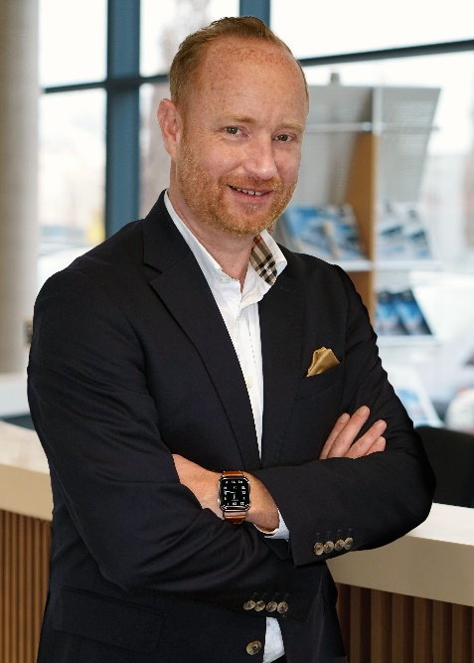 | Andreas Haller, CEO & Founder of Quantron AG

About Quantron AG
Quantron AG is a platform provider and specialist for sustainable transportation of people and goods; in particular for trucks, buses and vans with fully electric powertrains and H₂ fuel cell technology. As a high-tech spinoff of the renowned Haller GmbH, the German company from Augsburg in Bavaria combines over 140 years of commercial vehicle experience with state-of-the-art e-mobility know-how and positions itself globally as a partner to existing OEMs.
With the Quantron-as-a-Service Ecosystem (QaaS), QUANTRON offers an overall concept that covers all facets of the mobility value chain: QUANTRON INSIDE includes a wide range of both new vehicles and conversions for existing and used vehicles from diesel to battery and hydrogen electric powertrains using the highly innovative QUANTRON INSIDE technology. QUANTRON CUSTOMER SOLUTIONS ensures digital and physical aftersales solutions with a Europe-wide network of 700 service partners, as well as a service offering for maintenance, repair and spare parts, telematics and in-cloud solutions for remote diagnostics and fleet management. Customers receive individual solutions: rental, financing and leasing offers such as training courses and workshops at the QUANTRON Academy. In the future, QUANTRON ENERGY & POWER STATION will realize the production and distribution of green hydrogen and electricity as a platform. To this end, Quantron AG has joined forces with strong global partners. This Clean Transportation Alliance also forms an important building block for the supply of vehicles with the necessary green charging and H₂ refueling infrastructure.
QUANTRON stands for the core values Reliable, Energetic, Brave. The team of experts at the innovation driver for e-mobility is making a significant contribution to sustainable, environmentally friendly passenger and freight transport. You can find more information at www.quantron.net
Visit the Quantron AG on its social media channels on LinkedIn and YouTube.
Your contact:
Jörg Zwilling, Director Global Communications & Business Development Quantron AG, j.zwilling@quantron.net
Stephanie Miller, Marketing & Communications Quantron AG, press@quantron.net

