PRESS RELEASE 27th March 2024

Bavarian State Minister for Digital Affairs and QUANTRON leadership engage in strategic dialogue on pioneering solutions for sustainable transport

- QUANTRON welcomed the Bavarian Minister of State for Digital Affairs, Dr. Fabian Mehring, on March 26th, 2024
- Digitalization in transportation as a key to increase efficiency and to reduce CO₂ emissions
- ROQIT will deliver a customized digital platform, paired with relevant software solutions to technologically implement the Quantron-as-a-Service business model

Quantron AG, a leading clean tech company, welcomed the Bavarian Minister of State for Digital Affairs, Dr. Fabian Mehring, for a productive discussion on digitalization in transportation and the reduction of CO₂ emissions. The visit, held at QUANTRON's headquarters in Gersthofen, focused on exploring innovative approaches to increase efficiency and promote sustainable solutions in the transportation sector.
During the visit, Andreas Haller, CEO & Founder of Quantron AG, and Minister Dr. Mehring engaged in a comprehensive dialogue on the potential of digitalization to revolutionize the transportation industry. They emphasized the importance of reducing carbon emissions and explored strategies to achieve this objective through technological advancements.
One of the key topics of discussion was QUANTRON's groundbreaking Quantron-as-a-Service platform. This innovative approach offers a one-stop-shop transportation solution with zero emissions, based on a pay-per-kilometre model. By providing a comprehensive range of services, QUANTRON aims to enable businesses and fleet operators to transition to sustainable transportation seamlessly.

The Bavarian State Minister for Digital Affairs expressed his enthusiasm for QUANTRON's forward-looking approach: "Digitalization is the game changer for the climate transition. The Quantron-as-a-Service platform is a prime example of how artificial intelligence can significantly improve the climate footprint of the transport sector without restricting mobility and damage the economy. Instead, QUANTRON shows how a greener future can be achieved. Through innovation instead of regulation. This remains Bavaria's strategy: instead of pursuing deindustrialization in favour of climate protection, we are focusing on progress and conquering the leading positions in tomorrow's markets today - this benefits both the planet and economy!" Mehring also welcomes QUANTRON's open-technology approach, which includes both battery and hydrogen-electric propulsion systems and therefore currently offers the broadest portfolio of environmentally friendly mobility solutions.
In addition to discussing QUANTRON's initiatives, the meeting also shed light on the joint venture ROQIT, a collaboration between QUANTRON and Aiontech, a stock-listed IT company from India ( https://aiontech.ai/ ). This innovative joint business venture aims to build a digital transaction platform for the unique Quantron-as-a-Service ecosystem. The OEM-agnostic platform will consist of five digital pillars, including Data Insights, to enable sustainable and efficient fleet operations. Basically, ROQIT will deliver a customized digital platform solution, along with relevant software offerings, to effectively implement QUANTRON's business model.
Andreas Haller, CEO & Founder of Quantron AG stated: “ROQIT represents a significant milestone for QUANTRON. By integrating our expertise with Aiontech, we will be able to provide cutting-edge digital solutions that align with our vision of sustainable transportation. Together, we will transform the industry and pave the way for a greener future."
The meeting between Quantron AG and the Bavarian Minister of State for Digital Affairs highlighted the importance of digitalization in transportation and the urgent need to reduce CO₂ emissions. The Quantron-as-a-Service platform, along with ROQIT, exemplifies the company's commitment to driving innovation and sustainability in the transportation sector.

Images (Please click on the image preview to download):
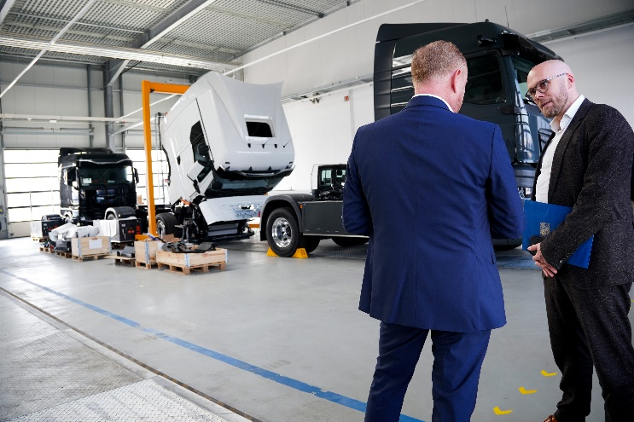 | From left to right: Andreas Haller, CEO & Founder of Quantron AG; Dr. Fabian Mehring, Bavarian Minister of State for Digital Affairs
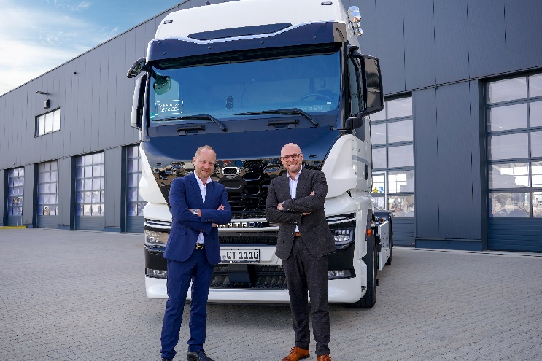 | From left to right: Andreas Haller, CEO & Founder of Quantron AG; Dr. Fabian Mehring, Bavarian Minister of State for Digital Affairs
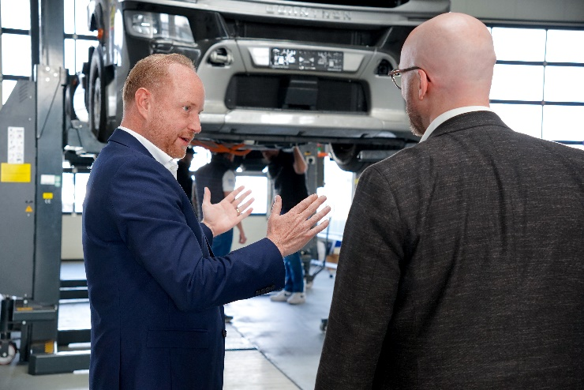 | From left to right: Andreas Haller, CEO & Founder of Quantron AG; Dr. Fabian Mehring, Bavarian Minister of State for Digital Affairs

You can find the original images in both high and low resolutions here: Press releases from Quantron AG (https://www.quantron.net/en/q-news/press-releases/)
About Quantron AG
Quantron AG is a platform provider and specialist for sustainable transportation of people and goods; in particular for trucks, buses and vans with fully electric powertrains and H₂ fuel cell technology. As a high-tech spinoff of the renowned Haller GmbH, the German company from Augsburg in Bavaria combines over 140 years of commercial vehicle experience with state-of-the-art e-mobility know-how and positions itself globally as a partner to existing OEMs.
With the Quantron-as-a-Service Ecosystem (QaaS), QUANTRON offers an overall concept that covers all facets of the mobility value chain: QUANTRON INSIDE includes a wide range of both new vehicles and conversions for existing and used vehicles from diesel to battery and hydrogen electric powertrains using the highly innovative QUANTRON INSIDE technology. QUANTRON CUSTOMER SOLUTIONS ensures digital and physical aftersales solutions with a Europe-wide network of service partners, as well as a service offering for maintenance, repair and spare parts, telematics and in-cloud solutions for remote diagnostics and fleet management. Customers receive individual solutions: rental, financing and leasing offers such as training courses and workshops at the QUANTRON Academy. In the future, QUANTRON ENERGY & POWER STATION will realize the production and distribution of green hydrogen and electricity as a platform. To this end, Quantron AG has joined forces with strong global partners. This Clean Transportation Alliance also forms an important building block for the supply of vehicles with the necessary green charging and H₂ refueling infrastructure.
QUANTRON stands for the core values Reliable, Energetic, Brave. The team of experts at the innovation driver for e-mobility is making a significant contribution to sustainable, environmentally friendly passenger and freight transport. You can find more information at www.quantron.net
Visit the Quantron AG on its social media channels on LinkedIn and YouTube.
Your contact:
Jörg Zwilling, Chief Marketing Officer, Quantron AG, j.zwilling@quantron.net, press@quantron.net

