PRESS RELEASE 19th March 2024

QUANTRON Design Award 2024 Ceremony
celebrated Innovation, Technology and Design
in the Transportation sector

- QUANTRON Design Award 2024 celebrated the winners on March 18th, 2024
- Young talents from all over the world had the chance to participate, showcasing remarkable results in the field of transportation design
- QUANTRON and the partners selected three top winners together with a mention award

Quantron AG, specialist in sustainable passenger and freight transportation, proudly announced the successful completion of the QUANTRON Design Award 2024 during the official ceremony on March 18. The event was conducted online, allowing the participants from around the world together with the project partners to join in the celebration of the design achievements. The competition, which attracted 35 applications, representing more than 10 different countries and 20 prestigious universities and design schools, aimed to recognize and reward the work of young talented designers and design students suggesting new ideas to the transportation sector, proposing unconventional solutions with out of the box approaches.
With the goal of attracting young talents with fresh perspectives, this event served as a platform to challenge the status quo of the European transportation and logistics sector with forward-thinking yet practical ideas. After a thorough selection process, the panel selected three top winners and awarded one honourable mention award:
- 1st Place: Siddhartha Dutt, CCS (College for Creative Studies), Detroit, USA
- 2nd Place: Ana Alvarez Maestro, University of Navarra, Spain
- 3rd Place: Lorenzo Benzoni, IED (Istituto Europeo di Design), Turin, Italy
- Mention Award: George (Siu Fung Lau), IED (Istituto Europeo di Design), Turin, Italy
By unanimous vote, Siddhartha Dutt from CCS University in Detroit, USA, was chosen as the winner of the QUANTRON Design Award 2024. His design entry exhibited a comprehensive approach, effectively reflecting the full potential of the design brief through detailed visualization and extensive research and design process.
Ana Alvarez Maestro from University of Navarra in Spain, despite being among the youngest applicants, impressed the jury with her exceptional execution, proficient 3D modeling skills, and compelling visualizations, proving to be the most practical and compatible approach for the QUANTRON-as-a-Service concept.
Lorenzo Benzoni, student of IED University in Turin, Italy, showcased with his project a sophisticated approach to efficiency, seamlessly integrating aerodynamics and innovative cabin structures. Its captivating visualizations and presentations elevate the overall impact, underscoring the courage in both design and execution.
Siu Fung George Lau exhibited an exemplary problem-solving and industrial design-oriented approach, characterized by its ingenious out-of-the-box solutions. Its innovative design choices and exceptional execution make it a standout contender, worthy of recognition alongside our top three winners.
The success of this international design competition highlights the importance of collaboration and the power of creativity in driving innovation within the automotive design sector. The partners in the Design Award project Vizcom, Gravity Sketch, and Automotive Design Planet extend their congratulations to all participants.
Jordan Taylor, CEO & Co of Vizcom stated: “We were excited to partner with QUANTRON in the Design Award. As a company deeply committed to the future of design, we were both honored and excited to be part of this celebration of creativity, innovation, and excellence. Our mission has always been to empower creators with the tools they need to bring their visions to life. By sponsoring the QUANTRON Design Award, we are reaffirming our commitment to this goal. We not only got to acknowledge and appreciate the incredible talent within the design community, but also to inspire and be inspired by the groundbreaking work being done in our field.”
Oluwaseyi Sosanya, CEO of Gravity Sketch stated: “Gravity Sketch was thrilled to partner with Quantron AG and Vizcom for the QUANTRON Design Award! I was consistently more impressed with the work I saw in academia than that of our industry partners. Students are leading the charge of more creative and sustainable design solutions, which both play important roles in our company mission and vision. This collaboration highlighted our shared values in creativity, innovation, and style.”
Nishant Dhakla CEO & Cofounder of Automotive Design Planet stated: “We were very glad to join as a media partner for this year's QUANTRON Design Award. It aligned perfectly with our mission at Automotive Design Planet to celebrate innovation and creativity in the automotive design space. Working with the QUANTRON team was an absolute pleasure and It's clear that they had put a lot of thought and effort into creating a contest that would showcase the best and brightest side of commercial automotives. ADP team congratulate all the winners of the QUANTRON Design Award, and you can read more about the winning projects on our website.”
Andreas Haller, CEO & Founder of QUANTRON stated: “We were truly impressed by the caliber of the submissions we received. The level of talent and dedication demonstrated by the participants was remarkable, making the selection process extremely challenging. We are recognizing the exceptional talent and innovative ideas that emerged from this competition, these designers have demonstrated their ability to push boundaries and shape the future of the transportation design industry. This reflects our approach to changing the industry with unconventional solutions, empowered by deep understanding of technology, intelligent engineering, and innovative design.”
For more information please check: https://event.quantron.net/quantron-design-award-2024
Images (Please click on the image preview to download):
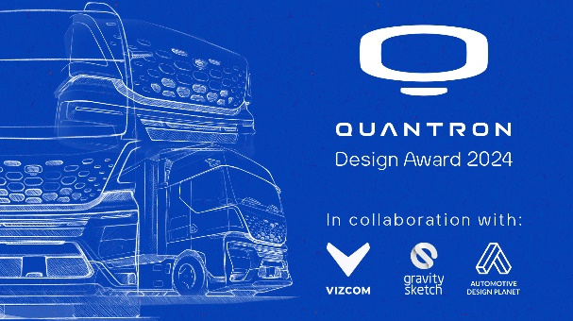 | QUANTRON Design Award 2024  In collaboration with:  Vizcom, Gravity Sketch &  Automotive Design Planet
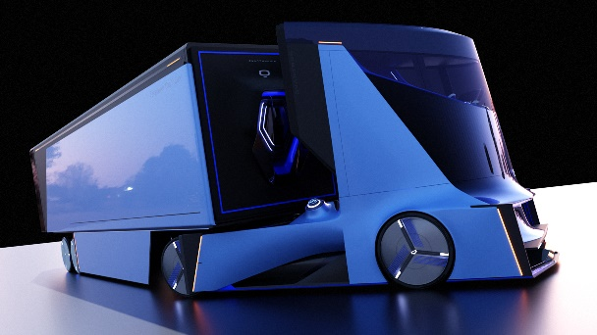 | QUANTRON Design Award 2024  1st Place Winner,  Siddhartha Dutt  CCS (College for Creative Studies), Detroit, USA
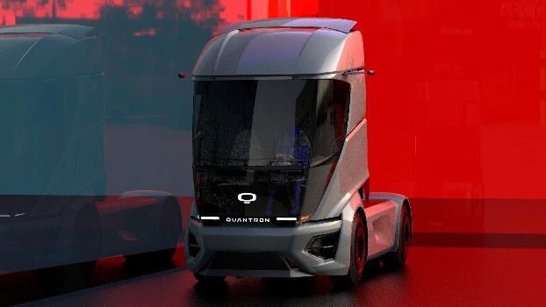 | QUANTRON Design Award 2024  2nd Place Winner,  Ana Alvarez Maestro  University of Navarra, Spain
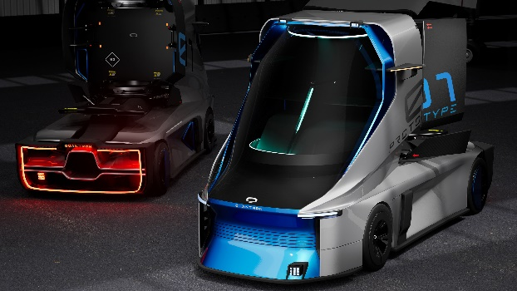 | QUANTRON Design Award 2024  3rd Place Winner,  Lorenzo Benzoni  IED (Istituto Europeo di Design), Turin, Italy
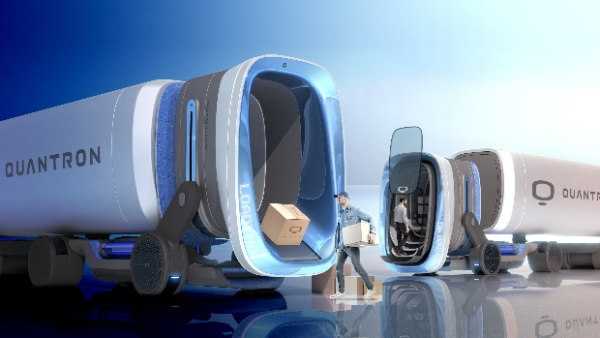 | QUANTRON Design Award 2024  Mentioned Award,  George Siu Fung Lau  IED (Istituto Europeo di Design), Turin, Italy
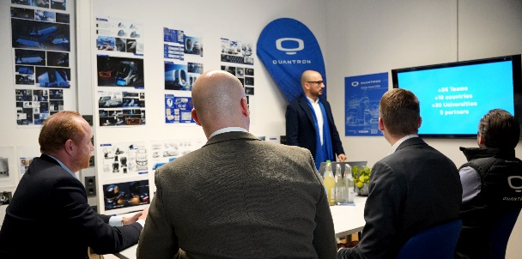 | QUANTRON Design Award 2024  Jury Day

You can find the original images in both high and low resolutions here: Press releases from Quantron AG (https://www.quantron.net/en/q-news/press-releases/)
About Quantron AG
Quantron AG is a platform provider and specialist for sustainable transportation of people and goods; in particular for trucks, buses and vans with fully electric powertrains and H₂ fuel cell technology. As a high-tech spinoff of the renowned Haller GmbH, the German company from Augsburg in Bavaria combines over 140 years of commercial vehicle experience with state-of-the-art e-mobility know-how and positions itself globally as a partner to existing OEMs.
With the Quantron-as-a-Service Ecosystem (QaaS), QUANTRON offers an overall concept that covers all facets of the mobility value chain: QUANTRON INSIDE includes a wide range of both new vehicles and conversions for existing and used vehicles from diesel to battery and hydrogen electric powertrains using the highly innovative QUANTRON INSIDE technology. QUANTRON CUSTOMER SOLUTIONS ensures digital and physical aftersales solutions with a Europe-wide network of service partners, as well as a service offering for maintenance, repair and spare parts, telematics and in-cloud solutions for remote diagnostics and fleet management. Customers receive individual solutions: rental, financing and leasing offers such as training courses and workshops at the QUANTRON Academy. In the future, QUANTRON ENERGY & POWER STATION will realize the production and distribution of green hydrogen and electricity as a platform. To this end, Quantron AG has joined forces with strong global partners. This Clean Transportation Alliance also forms an important building block for the supply of vehicles with the necessary green charging and H₂ refueling infrastructure.
QUANTRON stands for the core values Reliable, Energetic, Brave. The team of experts at the innovation driver for e-mobility is making a significant contribution to sustainable, environmentally friendly passenger and freight transport. You can find more information at www.quantron.net
Visit the Quantron AG on its social media channels on LinkedIn and YouTube.
Your contact:
Jörg Zwilling, Chief Marketing Officer Quantron AG, j.zwilling@quantron.net
Stephanie Miller, Communications Expert Quantron AG, press@quantron.net

