PRESS RELEASE March 4th, 2024
Quantron AG strengthens management team with new key positions
- Reto Leutenegger has been appointed Chief Sales Officer (CSO)
- Alexander Stucke was promoted to Director Global Sales Bus & Tender
- Martin Lischka is new Director Global Product Management
- Jörg Zwilling has taken over the position of Chief Marketing Officer (CMO)
Quantron AG, specialist for sustainable passenger and freight transportation, has strengthened its management team with Reto Leutenegger as Chief Sales Officer (CSO). This development underscores the clean tech company's progressive course as part of its global expansion strategy.
Reto Leutenegger, Managing Director of the subsidiary Quantron Switzerland AG since January 2023, is responsible as CSO for sales and the roll-out of the innovative Quantron-as-a-Service ecosystem of Quantron AG, based in Augsburg. Leutenegger has been involved in the sale of zero-emission vehicles since 2014 and is predestined to drive QUANTRON's growth forward thanks to his extensive expertise in the field of vehicle technology.
Alexander Stucke, former Head of Sales Bus at QUANTRON was promoted to Director Global Sales Bus & Tender. He has more than 20 years of industry and leadership experience in global bus sales and will drive the global zero-emission bus business forward.
Martin Lischka has moved within QUANTRON to the role of Director Global Product Management. He had previously been Director of Marketing and Strategy since 2022. In his new position, Lischka is expanding the global portfolio for BEV and FCEV trucks and buses. In addition to the Product Strategy and Product Design organizational units, he is also responsible for Product Marketing. He therefore focuses on global customer requirements and supports the sales activities of Reto Leutenegger and his team.
Jörg Zwilling took responsibility of marketing, communications and external affairs as new Chief Marketing Officer (CMO). With his extensive expertise in brand management and communication, Zwilling is supporting the dynamic development of Quantron AG with new impulses in marketing.
These changes at management level are decisive steps towards the consistent implementation of QUANTRON's corporate strategy. Reto Leutenegger comments: "Quantron AG's motto for 2024 is 'Time to Deliver'. This means not only the delivery of vehicles to our customers, but also the establishment of the innovative all-inclusive ‘Quantron-as-a-Service’ offer, where the customer receives the zero-emission vehicle including energy and relevant digital services from a single source for one price per kilometer."
Andreas Haller, Founder and CEO of Quantron AG: "With Reto Leutenegger, we gained a pioneer in climate-friendly commercial vehicle technology as CSO for Quantron AG. His expertise in sales and vehicle technology fits in perfectly with the dynamic development of our company. I would like to congratulate Martin Lischka, Jörg Zwilling and Alexander Stucke on their new positions. We have set ourselves ambitious goals for this year and I am confident that these restructuring measures will put us in an excellent position to achieve them in the coming months."

Images (Please click on the image preview to download):
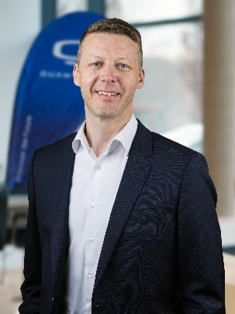 | Reto Leutenegger, CSO Quantron AG
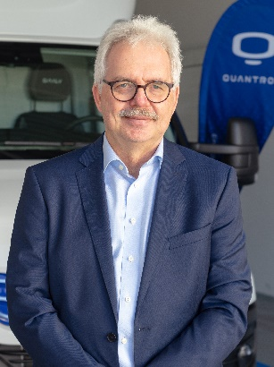 | Alexander Stucke, Director Global Sales Bus & Tender Quantron AG
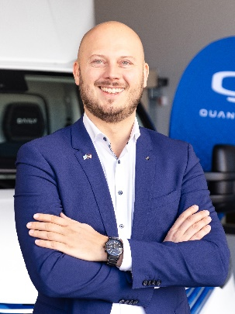 | Martin Lischka, Director Global Product Management Quantron AG
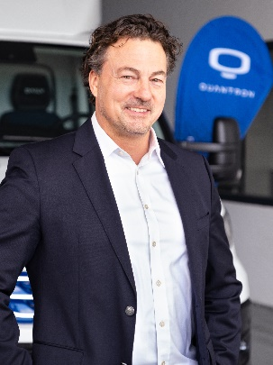 | Jörg Zwilling, Chief Marketing Officer Quantron AG

You can find the original images in both high and low resolutions here: Press releases from Quantron AG (https://www.quantron.net/en/q-news/press-releases/)

About Quantron AG
Quantron AG is a platform provider and specialist for sustainable transportation of people and goods; in particular for trucks, buses and vans with fully electric powertrains and H₂ fuel cell technology. As a high-tech spinoff of the renowned Haller GmbH, the German company from Augsburg in Bavaria combines over 140 years of commercial vehicle experience with state-of-the-art e-mobility know-how and positions itself globally as a partner to existing OEMs.
With the Quantron-as-a-Service Ecosystem (QaaS), QUANTRON offers an overall concept that covers all facets of the mobility value chain: QUANTRON INSIDE includes a wide range of both new vehicles and conversions for existing and used vehicles from diesel to battery and hydrogen electric powertrains using the highly innovative QUANTRON INSIDE technology. QUANTRON CUSTOMER SOLUTIONS ensures digital and physical aftersales solutions with a Europe-wide network of service partners, as well as a service offering for maintenance, repair and spare parts, telematics and in-cloud solutions for remote diagnostics and fleet management. Customers receive individual solutions: rental, financing and leasing offers such as training courses and workshops at the QUANTRON Academy. In the future, QUANTRON ENERGY & POWER STATION will realize the production and distribution of green hydrogen and electricity as a platform. To this end, Quantron AG has joined forces with strong global partners. This Clean Transportation Alliance also forms an important building block for the supply of vehicles with the necessary green charging and H₂ refueling infrastructure.
QUANTRON stands for the core values Reliable, Energetic, Brave. The team of experts at the innovation driver for e-mobility is making a significant contribution to sustainable, environmentally friendly passenger and freight transport. You can find more information at www.quantron.net
Visit the Quantron AG on its social media channels on LinkedIn and YouTube.

Your contact:
Jörg Zwilling, Chief Marketing Officer Quantron AG, j.zwilling@quantron.net
Stephanie Miller, Communications Expert Quantron AG, press@quantron.net

