PRESS RELEASE 16th April 2024

QUANTRON strengthens Supervisory Board with Herbert Robel and Hansjörg Cueni following a successful Annual General Meeting

- Quantron AG adds experienced industry experts to the Supervisory Board
- Herbert Robel, previously member of the Board of Management at Quantron AG, and Hansjörg Cueni, Chairman of the Board of Directors at Quantron Switzerland AG will bring in-depth expertise and a proven track record to their new positions
- The number of members of the Supervisory Board was increased from seven to nine

Quantron AG, specialist in sustainable passenger and freight transportation, announces the election of Herbert Robel and Hansjörg Cueni as new members of the company's Supervisory Board. This latest development was confirmed during the Annual General Meeting (AGM) held on the 21st of March 2024, at which the existing seven members were reelected, with Klaus Schmitt being confirmed as Chairman of the Supervisory Board. The total number of members was increased from seven to nine, necessitating a new election for the two positions with a supplementary election.
Herbert Robel, Co-Founder of Quantron AG and previous member of the Board of Management until the 31st of December 2023, is now elected as member of the Supervisory Board of QUANTRON. With his experience in the transportation industry and managing positions in various companies, Robel will play a crucial role in guiding QUANTRON´s Top Management during the next phase of progressive development.
Hansjörg Cueni, Chairman of the Board of Directors at Quantron Switzerland AG and now also member of the Supervisory Board, is a seasoned executive with a proven track record in leading successful organizations. Cueni's leadership skills and deep understanding of the zero-emission transportation industry will be instrumental in driving QUANTRON’s innovation and expansion plans.

The appointment of Herbert Robel and Hansjörg Cueni reflects QUANTRON’s commitment to appointing a diverse and experienced Board of Supervisors to effectively guide the company through its next phase of growth. As members of the Supervisory Board, they will play a key role in monitoring the company's strategic direction, ensuring compliance with legal and regulatory requirements, and safeguarding the interests of QUANTRON's stakeholders.
Herbert Robel, member of the Supervisory Board of Quantron AG, stated: “I am honored and proud to have been elected to the Supervisory Board of QUANTRON. This appointment is a testament to the trust placed in me by my colleagues and stakeholders. I am eager to contribute my expertise and dedication to QUANTRON's continued success and innovation in the sustainable transportation sector."
Hansjörg Cueni, Chairman of the Board of Directors at Quantron Switzerland AG and member of the Supervisory Board of Quantron AG, stated: “It is a privilege to join such a forward-thinking Supervisory Board at the forefront of sustainable transportation solutions. I look forward to leveraging my experience and knowledge to contribute to QUANTRON's continued growth and success in revolutionizing the transportation industry."
Chairman of the Supervisory Board Klaus Schmitt said: “I´m delighted to serve on my second term as Chairman of the Supervisory Board and welcome the two new members to the Supervisory Board. They will complement the fantastic expertise of the existing seven members. Together we will work closely with the Board of Management of QUANTRON to guide them through their dynamic development path.”
Andreas Haller, CEO & Founder of Quantron AG, stated: “We are delighted to welcome Herbert Robel and Hansjörg Cueni to the Supervisory Board, their extensive experience and proven leadership will be invaluable as we continue to drive growth and innovation in our industry. We are confident that their contributions will further strengthen our position as industry leaders."
Images (Please click on the image preview to download):
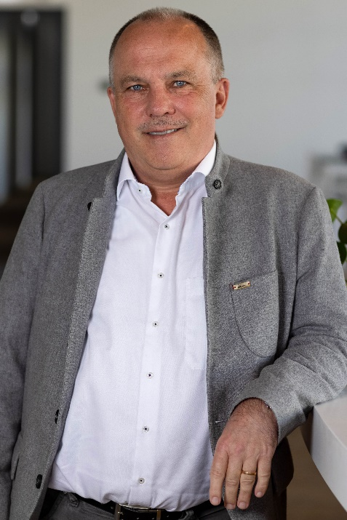 | Herbert Robel, member of the Supervisory Board, Quantron AG
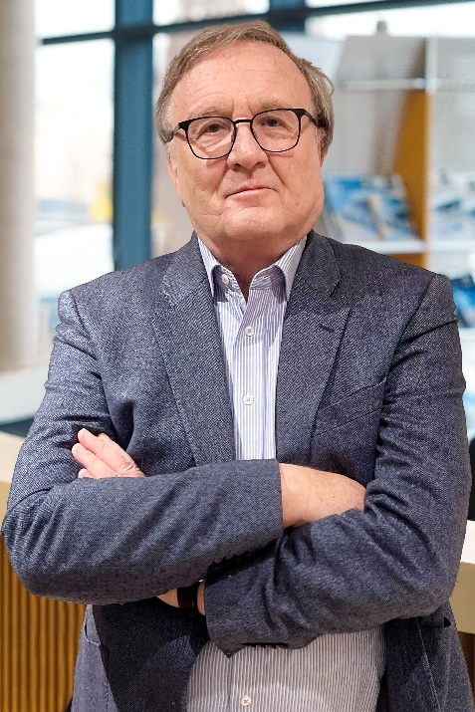 | Hansjörg Cueni, Chairman of the Board of Directors at Quantron Switzerland AG and member of the Supervisory Board at Quantron AG
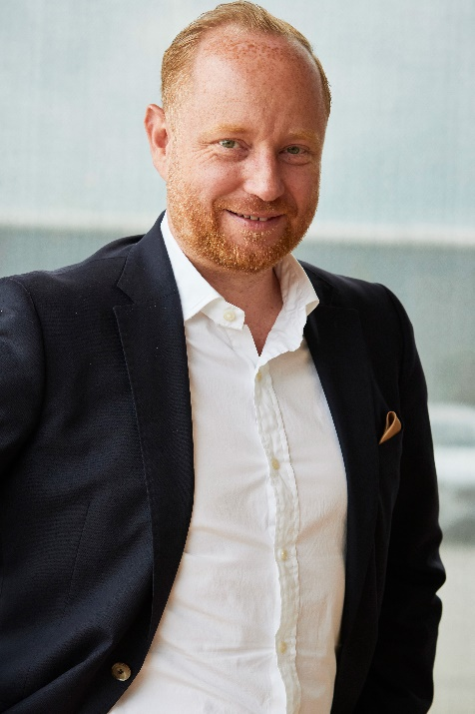 | Andreas Haller, CEO & Founder of Quantron AG

You can find the original images in both high and low resolutions here: Press releases from Quantron AG (https://www.quantron.net/en/q-news/press-releases/)
About Quantron AG
Quantron AG is a platform provider and specialist for sustainable transportation of people and goods; in particular for trucks, buses and vans with fully electric powertrains and H₂ fuel cell technology. As a high-tech spinoff of the renowned Haller GmbH, the German company from Augsburg in Bavaria combines over 140 years of commercial vehicle experience with state-of-the-art e-mobility know-how and positions itself globally as a partner to existing OEMs.
With the Quantron-as-a-Service Ecosystem (QaaS), QUANTRON offers an overall concept that covers all facets of the mobility value chain: QUANTRON INSIDE includes a wide range of both new vehicles and conversions for existing and used vehicles from diesel to battery and hydrogen electric powertrains using the highly innovative QUANTRON INSIDE technology. QUANTRON CUSTOMER SOLUTIONS ensures digital and physical aftersales solutions with a Europe-wide network of service partners, as well as a service offering for maintenance, repair and spare parts, telematics and in-cloud solutions for remote diagnostics and fleet management. Customers receive individual solutions: rental, financing and leasing offers such as training courses and workshops at the QUANTRON Academy. In the future, QUANTRON ENERGY & POWER STATION will realize the production and distribution of green hydrogen and electricity as a platform. To this end, Quantron AG has joined forces with strong global partners. This Clean Transportation Alliance also forms an important building block for the supply of vehicles with the necessary green charging and H₂ refueling infrastructure.
QUANTRON stands for the core values Reliable, Energetic, Brave. The team of experts at the innovation driver for e-mobility is making a significant contribution to sustainable, environmentally friendly passenger and freight transport. You can find more information at www.quantron.net
Visit the Quantron AG on its social media channels on LinkedIn and YouTube.
Your contact:
Jörg Zwilling, Chief Marketing Officer Quantron AG, j.zwilling@quantron.net, press@quantron.net

