PRESS RELEASE 3rd April 2024

QUANTRON leverages alternative hydrogen pathways together with its Clean Transportation Alliance partners

- Quantron AG releases a new whitepaper highlighting the role of waste-to-hydrogen technologies in decentralizing and localizing hydrogen production
- Companies like BtX Energy, as a part of QUANTRON’s Clean Transportation Alliance, are featured with their technology and the corresponding opportunities for zero emission ecosystems
- Such collaborations enable the transition from diesel powered to fuel cell powered vehicles and to lead the way in clean transportation fleets

Quantron AG, specialist in sustainable passenger and freight transportation, launched a new whitepaper titled, “Unlocking New Possibilities: Waste-to-Hydrogen as an Energy Source for Fuel Cell Vehicles”. This sheds light on how the technology complements current efforts to grow the hydrogen economy, its economic and environmental benefits, and its role in building local ecosystems. Further, the whitepaper also puts a spotlight on six selected partners from QUANTRON’s Clear Transportation Alliance who developed waste-to-hydrogen technologies and establish corresponding plants.
One such company is BtX Energy GmbH based in Hof, Bavaria. Among the early members of the Clean Transportation Alliance, BtX Energy recently achieved a significant milestone by becoming the first company in Europe to receive certification for hydrogen of biogenic origin that is eligible for GHG quota. “This certification underscores BtX Energy's commitment to producing sustainable and environmentally friendly hydrogen. We are excited to partner with QUANTRON to deliver hydrogen for fuel cell vehicles like the QLI FCEV, the first such vehicle in the 7.5-ton segment, to customers in the region," says BtX Managing Director Andy Gradel. Over the past few years, his team of experts has helped to shape the legal basis, set up the system technology, and successfully completed the REDcert-EU audit.
The whitepaper has been authored by Dr. Srinath Rengarajan who took over as the Head of Strategy at QUANTRON earlier this year. He says, “I am excited to contribute to strategy at QUANTRON as we continue our evolution from being an asset-light OEM into a leading platform provider of zero emission transportation solutions. One of those building blocks is the collaboration with waste-to-hydrogen partners like BtX Energy who are producing clean hydrogen from biogenic waste. QUANTRON will foster decentralized ecosystems that can harnesses the full potential of hydrogen, including its use in fuel cell vehicles.” By utilizing hydrogen produced from feedstock that is considered waste, these vehicles offer a clean and efficient solution for the transportation sector.
"We are thrilled to be working with companies in the Clean Transportation Alliance. Partners like BtX Energy advance the adoption of hydrogen as a sustainable energy source for mobility," added Andreas Haller, CEO, and Founder of QUANTRON. "Through our partnership, we aim to create ecosystems that not only reduce carbon emissions but also promote the use of renewable energies in the transportation sector from sources which were mainly untapped before." By fostering intelligent collaborations and promoting sustainable solutions, QUANTRON continues to lead the way in shaping the future of clean and efficient transportation.
To download the Whitepaper please click here: https://www.quantron.net/wp-content/uploads/2024/04/Waste-to-Hydrogen-Whitepaper.pdf
Images (Please click on the image preview to download):
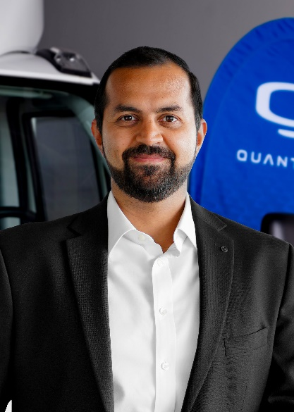 | Dr. Srinath Rengarajan, Head of Strategy Quantron AG
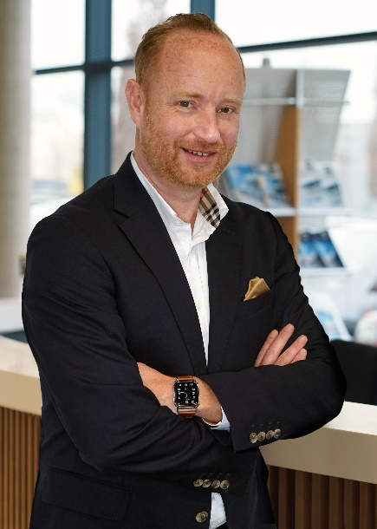 | Andreas Haller, CEO & Founder, Quantron AG

You can find the original images in both high and low resolutions here: Press releases from Quantron AG (https://www.quantron.net/en/q-news/press-releases/)
About Quantron AG
Quantron AG is a platform provider and specialist for sustainable transportation of people and goods; in particular for trucks, buses and vans with fully electric powertrains and H₂ fuel cell technology. As a high-tech spinoff of the renowned Haller GmbH, the German company from Augsburg in Bavaria combines over 140 years of commercial vehicle experience with state-of-the-art e-mobility know-how and positions itself globally as a partner to existing OEMs.
With the Quantron-as-a-Service Ecosystem (QaaS), QUANTRON offers an overall concept that covers all facets of the mobility value chain: QUANTRON INSIDE includes a wide range of both new vehicles and conversions for existing and used vehicles from diesel to battery and hydrogen electric powertrains using the highly innovative QUANTRON INSIDE technology. QUANTRON CUSTOMER SOLUTIONS ensures digital and physical aftersales solutions with a Europe-wide network of service partners, as well as a service offering for maintenance, repair and spare parts, telematics and in-cloud solutions for remote diagnostics and fleet management. Customers receive individual solutions: rental, financing and leasing offers such as training courses and workshops at the QUANTRON Academy. In the future, QUANTRON ENERGY & POWER STATION will realize the production and distribution of green hydrogen and electricity as a platform. To this end, Quantron AG has joined forces with strong global partners. This Clean Transportation Alliance also forms an important building block for the supply of vehicles with the necessary green charging and H₂ refueling infrastructure.
QUANTRON stands for the core values Reliable, Energetic, Brave. The team of experts at the innovation driver for e-mobility is making a significant contribution to sustainable, environmentally friendly passenger and freight transport. You can find more information at www.quantron.net
Visit the Quantron AG on its social media channels on LinkedIn and YouTube.
Your contact:
Jörg Zwilling, Chief Marketing Officer Quantron AG, j.zwilling@quantron.net, press@quantron.net

